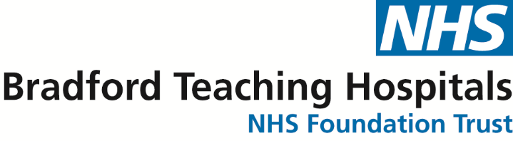

We are writing to inform you of an important patient safety alert concerning non-sterile cleansing wipes. Recent reports have linked certain brands of non-sterile cleansing wipes to an outbreak of a harmful bug called Burkholderia stabilis. This is an unusual bacteria that has been identified as a potential risk for serious infections.
What You Need to Know:
- Don’t worry if you have used these wipes in the past as any infection would have occurred within a matter of days of you using them.
- The following brands of non-sterile cleansing wipes have been found to be contaminated with the bacteria Burkholderia stabilis and have been withdrawn from the market: They were not used by Bradford Teaching Hospitals
  - ValueAid Alcohol Free Cleansing Wipes
  - Microsafe Moist Wipe Alcohol Free
  - Steroplast Sterowipe Alcohol Free Cleansing Wipes
  - Reliwipe Alcohol Free

These wipes may still be present in first aid boxes at home, in workplaces, or in other settings. We strongly recommend checking any wipes you have and disposing of any affected brands immediately.
- The affected non-sterile cleansing wipes have been associated with an increased risk of infection, particularly for individuals who use them on injuries, wounds or broken skin.
- These wipes should not be used to clean intravenous lines (devices in blood vessels), dialysis lines, PICC lines or peritoneal dialysis lines or any other medical devices.
What We Advise Moving Forward:
- In centre dialysis patients with dialysis lines or fistulas: Please do not attempt to clean them yourself. Only the trained dialysis unit staff should clean lines to make sure proper hygiene and minimise the risk of infection.
- Home therapies patients should follow the protocol for cleaning your access using hospital supplied sterile cleaning wipes
- Patients going home with an intravenous drip or PICC line for antibiotics into a vein (or other medications given into a vein by nurses at home): Please do not attempt to clean them yourself. Only trained nursing staff should clean lines to make sure proper hygiene and minimise the risk of infection.

Your health and safety are our top priorities, and we want to make sure that you have the right information and guidance. The overall risk remains very low with only 51 cases in the UK over a 7 year period.

