Logging into DrDoctor
- You can log into DrDoctor by clicking the link sent to you by your healthcare provider
- Alternatively, you can log into DrDoctor via https://drdoctor.thirdparty.nhs.uk/
- The login page, shown below, will ask for some basic details

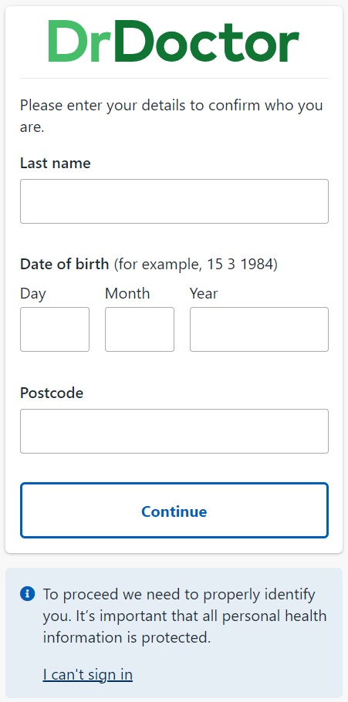

- Enter your one time verification code
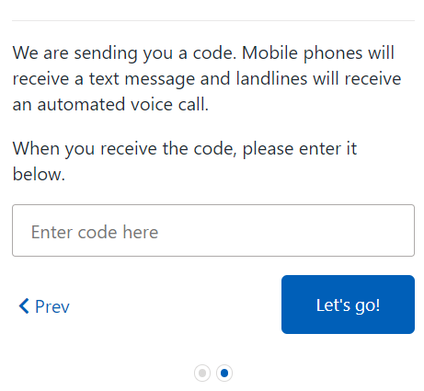
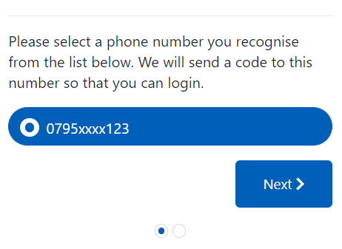

Overview
- There are 3 main sections on the patient portal: Appointments, Letters, Online Care
- Your appointments will be shown on the ‘Appointments’ tab
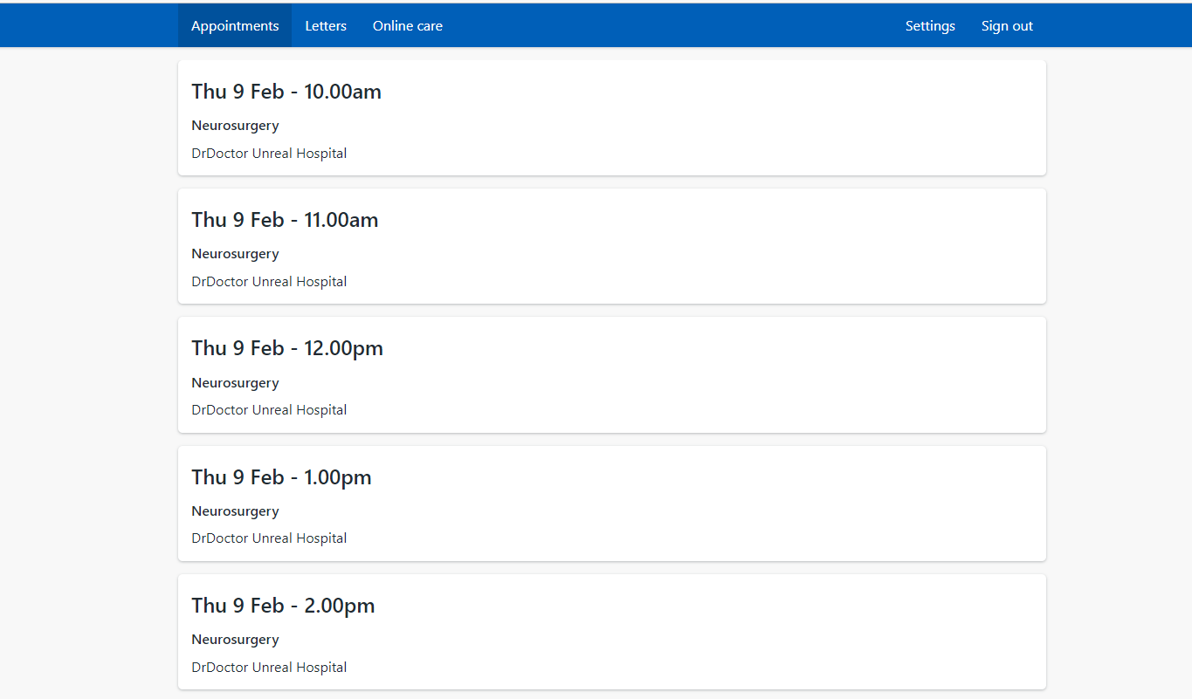
- When you click on an appointment, you’ll see the following pieces of information: Appointment Information, Directions & Clinic Info
- Click on each sub-tab to view various appointment related information
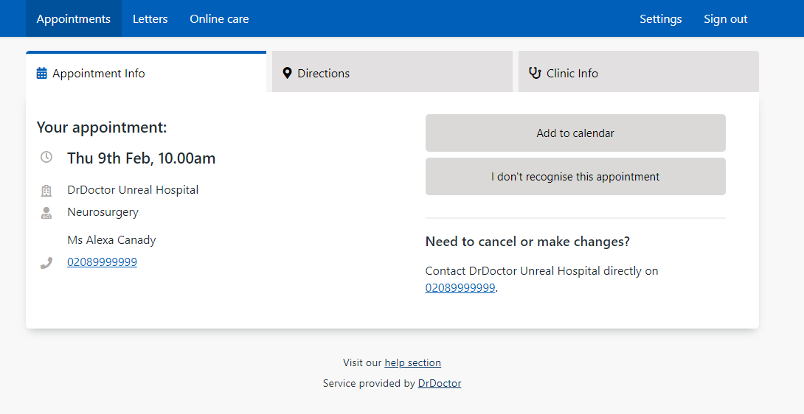
- Click on the “Letters” main tab at the top of the page to view any digital letters sent to you by your hospital

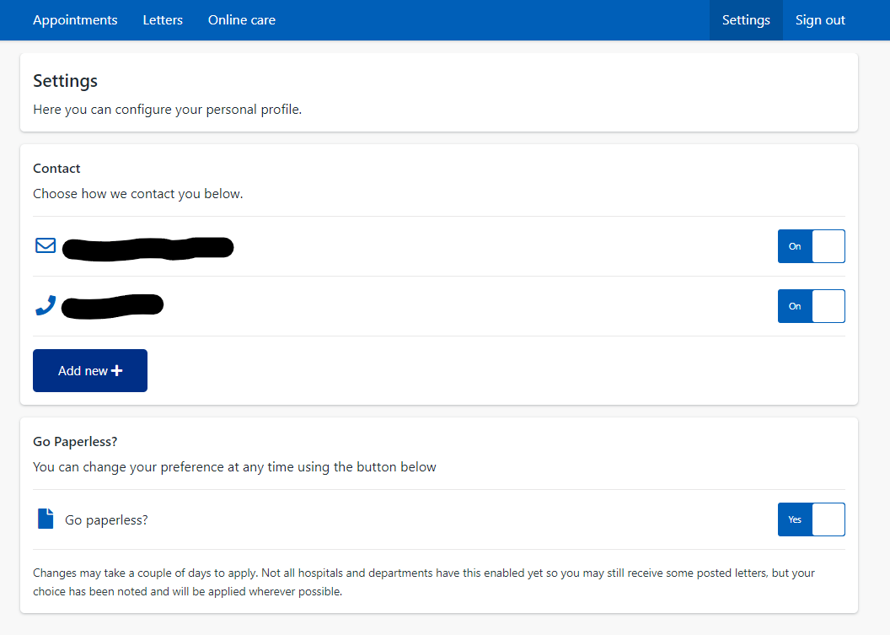

- Click on the “Online Care” main tab at the top of the page to view any assessments that have been sent to you by your hospital. These include forms that hospitals sometimes ask patients to complete before, during or after appointments. Your hospital will notify you if they require you to complete an assessment.

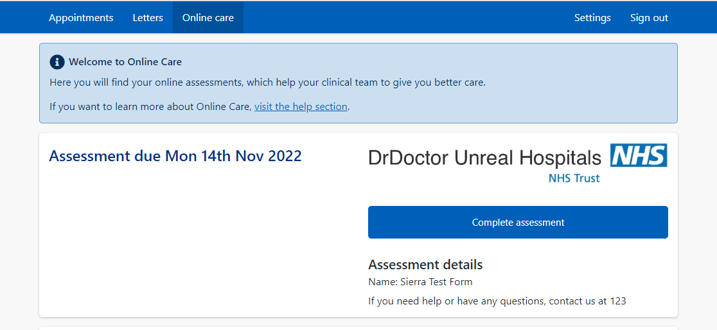

- Click on the “Settings” main tab at the top right of the page
  - Here you can update your contact details and choose your contact preferences

