Endotracheal Intubation

Authors: Sam Wallis

Approved by: Neonatal Guidelines Group 04/03/2014.

Updated with checklist 23/02/2016 and 26/04/2017. Reviewed and approved NGG 01/04/2019. Reviewed and approved NGG 07/12/2021.

Review date: 07/12/2024

Version: 5



**Endotracheal Intubation**

Intubation should be supervised by trained staff with knowledge of the effects of the intubation process and the medications used.

If you are not confident in performing the procedure, it is safer to follow the NLS protocol and manage airway and breathing with an appropriate size mask.

Please complete an intubation checklist and file in the notes

See also – Neonatal Ventilation guideline

**Contents**

1. Preparation
2. Sedation
3. Tube size / lengths
4. Insertion, checking and securing

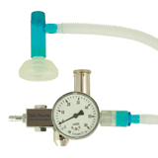**Preparation**

Equipment

* Oxygen / air supply turned on – Tom Thumb
* T-piece connected and pressures adjusted
* Appropriate size face mask
* Suction checked and suction catheter connected
* Stethoscope
* ET tube – est size + 1 smaller + 1 larger
* Introducer if required
* Video Laryngoscope + spare conventional + appropriate size blade
* 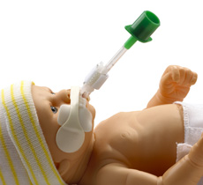NEO-fit securing system
* Pedi-cap CO2 detector
* Incubator areas secured

Team

* At least 2 with clearly defined roles
* 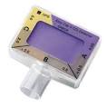Procedure sequence discussed

Patient

* Appropriate positioning
* Monitoring (HR / Sats)
* Measures to avoid hypothermia agreed
* IV line flushed
* NG / OG tube aspirated
* Premedication/ Sedation (see below) drawn up and ready

“Everyone ready?”

**Sedation**

Unless it is an emergency situation you should pre-medicate before intubation.

Endotracheal intubation is unpleasant and stressful and can cause serious disruption to the cardiorespiratory status of the baby.

* Reducing pain for our patients is an ethical obligation.
* Intubation may induce bradycardia, hypoxia, hypotension and raised intracranial pressure
* In awake patients, there is greater potential for traumatic injury to the airway.

**In Bradford we use -**

1. **Fentanyl**  IV (over 1 min) **3** micrograms/kg (dose range 2-5microg/kg)
2. **Atracurium** IV **500** micrograms/kg (dose range 300-500microg/kg)

**Fentanyl** – is an opiate whose onset of action is 1 minute, and lasts 30 – 60 minutes. It has a protective effect on intracranial pressure and blood pressure. It has good analgesic effect and is reversible with Naxolone. It’s short action means that there is no interference with background analgesia of morphine.  
  
Fentanyl comes in 2 ml ampoules of 100 micrograms.

It is a controlled drug and is kept in the CD cupboard

*Remember that 1 ampoule contains 25 times the maximum does for a 1kg baby*

Dilute 1:5 with 0.9% Saline i.e. 4 ml 0.9% Saline and add 1 ml (50microg) Fentanyl

Once diluted 1 ml = 10 micrograms  
The dose of Fentanyl is 3 micrograms / kg i.e. 0.3 ml / kg IV of diluted solution

Mix the syringe prior to use by inverting several times and prepare immediately prior to use

Give over **1 minute** as a slow bolus

Naloxone should be available

Fentanyl may accumulate with repeat doses so consider reducing subsequent doses to 1 microg / kg (0.2 ml / kg of diluted solution)

**Atracurium**. - is a non-depolarising neuromuscular blocker. Never paralyse a baby unless you can control the airway. Its onset of action is 1-2 minutes, duration of action 25-40 minutes. Usually its effects allow intubation after 2-4 minutes. Neonates may be very sensitive to it’s action.  
  
It has few side effects; occasionally histamine release. Duration of neuromuscular blockade is not prolonged by large or repeated doses.  
  
Atracurium is supplied in 2.5 or 5 ml ampoules at a concentration of 10 mg / ml.

*Remember that a 2.5 ml ampoule contains 50 times the dose required for a 1 kg baby*

Dilute 1:10 with 0.9% Saline i.e. 4.5 ml 0.9% Saline plus 0.5 ml (5mg) Atracurium

Once diluted 1 ml = 1 mg (1000microg) or 0.5 ml = 500 microg  
Dose is 500 microg / kg = 0.5 ml / kg IV of diluted solution.  
Make syringe up immediately prior to use

Give after Fentanyl

There is no antidote, respiration will need to be supported until after the effects wear off

**Atropine.** This would be used routinely in children and adults.

We do not use it routinely in neonates but it may be appropriate to use if profound and prolonged bradycardia occurs – the dose is 10 microg – 20 microg / kg.

**Tube size / lengths**

|  |  |  |  |  |
| --- | --- | --- | --- | --- |
| Gestation | Weight (kg) | Diameter (mm) | Oral length (cm) | Nasal Length (cm) |
| 23-24 | 0.5 | 2.5 | 6 | 7 |
| 25-26 | 0.75 | 2.5 | 6.5 | 7.5 |
| 27-29 | 1.0 | 2.5 | 7 | 8 |
| 30-32 | 1.5 | 3.0 | 7.5 | 8.5 |
| 33-35 | 2 | 3.0 | 8 | 9.5 |
| 36-37 | 2.5 | 3.0 | 8.5 | 10.5 |
| 38-39 | 3 | 3.5 | 9 | 11 |
| 40+ | 3.5 | 3.5 | 9.5 | 12 |

Oral length is given at the top lip

Avoid size 2.0 tubes if possible – they are very narrow and fixation and suction difficult

Only advance to the point where the **black tip** is seen to disappear past the cords. Do NOT advance further.

This is only a guide – tube position should be confirmed on x-ray (see below)

**Insertion Technique -** [**Adapted from Yorkshire Neonet Intubation Training Guide**](http://www.yorkshireneonet.nhs.uk/guidelines/guidelines-1/NeonatalIntubationteachingpackagefinal2009.pdf)

Preparation is key – use the checklist

Explain procedure to family

1. Prescribe and prepare medication, check IV access
2. Prepare and check equipment and team

Kit, Oxygen turned on, face mask, suction, team roles

Our default position is to inubate withoutn and introducer to minimise risk of iatrogenic harm but have available.

Check tip of introducer does not extend beyond tip of the tube

1. Consider environment (screens / other families / is everything within reach)
2. Position infant appropriately

Correct incubator height, position of baby and access for other team members

You will need to open the door and bring the incubator tray out – don’t do this until you are ready as the baby will get cold – consider warm blankets / transwarmer

The baby will need to be turned 90 degrees and the head on the edge of the mattress. Head should be in midline with small degree of extension.

1. Aspirate NG / OG tube
2. Pre-oxygenate

2-3mins. Check you are in position to manage the airway

1. Give medications (with flush)

Wait until taken effect. Support airway, continue oxygenation.

1. Intubate

Open mouth with finger

Insert laryngoscope

* gently, taking care not to damage lip/gums

Move blade along right side of mouth, displacing tongue to the left. Some people may find it easier starting in the midline.

Bring blade to base of the tongue and clear any secretions with suction

Bring tip of blade to rest anterior to the tip of the epiglottis

Lift laryngoscope blade forward to obtain view of cords

* do not tilt or lever against the gums

If you can’t see cords then blade may be beyond larynx

* consider withdrawing slowly
* consider cricoid pressure

If the cords are together, wait for them to open.

* don’t try and force the tube through.

Bring in tube from right, try to not to obscure view

Advance tube through the cords – there should not be any resistance

* only advance to the point where the black tip is seen to disappear.

Note the length at the lips

Carefully withdraw laryngoscope – keep hold of the tube so it doesn’t move

Attach ET tube to T-piece / Ventilator and start ventilating

1. Check position

Are you confident you saw the tube go through the cords?

Check the heart rate / saturations

* are they maintained / improving?

Is there bilateral chest movement?

Listen at both sides for air entry

* this should be symmetrical, it is easy to put the tube in too far and be ventilating only 1 lung
* if air entry is unequal, try pulling the tube back slightly and reassessing

Attach a Pedi-cap and look for colour change

* This is not always required if seen going thorugh cords on video

Gold = good. Tan / Purple = Oesophageal intubation or poor perfusion

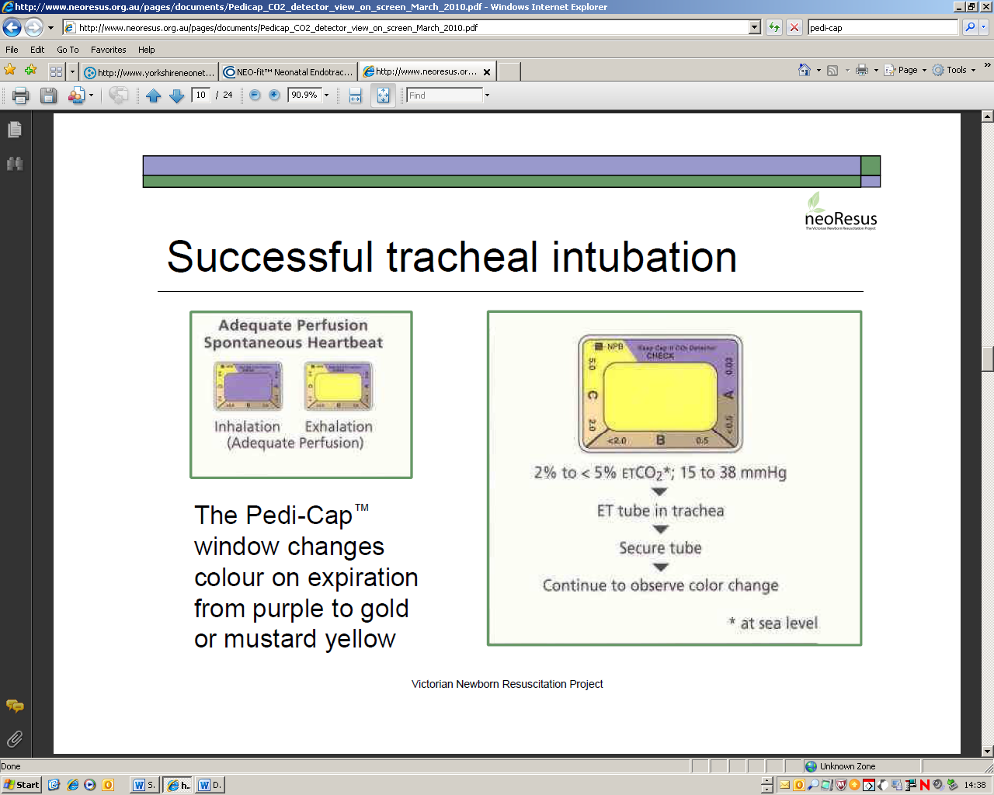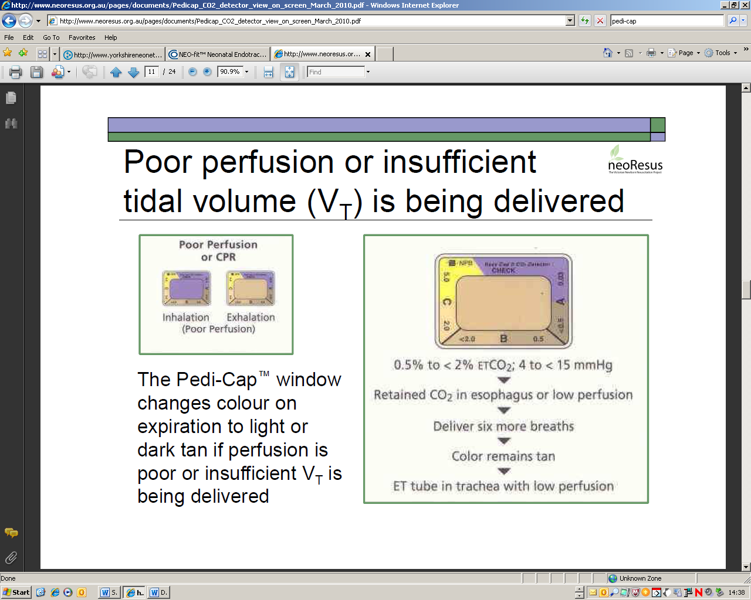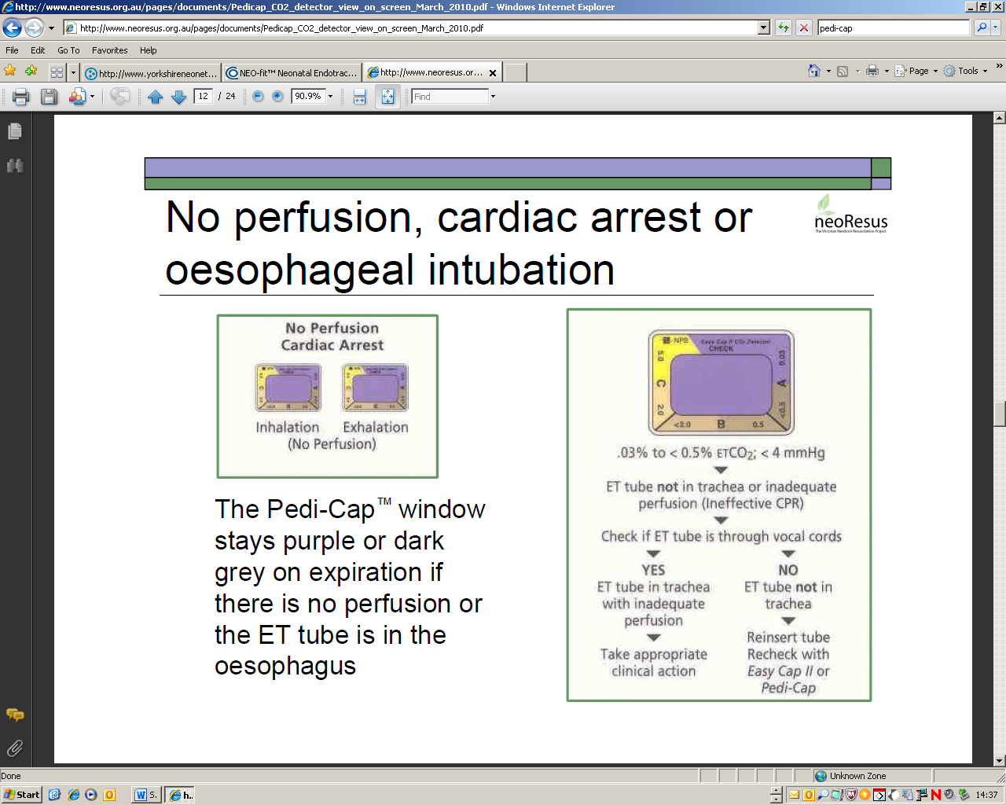

* Occasionally in tiny babies or in an arrest situation, CO2 excretion is insufficient to cause colour change.
* If in doubt – take it out



1. Secure tube

Keep hold of the tube and head while an assistant attaches the NEO-fit

* The attachment goes between the nose and mouth
* Don’t let go of the tube until you are happy it is secure

Check it is secure (push test) but not wrapped too tight that it obstructs passage of the suction catheter



1. Confirm position on X-ray

Optimal position is at T2, this usually corresponds to the tip of the ETT just below the head of the clavicles

You don’t need to X-ray after every tube change if position is known to be correct on previous films

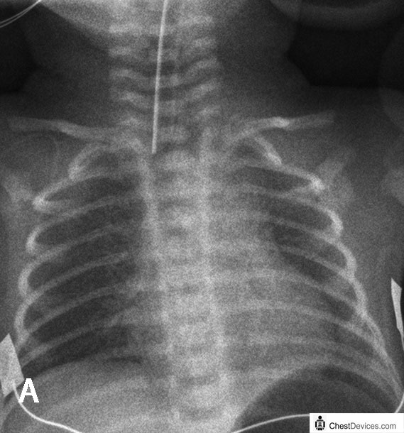

This Tube is in an acceptable position at T1, with the tip at the clavicles

1. Attach “flag”

Wrap a small section of Zinc Oxide tape around the tube, just above the NEO-fit

Checking to see if the tube has moved by looking at length is often difficult so the flag acts as a useful visual marker.



13. Complete checklist and file in notes