Difficult Airway Management - Neonates

Authors: Carol Hudson, Chakra Vasudevan

Approved by: Neonatal Guidelines Group, 27/10/2015.

Updated and Approved 01.12.2018

Updated 17/07/2020. Minor edit to difficult airway box location 12/04/2023.

Review date: 17/07/2025

Version: 3



This guideline will outline a management strategy when attempts at securing definitive airway (ie. Endotracheal intubation) has been unsuccessful.

Difficulties in Neonatal intubation may occur in the following situations

**Anticipated**

* Syndromes such as Pierre-Robin, Goldenhaar, cleft palate with micrognathia, known airway abnormalities, neuromuscular disorders

**Unanticipated**

* Undiagnosed airway abnormalities, tracheal / laryngeal atresia / stenosis

Irrespective, it is important to be prepared and identify clear strategy to manage if there is a problem.

**Difficult / Unsuccessful intubation**

* **Can’t intubate** **but able to ventilate** through face mask
  + **See below**
* **Can’t intubate and can’t ventilate** – Clearly this is more worrying and an urgent response is needed.
  + **See below**

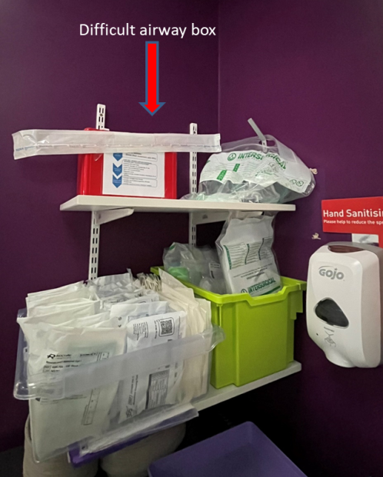**Please get the difficult airway box from Room 1 – Red box next to the intubation trolley**

**Laryngeal mask insertion**

**Cricothyroidotomy**

**Emergency Drugs (reversal)**

**CANT INTUBATE / ABLE TO VENTILATE**

This situation usually arises when there is difficulty visualising the vocal cords

The laryngeal view has been classified by **Cormack and Lehane** as follows

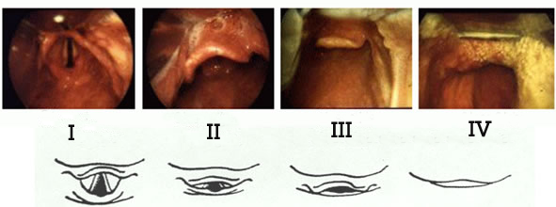

**Grade 1**: Visualization of the entire laryngeal aperture. There should be no difficulty in intubation

**Grade 2**: Visualization of just the posterior portion of the laryngeal aperture. There may be slight difficulty. Cricoid pressure will improve visualisation

**Grade 3**: Visualization of only the epiglottis. This can result in severe difficulty; cricoid pressure may be helpful

**Grade 4**: visualization of just the soft palate only, not even the epiglottis is visible. This is always difficult and usually accompanies obvious pathology but may also occur totally unexpectedly. This must have senior support available

If there is difficulty in obtaining a good view,

1. Ensure that the baby is being oxygenated and ventilated throughout the process
2. Get senior help as soon as possible and identify who the nearest is (Paediatric Registrar, Neonatal Consultant, Obstetric Anaesthetist)
3. Check that you are using the right size laryngoscope blade (sometimes a longer or a shorter blade would be ideal)
4. If not using the video laryngoscope then consider its use. It is stored in room 0.5.
5. Consider McGrath video laryngoscope if experienced – found in the difficult airway box.
6. Consider using the glidescope - This is stored in the equipment store room.
7. Cricoid pressure is useful in situations where the cords appears to be anterior but avoid too much pressure on the cricoid
8. If you are able to ventilate the baby, avoid repeated attempts until senior help arrives. In general, it is not advisable to have more than 2 attempts (unless by a senior clinician or after discussion with senior member of the team)
9. Ensure that the baby is kept warm, place a NG tube (free drainage) to decompress gastric air and be vigilant for pneumothorax, if there is a sudden deterioration.
10. Be cautious about repeating any further doses of muscle relaxants as this may worsen the situation.
11. On occasions where muscle relaxants have been administered and there are difficulties in intubation, you may want to consider reversal of muscle relaxation and sedation. For further info, refer to appendix (Reversal of paralysis and sedation)

**CAN’T INTUBATE / CAN’T VENTILATE**

This is a dire emergency and may be prevented by anticipating airway difficulties (in cases where airway difficulties are anticipated, make sure you are able to ventilate before administering muscle relaxants)

Commonly, this happens because of suboptimal airway positioning

If you are in this situation, the following needs to be considered

1. ASK FOR SENIOR HELP – INVOLVE OTHER TEAMS in addition to calling the CONSULTANT NEONATOLOGIST – Call the Paediatric Registrar, then Anaesthetist on for Obstetrics (they may have skills which can help)
2. Check seal on the mask, appropriate size of the mask and consider increasing the pressure and FiO2 (FiO2 – 100% and sometimes PIP of 30 or above may be needed)
3. Reposition airway – Use two person jaw thrust, consider using a rolled towel beneath the shoulders
4. Visualise oropharynx and if you can see any visible obstruction (ie,blood clot, meconium), use Yankauer suction to clear obstruction and consider Guedel airway. Also consider Nasopharyngeal airway
5. Consider suctioning below the cords (either through ET tube or with suction catheter directly)
6. Consider using the McGrath video laryngoscope (if experienced) – the laryngoscope is kept in the difficult airway box
7. If all these measures fail, consider using a Laryngeal Mask Airway (see below for instructions)
8. It is important to avoid repeated attempts at intubation if you are unable to visualise the cord and focus on optimising ventilation through face mask and get appropriate help as soon as possible. Discuss options with the team including senior nurses if more than 2 attempts.
9. It will be useful to consider use of bougie (with caution – as this may cause airway injury) or use of adjuncts such as McGrath laryngoscope(enables better visualisation)
10. In spite of all the above measures, if still the baby has not got an established airway, emergency cricothyrotomy should be considered with specialist input from ENT on call (Switchboard). We have used a large bored cannula (grey) inserted through the cricoid membrane to ventilate in case of suspected laryngeal atresia. This can be obtained from Labour Ward.

**Laryngeal Mask Airway insertion**

**Who**

* Size 1 iGel = 2 to 5 Kg
* Single use. Do not re-use as becomes stiff with time

**Where**

* In the sterile store room
* In the airway trolley (drawer 3 with guedels)
* 1x iGel in labour ward emergency trolley

**How**

* Open the packet
* Lubricate sides and back of iGel with water based lubricant
* Ensure no lubricant within the cuff of the mask
* Head in “sniffing air” position
* Place green mask in mouth with open side facing tongue
* Do not insert fingers in mouth
* Apply gentle pressure to push mask towards larynx
* When a definite resistance is felt, give breaths and check for lung inflation.
* Secure in place immediately with tape
* CO2 detector is not mandatory but can help confirm mask is correctly placed.

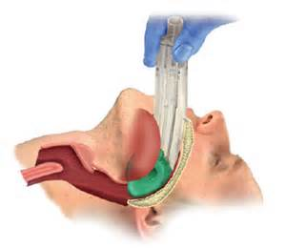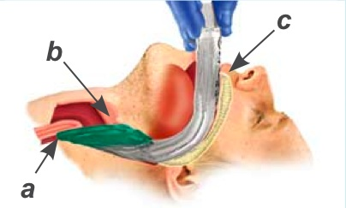 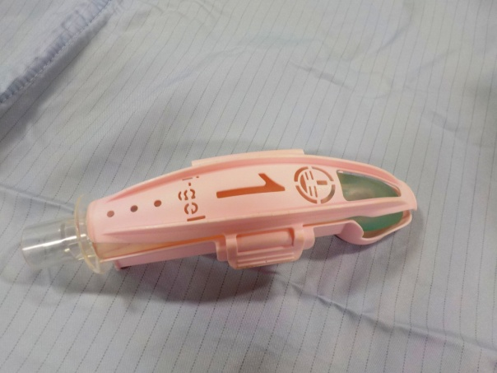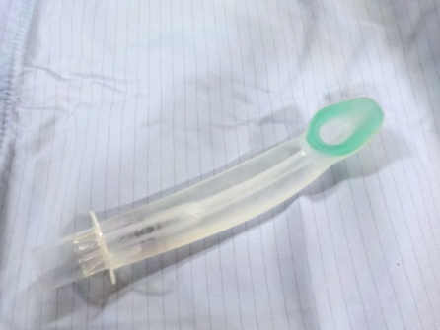

**Needle** **Criothyroidotomy**

This is an emergency holding-measure to provide oxygenation not ventilation, and is only used in exceptional circumstances. Careful consideration should be given before attempting this procedure; the baby will have had a prolonged period of hypoxia prior to attempts at needle cricothyroidotomy and continued resuscitation may not be appropriate.

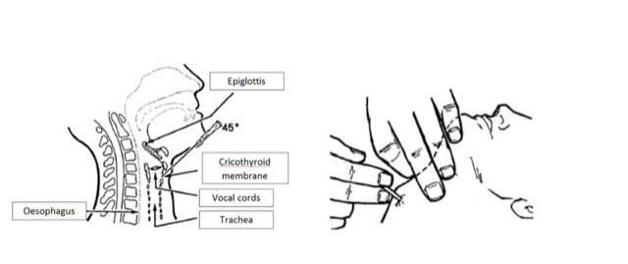

Adapted from the APLS and ARNI protocols:

•  Attach a 16G (grey) cannula to a 5ml syringe

•  Identify the cricothyroid membrane by palpation between the thyroid and cartilage cartilages

•  Clean the neck with an antiseptic wipe

•  Insert the needle through the cricothyroid membrane at a 45° angle caudally, aspirating as it is advanced

•  When air is aspirated, advance the cannula and withdraw the needle

•  Recheck that air can be aspirated

•  Connect to a 3-way tap and green oxygen tubing – connect to a gas supply: titrate flow to achieve chest rise

•  Switch the 3-way tap OFF to air for 1 second to allow gas to pass into the lungs, then switch the 3-way tap ON to air for 4 seconds to allow passive exhalation

|  |  |  |  |  |  |
| --- | --- | --- | --- | --- | --- |
| **Emergency Drug Doses - NEONATES ONLY** | | | | | |
|  |  |  |  |  |  |
| **OPIOID - REVERSAL** | | | | | |
| **Drug** | **Dose** | **Route** | **Stock Vial** | **Making up** | **Final Concentration** |
| NALOXONE | 100  microgram/kg/dose | IV | 400 microgram /mL | Dilute 1ml (400microgram) in 3ml sodium chloride 0.9% | 100  microgram /mL |
| **BENZODIAZEPINE - REVERSAL** | | | | | |
| **Drug** | **Dose** | **Route** | **Stock Vial** | **Making up** | **Final Concentration** |
| FLUMAZENIL | 10  microgram/kg/dose | IV | 500  microgram in 5mL | Dilute 1mL(100micorgram) in 9mL sodium chloride 0.9% | 10  microgram/mL |
| **NON-DEPOLARISING NEUROMUSCULAR BLOCKADE - REVERSAL** | | | | | |
| **Drug** | **Dose** | **Route** | **Stock Vial** | **Making up** | **Final Concentration** |
| NEOSTIGAMINE | 50 microgram/kg/dose | IV | 2.5  mg/mL | Dilute 1ml(2.5mg) in 15.5ml sodium chloride 0.9% | 150  microgram/mL |
| ATROPINE | 20 microgram/kg/dose | IV | 400  microgram  /mL | Dilute 1.5mL (600microgram) in 8.5mL sodium chloride 0.9% | 60  microgram/mL |

Equipment list for difficult airway box

1. Bougie (outside the box)
2. Flow charts – Can’t intubate / can’t ventilate and Can’t intubate / can ventilate
3. Oropharyngeal airways X 4 (different sizes)
4. Laryngeal mask
5. Tracheal intubation stylet
6. Magill’s forceps (18.5cms)
7. Grey cannula (if needed for cricothyrotomy)
8. McGrath Laryngoscope with blades Size 1
9. Copy of the latest difficult airway guideline