5 top tips to support with Fatigue and disturbed sleep

1. Positioning: Being comfortable in bed is key, ensuring pillows are giving correct support. Using the bedroom for sleeping only and not lying in bed for a long time once awake, can be helpful for the brain to continue to relate the bedroom to sleeping and thus in turn helping you to feel relaxed when in bed.
2. Medications: Use of medications as recommended by nurses and doctors is important to getting pain under control. Taking pain relief appropriately as required before bed time can aid sleep.
3. Reductions: Routine is important to helping sleep hormones come on naturally to help you feel sleepy at the correct times. Reducing napping throughout the day, screen time close to bed time and caffeine no later than 8 hours before bed can also help. Try not to drink/ eat unless needed for around 2 hours before bed.
4. Reducing pressure on you: Reducing pressure on yourself can aid sleep. If you don’t sleep so well, use prioritisation and planning to complete activities with rest periods, rather than feeling the need to complete everything which may not be a priority and then feeling more tired. Try get a pre bed routine that works for you and stick to it, even if it improves sleep a small amount to start- note the small improvements! It takes time to change a mind set and routine.
5. When sleep is disturbed: Stay calm. Try to use techniques such as changing the pillows position, maybe completing simple exercises (warm water as required) before returning to try to sleep. Use of podcast/ calm music can help. If you are struggling to get back to sleep, try getting up and having a herbal (no milk or caffeine) drink then returning to bed, rather than tossing/ turning and increasing frustration.

4 top tips to support Pain

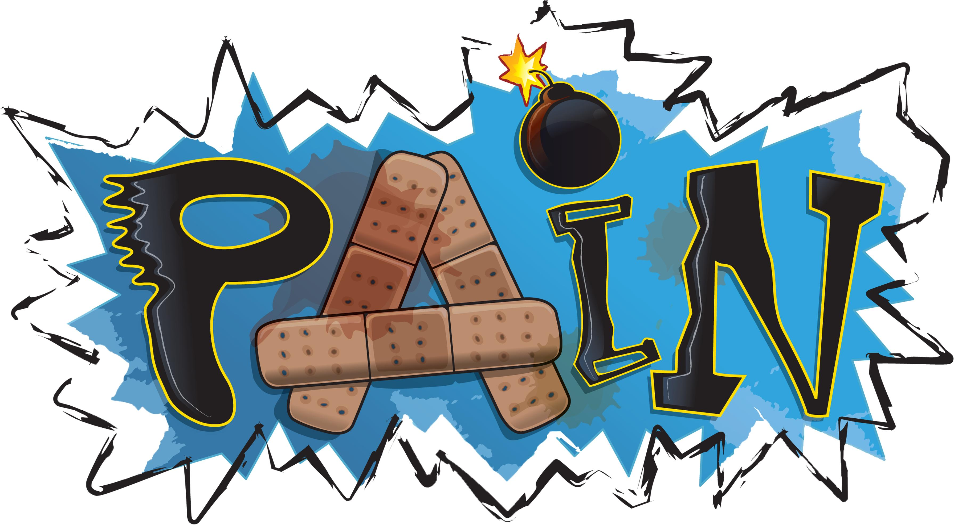

1. Pacing activities: Taking your time and breaking down tiring activities can be important. Also planning ahead and using other resources available, to support daily activities such as; family, aids and adaptations and personal management techniques such as warm water. On days you may have reduced symptoms it’s important to not complete everything, also known as ‘boom and bust’ to avoid making pain and symptoms worse the next days. Pacing can allow you to ensure your normal every day roles are maintained despite a flare up. Take a look at this resource to gain further advice on how pacing can help you: <https://livewellwithpain.co.uk/wp-content/uploads/pacing.pdf>
2. Relaxation: Taking time to do things you enjoy can be important to allow yourself to relax and focus onto something other than the pain. Having activities or interests outside of usual day to day activities can be helpful to allow your brain to relax. Rest periods throughout the day are important, even if it’s just sitting for 10 minutes. <https://www.paintoolkit.org/pain-tools>
3. Reflection: Take some time to reflect upon what might make your symptoms worse and what helps to make them better. Understanding your condition and symptoms can be vital to improving the way you self-manage your condition and understand why you are doing what you’re doing. Take a look at this resource: <https://www.versusarthritis.org/about-arthritis/conditions/arthritis/>
4. Exercises: It is important to complete exercises to maintain range of movement and strength of the joints/ muscles. If stiffness is a problem for you, try using warm water to relax- you could always complete hand exercises whilst hands are submerged. Cold water can also ease flared up joints that are hot. Helpful tips here: <https://mylivingwell.co.uk/about-us/20-minute-movement> , <https://mylivingwell.co.uk/physical-activity/10-tips-to-be-more-active>