Dana Diabecare i insulin pump.

Insulin is delivered from a reservoir inside the pump. The pump is programmed to deliver insulin continuously to keep blood glucose in constant control. When any carbohydrates are eaten the carbohydrate amount needs to be entered into the pump by the user/carer. The pump will then advise the bolus dose of insulin to be delivered.
It is powered by a AAA battery.

Navigating the Dana i Insulin Pump

The pump is attached to a thin flexible tube – the infusion set - which is inserted into the skin of the abdomen or buttock via a cannula. The cannula is held in place by an adhesive dressing.
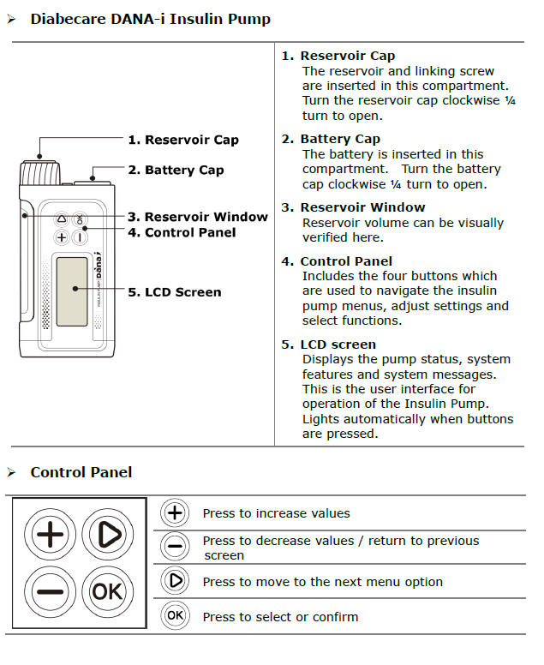

The Home screen.

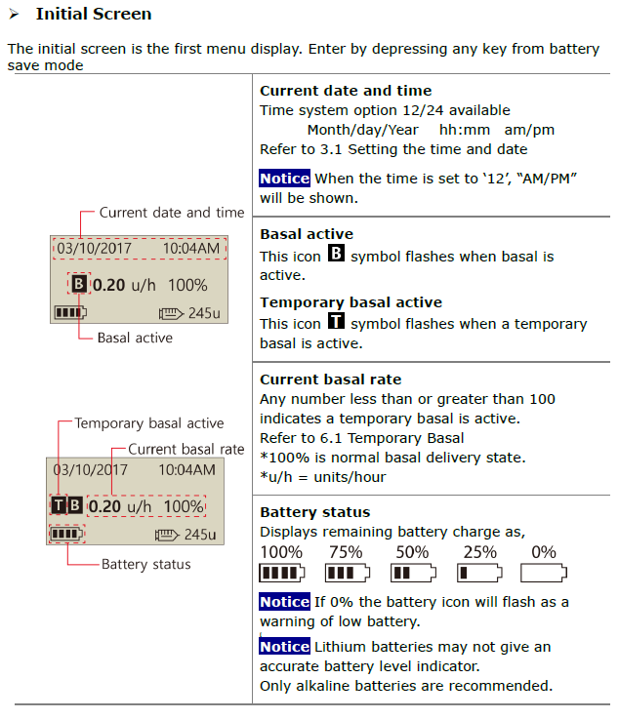

How to use the Dana i pump to give insulin
The key worker (or young person) will need to give insulin when:
- The blood glucose is greater than 14 mmol/L
- Whenever they intend to eat or drink any food containing carbohydrates

If the blood glucose is less than 4 mmol/L please follow treatment for hypoglycaemia.

1. Press OK to enter the main menu of the pump
2. Press the arrow button to highlight ‘BOLUS’

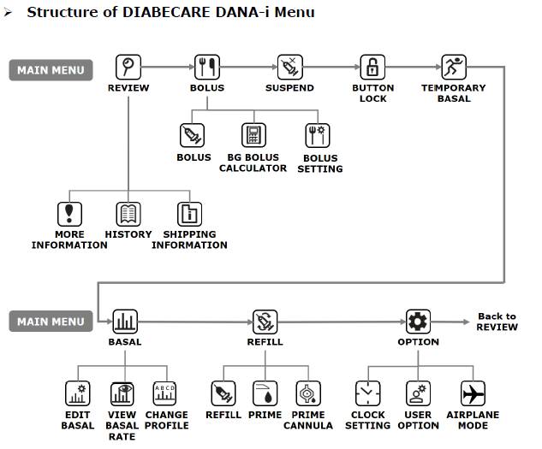

3. After pressing ‘OK’ on the ‘BOLUS’ option in the main menu, use the arrow to navigate to ‘BG BOLUS CALCULATOR’, and press ‘OK’.

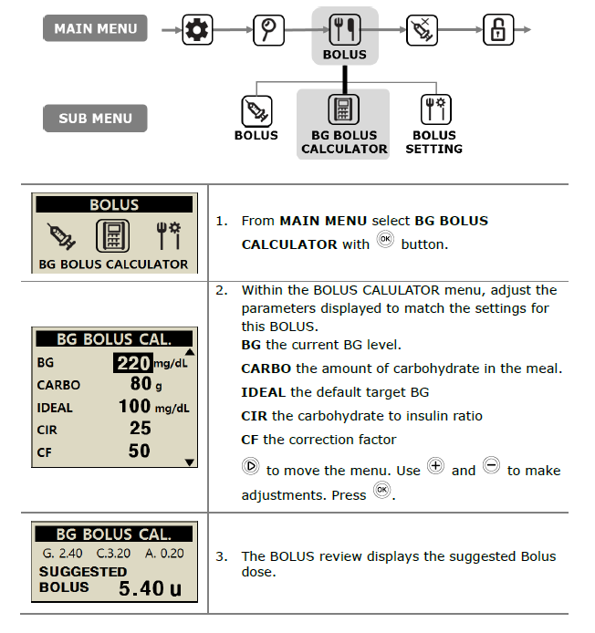
4. Ensure you enter the correct BG and the correct CARBO (grams of carbs being eaten). You do not need to enter or change any other value in the bolus calculator.

NB. If the young person is not eating, leave the carbs with a value of 0g.

5. Once the pump has shown the suggested bolus, press ‘OK’.
6. Choose the first ‘STEP BOLUS’ option for instant delivery, press ‘OK’.
7. The pump will show you the suggested bolus again, and the intended speed of delivery, press ‘OK’ and then ‘OK’ again to begin delivery.
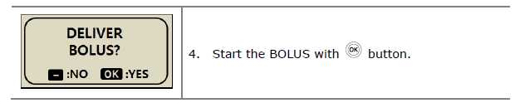

How to set temporary basal rates
The key worker (or young person) will need to set a temporary basal rate when:
- The child/young person undertakes exercise

Alongside having snacks to maintain blood glucose levels during exercise, the amount of basal insulin can also be decreased using temporary basal rates.
The pump is able to remain attached during exercise, however, it should be removed during certain activities such as contact sports to protect the young person from injuries and pump from damage.

- Navigate to ‘Temporary Basal’ in the pump Main Menu, press ‘OK’.
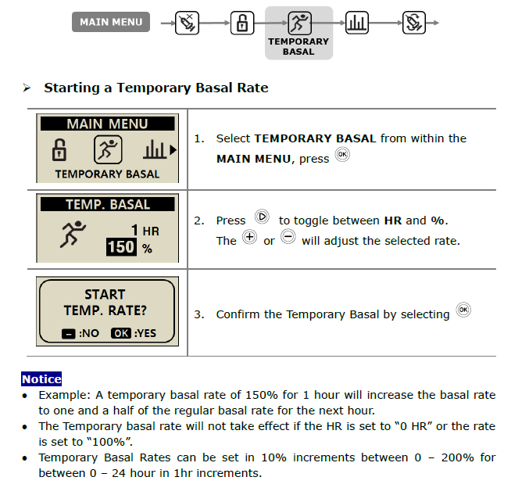

Alarms, Errors and Alerts:

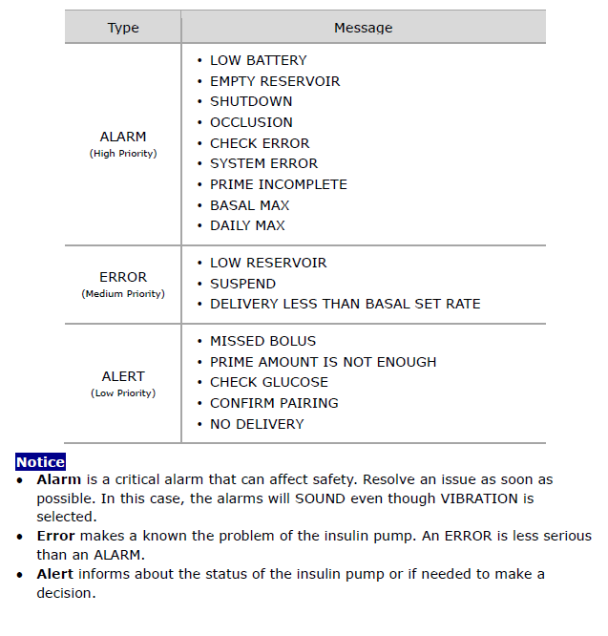

The Dana i User Guide contains a comprehensive list of alerts, errors and alarms with instructions on how to clear and solve them, if and where possible.

24 hour Technical Support &
Ordering supplies: Call 01926 833 273
Or
e-mail: info@atuk.ltd

Advanced Therapeutics (UK) Ltd,
17 Athena Court, Athena Drive
Tachbrook Park, Warwick, CV34 6RT
Tel: +44 (0)1926 833 273 fax: +44 (0)1926 426 028
e-mail: info@atuk.ltd
www.atuk.ltd.

