**INDIVIDUAL HEALTH CARE PLAN FOR A CHILD OR YOUNG PERSON WHO HAS TYPE 1 DIABETES**

**INJECTION THERAPY**

Type 1 diabetes is a lifelong condition in which the pancreas produces little or no insulin; Insulin is a hormone needed to allow sugar (glucose) to enter cells to produce energy.

Having Type 1 Diabetes will impact a child/young person’s day at school, this healthcare plan will support you to support them.

Please work with the family of the child/young person to ensure this plan is kept up to date.

**IF CHILD IS UNWELL ALWAYS CONTACT PARENTS FOR ADVICE**

**Contents**



* **Child/Young Person’s Information and Relevant Contact Information**
* **Monitoring, Treatment and Support**
* **Hypoglycaemia**
* **Hyperglycaemia**
* **Blood Ketone Monitoring**
* **PE, Sport and Swimming**
* **Additional Information**
* **Outline Page**
* **Appendix**

**CHILD/YOUNG PERSON’S INFORMATION**

|  |  |  |  |  |
| --- | --- | --- | --- | --- |
| **Name** | |  | **D.O.B** |  |
| **Nursery/School/College** | |  | **Year Group** |  |
| **Address**  **Town**  **County**  **Postcode** | |  |  | |
| **Date of Diagnosis** | |  |
| **Other Medical Conditions** | |  |
| **Allergies** | |  |
| **Date** |  | **Document to be updated** |  | |

**Family Contact Information**

|  |  |  |  |  |
| --- | --- | --- | --- | --- |
| **Name** |  |  |  |  |
| **Relationship** |  |  |  |  |
| **Telephone Numbers**  **Home**  **Work**  **Mobile** |  |  |  |  |
| **Name** |  |  |  |  |
| **Relationship** |  |  |  |  |
| **Telephone Numbers**  **Home**  **Work**  **Mobile** |  |  |  |  |
| **Name** |  |  |  |  |
| **Relationship** |  |  |  |  |
| **Telephone Numbers**  **Home**  **Work**  **Mobile** |  |  |  |  |

**Hospital Contacts**

|  |  |  |  |
| --- | --- | --- | --- |
| **Contacts** | **Name** | **Contact Number** | **Email** |
| **Key Worker** |  |  |  |
| **Diabetes Nurse** |  |  |  |
| **Diabetes Dietitian** |  |  |  |
| **Psychologist** |  |  |  |
| **Other** |  |  |  |

* Pupils with Diabetes must attend a minimum of 4 clinic appointments per year (occasionally this may increase). These should be recorded as authorised absence and **should not affect the child/young person’s attendance figures or ability to receive attendance rewards.**
* Education authority staff should be released to attend the necessary diabetes training sessions, in accordance with national guidance.

**MONITORING, TREATMENT AND SUPPORT**

**MONITORING**

Glucose monitoring is an essential part of the daily management of type 1 diabetes and can be carried out using different pieces of equipment.

**Target Blood Glucose**

Blood glucose targets are 4 – 7 mmol/l pre meal and <8mmol/l two hours after meals.

|  |  |
| --- | --- |
| **Glucose monitoring equipment used by the**  **child/young person** | **Please tick as appropriate** |
| **Blood Glucose Meter**  A tiny sample of blood from a finger prick is used to check blood glucose levels using a testing strip and meter. This procedure should be carried out in class or if preferred by the child/young person in a clean, private area. Hands must before washed before checking and lancets and blood glucose strips should be disposed of in a sharps box that will be provided by the parents. |  |
| **Continuous Glucose Monitor**  The child/young person wears a sensor which measures interstitial glucose (fluid that surrounds the cells just below your skin) every 5 minutes and displays current glucose levels, a trend arrow on a graph on a device. The device may alarm if the child/young person’s glucose is falling below or rising above agreed levels. You may need to check the device many times every day. There is no need for the child/young person to leave the classroom. The child/young person may also need to use a blood glucose meter to check high and low glucose readings and before eating.  The child/young person uses a (Insert name of CGM) |  |
| **Flash Glucose Sensor**  The child/young person wears a sensor which measures interstitial glucose (fluid that surrounds the cells just below your skin). When scanned with a device it will show current glucose levels and the trend of the last few hours. You may need to scan the sensor many times every day and there is no need for the child/young person to leave the classroom. The child/young person will also need to use a blood glucose meter to check high and low glucose readings and before eating. |  |

Information booklets are available for all monitoring equipment and will be provided by hospital staff upon request.

**Please note that equipment must not be shared**

|  |  |
| --- | --- |
| ‘*When I check my glucose levels, I prefer’ …* |  |

**TREATMENT**

The child/young person has TYPE 1 DIABETES requiring treatment with

(Insert name of insulin)_______using the following regime -

|  |  |
| --- | --- |
| **Regime used by child/young person** | **Please tick as appropriate** |
| Multi-dose injections (insulin with all meals and snacks) |  |
| 3 injections a day |  |
| 2 injections a day |  |

Please note that extra injections may be required to treat hyperglycaemia according to an Insulin Sensitivity Factor (ISF). Please see summary sheet for details.

**SUPPORT**

The child/young person requires the following support from trained school staff. We advise that 2 members of trained staff should be available at all times and parents should be informed if this is not available on any given day.

|  |  |
| --- | --- |
| **Support Required** | **Please tick as appropriate** |
| **Administration** - a trained member of staff will be required to carry out some/all of the glucose checks/insulin injections |  |
| **Supervision** - a trained member of staff will be required to supervise the child/young person to carry out their glucose checks/insulin injections |  |
| **Self-Administration** - the child/young person requires no support to carry out their glucose checks/insulin injections. |  |
| **Hypo Unawareness** - the child/young person has impaired hypo awareness and will need additional support to monitor their glucose levels |  |

**EQUIPMENT NEEDED FOR MONITORING AND TREATMENT**

|  |  |
| --- | --- |
| **The following items are used for monitoring and treatment**  **and must be kept in school at all times.** | **Please tick relevant equipment** |
| Finger pricking device, blood glucose meter and strips |  |
| Insulin pen and needles |  |
| Ketone testing monitor and strips |  |
| Spare batteries |  |
| Sharps box |  |
| Up to date care plan |  |
| Spare insulin (kept in fridge in a secure room) |  |
| Spare sensor and applicator |  |

**SUGGESTED DAILY ROUTINE**

When considering the monitoring, treatment and support requirements highlighted on the previous pages, the following daily routine is suggested.

Please note that changes to this routine will occur and will be communicated by the child/young person’s family.

|  |  |  |  |
| --- | --- | --- | --- |
|  | **Time** | **Insulin** | **Guidance (Please indicate whether a glucose check, snack, meal, insulin dose or all are required in the boxes below)** |
| **Breakfast Club**  **Check glucose** |  | Please select |  |
| **Morning break** |  | Please select |  |
| **Lunch**  **Check glucose** |  | Please select |  |
| **Afternoon break** |  | Please select |  |
| **After School Club** |  | Please select |  |

**HYPOGLYCAEMIA**

**Hypoglycaemia is when the glucose levels drop too low <3.9**

|  |  |
| --- | --- |
| Student displays hypo symptoms | Yes  Sometimes No |
| Common symptoms | Pale, Dark under eyes, Hungry, Wobbly, Shaky, Glazed eyes, Sweaty, Stomach ache, dizzy. Change in character/mood, Headache, Grumpy, Irritable, Tearful, Weepy |
| *‘When I am hypo, this is how I feel’…* |  |
| *‘My parent/carer will want to know when …* |  |

**Do not send child/young person out of class to treat a hypo**  A hypo box, provided by the family containing fast and slow acting carbohydrates should be kept in a designated area in school, staff and the child/young person should be aware of where it is kept and it should be taken with them if they are leaving the school premises or in the event of a school emergency.

|  |  |
| --- | --- |
| **School Hypo Box Contents** | Please tick when checked |
| Fast acting carbohydrates |  |
| Glucose gel |  |
| Long acting carbohydrates |  |
| Copy of up to date care plan |  |
| Glucagon (if required by risk assessment) |  |

**NEVER GIVE INSULIN IF CHILD/YOUNG PERSON IS HYPOGLYCAEMIC**

**Treatment of Hypoglycaemia**

**HYPOGLYCAEMIA**

(‘Hypo’ or Low BG Level)

BG level: 3.9 mmol/l or lower

|  |  |
| --- | --- |
| *This is what I like to have to treat my*  *hypo’s …* |  |

1. Check BG level, if 3.9 mmol/l or lower follow steps below
2. Give ……..grams of fast-acting carbohydrate

Or……. mls of Lift glucose juice

Or assist them to administer …. tube of glucose gel

**(Glucose gel is squeezed in small amounts inside the mouth and gently massaged into cheeks to aid absorption until child/young person is less confused and more alert)**

1. Check BG level after 15 minutes
2. If BG level still 3.9mmol/l repeat steps 2,3
3. When BG level above 4mmol/l consider giving…..grams of long acting carbohydrate or meal (if meal time)

**MILD/MODERATE**

**Child/young person can eat and drink independently and is able to swallow but made need some assistance**

1. Place child/young person in the recovery position
2. **Do not put anything in their mouth**
3. Never leave them alone
4. Dial 999 then contact parents

|  |
| --- |
| If a member of staff is trained, administer **GLUCAGON INJECTION.**  0.5mg (half dose) 8 years old and under  1mg (full dose) if over 8 years old |

1. When conscious/awake follow mild or moderate treatment depending on their condition and follow steps as above
2. Inform Diabetes Team within 24 hours

**SEVERE**

**Child/young person is unconscious and unable to swallow.**

**May lead to “fitting”**

**If in any doubt treat as SEVERE**

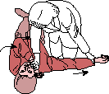1. Kneel next to the person. Place the arm closest to you straight out from the body. Position the far arm with the back of the hand against the near cheek.

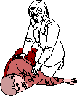4. Tilt the head up slightly so that the airway is open. Make sure that the hand is under the cheek. Stay close until help arrives.

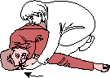

3. Protecting with one hand, gently roll the person toward you by pulling the far knee over and to the ground.

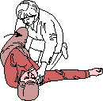

2. Grab and bend the person’s far knee.

**Examples of Approximate Carbohydrates for Treatment of Hypoglycaemia**

**Fast Acting Carbohydrates Long Acting Carbohydrates**

|  |
| --- |
| **Hypo treatment – approx. 5 grams** |
| 1 ½ dextrose tablets |
| 1 Lift tab |
| 65 mls Lucozade Original Energy (8.9g carb per 100ml)* |
| 50mls pure apple/orange juice |
| 25mls concentrated original Ribena (can dilute)* |
| 50mls cola * |
| 1 jelly baby |
| 3 jelly beans |
| Lift juice 1/3 bottle |
| Lift gel – ½ tube |
| 1 teaspoon sugar |

|  |  |
| --- | --- |
| **Hypo treatment – approx.10 grams** | **Long acting carbohydrate – approx.10 grams** |
| 3 dextrose tablets | 2 malted milk biscuit |
| 2 ½ Lift tab | 2 rich tea biscuit |
| 110 mls Lucozade Original Energy (8.9g carb per 100ml) | 1 digestive biscuit |
| 100mls pure apple/orange juice | 1 oat biscuit |
| 50mls concentrated original Ribena (can dilute)* | 3 cheddar biscuits |
| 100mls cola * | 1 slice of thin bread/toast |
| 2 jelly babies | 1 small apple |
| 5 jelly beans | 1 extra small banana |
| Lift juice 2/3 of bottle | 1 packet mini cheddars (multi-pack size) |
| Lift gel 1 tube | 1 packet crisps (multi-pack size) |
| 2 teaspoons sugar | 2 cream cracker |

|  |  |
| --- | --- |
| **GLUTEN FREE Options – approx.10 grams** | **Hypo treatment – approx.15 grams** |
| 1 Free From Digestive biscuit | 5 dextrose tablets |
| 1 Mcvities Gluten Free Original Hobnobs | 4 Lift tab |
| 2-3 Free From Plain Crackers | 170 mls Lucozade Original Energy (8.9g carb per 100ml) |
| 1 small apple | 150mls apple/orange juice |
| 1 extra small banana | 75mls concentrated original Ribena (can dilute)* |
| 1 gluten free packet crisps (multi-pack size) | 150mls cola * |
|  | 3 jelly babies |
|  | 8 jelly beans |
|  | Lift juice 1 bottle |
|  | Lift gel 1 ½ tubes |
|  | 3 teaspoons sugar |

**\* The formula of many sugary drinks has been changed recently to reduce the sugar content. Old formula bottles may still be available. All those using sugary drinks including Lucozade must be vigilant and check sugar content in bottle before use as a hypo treatment.**

GlUcagon Risk ASsessment

# RISK ASSESSMENT FOR THE AVAILABLITY AND TRAINING OF GLUCAGON WITHIN NURSERY/SCHOOL/COLLEGE

|  |  |
| --- | --- |
| Assessors Name |  |
| Date of Risk Assessment |  |
| Name of Educational Establishment |  |

**Severe Hypoglycaemia Definition**

Severe hypoglycaemia is defined as an event associated with severe cognitive impairment (including coma and convulsions) requiring external assistance by another person to actively administer carbohydrates, glucagon, or take other corrective actions *(ISPAD 2018).*

**GREEN** – THERE IS LOWER RISK OF A SEVERE HYPO.

SCHOOL STAFF CAN BE OFFERED TRAINING BUT NOT CONSIDERED MANDATORY

**Lower risk of prolonged severe hypoglycaemic episodes**

**in children and young people who:**

* Wear a continuous glucose sensor with low alert/alarms/low glucose suspend.
* Attend an establishment less than 20 miles from

the nearest ambulance station.

* Are over the age of 6 years and have hypo awareness.
* Have no history of severe hypo.

**RED** – THERE IS HIGHER RISK OF A SEVERE HYPO.

TRAINING RECOMMENDED

**Higher risk of prolonged severe hypoglycaemic episodes in**

**children and young people who:**

* Have impaired hypo awareness and do not wear a continuous glucose sensor

with low alert and alarms

* Have suffered a severe hypo within the last 24 months.
* Have recurrent prolonged hypos.
* Attend an establishment further than 20 miles from

the nearest ambulance station.

* Are under the age of 6 (ISPAD 2018).
* Also suffer from adrenal failure.

|  |  |
| --- | --- |
| Risk Agreed | Green □ Red □ |
| Review Date |  |

**HYPERGLYCAEMIA**

Children/young people who have diabetes may experience hyperglycaemia (high glucose levels). This is when the BG level is above the normal range of 4 - 7mmol/l pre-meal or >8 two hours after meal.

**If this occurs at meal times follow suggested daily routine, otherwise see below.**

|  |  |
| --- | --- |
| Student displays hyper symptoms | Yes  Sometimes No |
| Common symptoms | Increased thirst, passing urine more frequently , headache, tiredness, abdominal pain, bad/short tempered, lack of concentration, hyper-active, nausea, vomiting |
| ‘When I am hyper, this is how I feel’ … |  |
| ‘My parents will want to know when’…. |  |

Contact parents for advice and if unavailable contact the diabetes team

**BG level**

**14mmol/l or above & unwell for example;**

**Symptoms Headache Abdominal pain Nausea, Vomiting**

**BG level**

**14mmol/l or above & well**

1. Contact the parents immediately for advice and to collect child
2. Give sugar free fluids and allow access to the toilet.
3. Give a correction dose using ISF or as advised by bolus advisor meter
4. If blood ketone meter available check for ketones and follow advice according to level (see ketone table on next page)
5. Inform Diabetes Team within 24 hours

|  |
| --- |
| **If symptoms worsening such as drowsiness/vomiting/ heavy breathing/blood glucose level rising - Dial 999** |

1. Give sugar free fluids and allow access to the toilet
2. Give a correction dose using ISF or as advised by bolus advisor meter, **if 2 hours after last injection**
3. If blood ketone meter available check for ketones and follow advice according to level (see ketone table on next page)
4. Re-check BG level and ketones (if available) at next meal, if BG level still above 14mmol/l +/- ketones present (over 0.6) contact parents immediately for advice.
5. Give sugar free fluids and allow access to the toilet
6. Consider giving a correction dose using ISF or as advised by bolus advisor meter, **if 2 hours after last injection**
7. Re-check BG level at next meal
8. Inform parents at end of the school day or document in communication book (if used)
9. If unwell contact parents

**BG level**

**8-13.9mmol/l**

**Blood Ketone Monitoring**

Please be aware that a child can become unwell and have ketones even with an in-range blood glucose reading; always consider checking ketones or contact parents.

|  |  |
| --- | --- |
| **Blood Ketone monitoring** | You only need to check if it has been 90 minutes since last insulin bolus. |
| Times to test for ketones | 1. When student has a blood glucose level that is 14 mmols/L or above 2. If vomiting and/or complaining of abdominal pain |
| Can student perform own blood ketone checks? | Yes  Yes, with support  No |

|  |  |  |
| --- | --- | --- |
| **Ketone level** | **Guidance** | |
| **LO to 0.5 mmol/l** | | **Readings LO to 0.5 are in the normal range.** |
| **0.6 to 1.5 mmol/l** | | **Readings between 0.6 and 1.5 indicates a developing problem. Contact parents or diabetes team for advice.** |
| **1.6 mmol/l and above** | | **Readings 1.6 and above indicates a more acute problem.**  **Contact parents or diabetes team for advice immediately.** |

**PE AND SPORTS**

Below are details that will support a child/young person in participating in low-level exercise as part of a PE lesson. Any additional/individualised support that could be required for higher level sport/exercise can be found on the rear of the outline page within this care plan.

**Before Exercise -** Check BG or sensor glucose level prior to starting any physical activity

|  |  |
| --- | --- |
| Glucose | Action |
| If under 4 mmol/l | Follow hypoglycaemia treatment |
| 4-5.9 mmol/l | Child/young person should eat chosen snack containing 10g carbohydrate without an injection of insulin |
| 6.0-13.9 mmol/ | No action needed |
| Above 14mmol/l | Do not exercise if feeling unwell.  If available, check ketones. If <0.6 can exercise without an extra snack.  If >0.6 ring parents for further advice (not advisable to participate in PE) |

**During Exercise -** Ensure a hypoglycaemia treatment, BG meter and chosen snack are with teacher or in safe place close by.

**After Exercise** - Check glucose level and take action according to care plan if hypo or hyper.

**SWIMMING**

* If wearing a CGM sensor or transmitter on the skin, do not remove as they are fully waterproof and should continue to be worn in the pool.
* Inform the lifeguard which child/young person has diabetes
* Ensure hypoglycaemia treatment and BG meter are at the poolside
* Inform the child/young person to make their way to the side of the pool and/or put their hand up if they have symptoms of hypoglycaemia while in the pool
* Ensure the lifeguard is aware that the child/young person will do this

Below is the physical activity flowchart that will support a child/young person in participating in low-level exercise as part of a PE lesson. Any additional/individualised support that could be required for higher level sport/exercise can be found on the rear of the summary page at the front of this care plan.

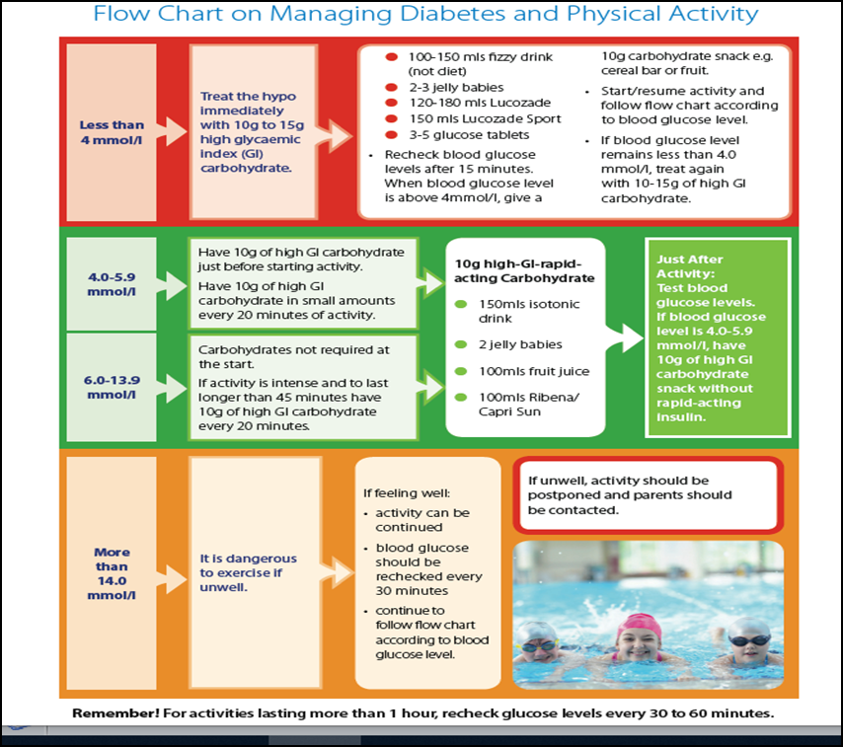

**ADDITIONAL INFORMATION**

* School to be kept informed of any changes by parents and/or the diabetes team involved in this child/young person’s management.
* The child/young person with diabetes should wear identification stating they have diabetes. These are in the form of a bracelet, necklace, watch or medical alert card.

Please use the box below for any additional information for this child/young person

|  |
| --- |
|  |

I give permission to the school staff, trained diabetes personnel and other designated staff members to perform and carry out the diabetes care tasks as outlined by this **DIABETES INDIVIDUAL HEALTH CARE PLAN**.

I also consent to the release of the information contained in this **DIABETES INDIVIDUAL HEALTH CARE PLAN** to all staff members and other adults who have custodial care of my child and who may need to know this information to maintain my child’s health and safety. A copy of this plan will be kept by the parents, school and Children’s diabetes team.

**Acknowledged and received by:**

|  |  |
| --- | --- |
| Young person’s Parent/Guardian | Date |

|  |  |
| --- | --- |
| School staff | Date |

**THIS DIABETES INDIVIDUAL HEALTH CARE PLAN HAS BEEN APPROVED BY:**

|  |  |
| --- | --- |
| Young person’s Diabetes Nurse Specialist | Date |

**TYPE 1 DIABETES SCHOOL CARE PLAN SUMMARY PAGE**

**MUST BE USED ALONGSIDE**

**AN INDIVIDUAL HEALTH CARE PLAN FOR A CHILD OR YOUNG**

**PERSON WHO HAS TYPE 1 DIABETES**

|  |  |
| --- | --- |
|  | **INSULIN REGIME** |
| **Insulin** |  |
| **Pump/Injections** |  |
|  |  |
|  | **GLUCOSE CHECKING** |
| **Glucose Monitoring Device** |  |
| **Timing of checks** |  |
| **Expected Levels** |  |

|  |  |
| --- | --- |
| **HYPO (3.9 and below)** | **HYPER (8.0 and above)** |
| **DO NOT GIVE INSULIN IF HYPO**  **Individualised Symptoms**  **Individualised Action**  **SEVERE HYPO**  **Call 999 and then parent.** | **If hyperglycaemic a correction dose may be required, this is also known as an insulin sensitivity factor (ISF). eg If BG is 15mmols and BG target is 5mmols and the ISF is 1:5 then 2 units of insulin will be required.**  **(15-5 =10 divided by 5 = 2units)**  **Individualised Symptoms**  **Individualised Action**  **PROLONGED HYPER**  **Contact parent if blood glucose readings do not lower after 3 hours.** |

**EMERGENCY CONTACTS:**

|  |  |
| --- | --- |
| **Name/Relationship** | **Contact Number** |
|  |  |
|  |  |

**APPENDIX**

**Pastoral Support**

**How to give an injection using a covered safety needle**

**How to give an injection using an exposed needle**

**Safety needle agreement**

**Iport for administering insulin**

**Carbohydrate counting**

**Residential trips**

**Exams**

**CGMS - Direction arrows, alarms, alerts, trends and accuracy**

**Freestyle Libre - Direction arrows, trends and accuracy**

**Data Sharing**

**What to do if Expert Meter is not available**

**Responsibility for supplies**

**School staff training**

**Extra space for advanced exercise advice**

**Links to relevant resources**

**TYPE 1 DIABETES SCHOOL CARE PLAN**

**ADAVANCED EXERCISE INFORMATION**

**MUST BE USED ALONGSIDE**

**THE INDIVIDUAL HEALTH CARE PLAN FOR A CHILD OR YOUNG**

**PERSON WHO HAS TYPE 1 DIABETES**

**PASTORAL SUPPORT**

|  |  |
| --- | --- |
| **ABSENCES** | Children and young people with T1D rarely have excessive absences from school. Families are required to attend outpatient hospital appointment every 3 months as authorised absences. It is unacceptable to penalise young people for their attendance record if their absences are related to their medical condition. |
| **EXAMS** | T1D affects cognitive ability and concentration; DFE guidance and JCQ Regulations recommends reasonable adjustments, such as extra time to complete examinations to ensure students are not disadvantaged due to their medical condition. Please ask your Nurse for supporting paperwork |
| **SOCIAL DEVELOPMENT**  **Clubs and Trips** | **Governing bodies should ensure that arrangements are clear and unambiguous in relation to school staff actively supporting young people with medical conditions to participate in trips, visits, sporting activities and residential holiday.**  *Schools should consider what reasonable adjustments they might make to enable children with medical needs to participate fully and safely on visits. It is best practice to carry out a risk assessment so that planning arrangements take account of any steps needed to ensure that pupils with medical conditions are included. This will require consultation with parents and pupils and advice from the relevant healthcare professional to ensure that pupils can participate safely* (DFE, 2014). |
| **EMOTIONAL DEVELOPMENT** | Young people with medical conditions must not only deal with the usual developmental issues of growing up but also with learning to manage a chronic disease. The care tasks young people have to do to manage their medical conditions can set them apart from their peers, may make them feel different to their peers, and may make them feel resentful of their condition.  The stress and frustration of having a long term condition, and in some cases the condition itself, can cause behaviour changes. Any behavioural issues should be discussed with the young person, their family and, if needed, their healthcare professional. Support in the educational environment should be offered to the young person to help them understand the changes in behaviour they experience;  To manage these changes & to communicate effectively in these situations.  If young people do not have the holistic support they need to manage their medical condition, their education, social and emotional development are at risk. |
| *What I find difficult about my condition’* |  |
| *‘How school carers can help me’* |  |
| *‘Who I want to know about my condition’* |  |
| *‘What I want them to know about my condition’* |  |

**HOW TO GIVE AN INSULIN INJECTION USING A**

**SAFETY NEEDLE**

1. Check you have the correct insulin and that it is intact, clear and in date.
2. Remove paper top from safety needle, screw onto the pen device, remove outer cap. Dial-up 2 units.
3. Hold the pen device with the needle uppermost and push the “plunger” to expel some insulin. This is called an “air shot”. If you don’t see insulin at the needle tip, repeat step 3 and 4.
4. Dial up the required dose of insulin – check numbers in the window and audible clicks.
5. Ask child/young person to choose injection site, ensure he/she is comfortable.  Injections MUST NOT be given through clothing.
6. Hold the pen device securely ensuring that your thumb can reach the plunger.
7. Insert the needle straight into the skin in one continuous motion until the clear outer shield retracts and the white sleeve is flush with the skin.
8. Push the plunger until whole dose is given i.e. there is a 0 in the window.
9. Count to 10 slowly.
10. Lift the pen away from the skin. The inner shield will automatically deploy and lock in place.
11. Unscrew the needle to remove; both ends of the needle are covered so there is no risk of needle injury.
12. Dispose of the needle into a yellow sharps box. Do not lock the box until full.
13. Insulin in use should be stored at room temperature and is stable for 1 month.
14. Any spare insulin cartridges (not in use) must be kept in a locked fridge/not accessible to children. They have an expiry date on the side of each cartridge.
15. Click [here](https://hma.wistia.com/medias/ol5487hbcu) to view a video guide

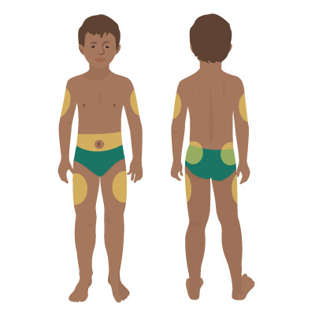

**HOW TO GIVE AN INSULIN INJECTION USING AN EXPOSED NEEDLE**

1. Check you have the correct insulin and that it is intact, clear and in date.
2. Remove paper top from needle, screw needle onto the pen device and remove both outer caps. Dial-up 2 units.
3. Hold the pen device with the needle uppermost and push the “plunger” to expel some insulin. This is called an “air shot”. If you don’t see insulin at the needle tip, repeat step 3 and 4.
4. Dial up the required dose of insulin – check numbers in the window and audible clicks.
5. Agree an injection site, ensure he/she is comfortable.  Injections MUST NOT be given through clothing.
6. Hold the pen device securely ensuring that your thumb can reach the plunger.
7. Insert the needle straight into the skin in one continuous motion ensuring the full length of the needle is inserted.
8. Push the plunger until whole dose is given i.e. there is a 0 in the window.
9. Count to 10 slowly.
10. Remove the needle from the child/young person skin.
11. Ask the child to take the needle off the pen if they are able to. If the child/young person is not able to remove the needle staff MUST use a needle remover/clipper to avoid handling the used needle.
12. Dispose of the needle into a yellow sharps box. Do not lock the box until full.
13. Insulin being used should be stored at room temperature and is stable for 1 month.
14. Any spare insulin cartridges (not in use) must be kept in a locked fridge/not accessible to children. Each cartridge has an expiry date on the side.



**SAFETY NEEDLE AGREEMENT**

**Add Trust logo and address**

**Add school name and address**

**Add date**

The Children and Young People’s Diabetes Team follow the Health and Safety (Sharp Instruments in Healthcare) Regulations 2013 which states staff should use safety needles when administering insulin to reduce the risk of sharps injuries and the associated risks of infection from blood-borne viruses.

Links to the relevant guidance can be found at [www.HSE.gov.uk/healthservices/index.htm](http://www.HSE.gov.uk/healthservices/index.htm).

We recommend you follow this advice.

Staff Member 1

I, _______________________________ agree to the use of standard needles instead of safety needles when administering insulin within school and I understand this is against the advice of the Children and Young People’s Diabetes Team.

__________________________________________________________________

Signature Date

----------------------------------------------------------------------------------------------------------------

Staff Member 2

I, _______________________________ agree to the use of standard needles instead of safety needles when administering insulin within school and I understand this is against the advice of the Children and Young People’s Diabetes Team.

__________________________________________________________________

Signature Date

----------------------------------------------------------------------------------------------------------------

Staff Member 3

I, _______________________________ agree to the use of standard needles instead of safety needles when administering insulin within school and I understand this is against the advice of the Children and Young People’s Diabetes Team.

__________________________________________________________________

Signature Date

----------------------------------------------------------------------------------------------------------------

Signature Parent/Carer of Child/Young Person

**iPORT ADVANCE FOR ADMINISTERING INSULIN**

i-Port Advance is a small injection port that allows for insulin to be administered without having to puncture the skin for each injection. It's easy to wear and easy to use. The iPort will be positioned and inserted at home.

Step by Step Guide to injecting insulin via iPort Advance

* Using an alcohol wipe, lean the Iport (septum) before every use
* Puncture the Iport (septum) using injection needle
* Slowly inject the insulin ensuring that all the dose has been administered
* Remove injection needle



**Please note, only 5-8mm needles can be used with the i-Port**

**CARBOHYDRATE COUNTING**

If a child/young person is required to carbohydrate count in order to have an injection of insulin at school they will need to know certain amounts of information from the school. It is often necessary for a member of staff to learn the basics of carbohydrate counting too, so they can support the child/young person.

**What this means.**

The diabetes dietitian will already be involved with the child/young person and be teaching them and their family how to count carbohydrates at each meal. Each time the child/young person eats more than a small carbohydrate containing snack they may need an injection of insulin. Sometimes the child/young person will be comfortable doing this themselves however, often we will ask a teacher or lunchtime supervisor to do or oversee the calculating of the carbohydrate and give the insulin.

The diabetes nurses and dietitians will work with the schools to come up with a plan to put in place around meals times at the child/young person’s school.

**What is needed?**

If the child/young person has school dinners, the dietitian will need to liaise with the school teacher, cook and council/school meal provider to ascertain menus and nutritional analysis which may have already been completed.

If the child/young person has packed lunches, the parents will include a list of the carbohydrate content of the different foods in the lunch.

A meeting with a Dietitian may be arranged, for two reasons:

1. For the dietitian to meet and train relevant members of staff in carbohydrate counting.

2. To discuss menus, recipes and meal provision with the cook, only if the child/young person has school meals.

**What else is required?**

Other things that might help are

* accurate/electronic weighing scales
* current recipes being used by the kitchen
* a ‘carbs and cals’ book (Carbs and Cals by Chris Cheyette and Yello Balolia, Chello Publishing Ltd, ISBN no: 978-0-9564430-0-7).

There are a lot of schools doing this now and we as a diabetes team are very experienced in working out the best systems to use, that work for the child/young person and the school, and we will be happy to discuss this at length with you.

**RESIDENTIAL TRIPS**

**This School Care Plan MUST be taken and followed on the trip**

**Please ensure the family have informed their diabetes team of the trip**

**There should be a meeting with the child/young person and their family before any residential trip**

**Points for discussion**

**Equipment**

* Blood glucose meter and strips
* Blood ketone meter and strips
* Injection pens, needles, insulin
* Sharps box, needle remover/clipper
* Finger pricking device, lancets and finger wipes
* Hypo box
* Meter charger or spare batteries
* Carbs and Cals book/app

**Medication**

* Different insulin types/injection timings
* Injection technique - training required if not previously done for school
* Insulin storage – insulin cooling wallet, fridge
* Doses - consider reduction or increase depending on activity levels (as advised by parent/carer)
* Supervision
* Glucagon - staff training

**Dietary requirements**

* Consider extra snacks, sugar free juice available, special dietary requirements e.g. coeliac/nut allergy

**Glucose checking**

* More checking and snacks required for high intensity or prolonged activities
* Extra checking - before and after activities, pre-meal, before bed, during the night

**Travel**

* Flying - customs letter, airport scanners, all medication in hand luggage, extra food available, alternative hypo treatment, time-zones, language barriers.
* Skiing - Consider the temperature, make sure equipment doesn’t get too cold, good fitting ski boots, layers of clothing to keep body warm, larger reductions to doses
* Temperature - be aware that extreme cold/heat can affect BG and insulin absorption

**Overnight safety**

* Substantial supper containing long acting carbohydrate, hypo treatment near bed
* Sleep on bottom bunk, room-mates aware of needs, staff in room close by
* Consider nightly phone call to parents for advice
* Overnight testing may be required

**Illness**

* Correction doses, contact parents, check ketones

**EXAMS**

**Under equality laws across the UK, every school has to make reasonable adjustments to help any child who might have a disability, which includes Type 1 diabetes.**

Although parents and children might not consider diabetes as a disability, they are still covered under these equality laws. In the England, Scotland and Wales these laws come under the Equality Act 2010 and in Northern Ireland they come under the Disability Discrimination Act 1995.

**Who is responsible for making reasonable adjustments?**

The responsibility for making reasonable adjustments depends on the type of exam that a child is taking.

Some adjustments will be the school’s responsibility, and some will be the Joint Council for Qualifications, or the JCQ, responsibility.

The JCQ is the organisation most of the national awarding bodies that offer qualifications in the UK. If the reasonable adjustments are the responsibility of the JCQ, it’s important that these are made ahead of time.

**What type of reasonable adjustments are there?**

The two main types of help which might be available for a child with diabetes are **access arrangements** and **special considerations.**

**Examples of access arrangements**

* Being allowed to take drinks and snacks into an exam to prevent or treat a hypo or hyper.
* Being allowed to bring in their glucose monitor and insulin treatment into an exam.
* Taking a supervised rest break to treat a hypo or hyper. Supervised rest breaks are where the clock is paused while a student treats themselves. The clock restarts when they’ve recovered.

**Special considerations**

Getting special considerations can be difficult because there must be evidence showing what happened, for example, a record of the child’s glucose levels.

Students with Type 1 diabetes might be able to apply for special considerations if their glucose has been low or high and it has affected their performance in an exam. It is a good idea for the glucose level to be recorded on the exam sheet along with time and invigilator signature.

To find out more about helping a child with Type 1 diabetes prepare for their exams, download the Diabetes UK Type 1 diabetes and exams resource.

<https://www.diabetes.org.uk/guide-to-diabetes/your-child-and-diabetes/schools/school-staff/exams>

**DIRECTION ARROWS**

**MEDTRONIC**

|  |  |
| --- | --- |
| **Trend Arrow** | **What this means** |
| or | Sensor Glucose has been rising or falling by about 1-2 mmol/L over the last 20 minutes |
| or | Sensor Glucose has rising or falling by about 2-3 mmol/L over the last 20 minutes |
| or | Sensor Glucose has been rising or falling by about 3 mmol/L over the last 20 minutes |

**ALARMS AND ALERTS**

**Medtronic CGM Alarms**

ANY SUSPECTED HIGH OR LOW SENSOR GLUCOSE SHOULD BE CHECKED WITH A FINGER PRICK BG BEFORE ANY ACTION IS TAKEN.

It is helpful to write the sensor glucose recording and any finger prick blood glucose level in the home/school communication book.

CGM alarm and alert settings that have been individually agreed are -

|  |  |
| --- | --- |
| **Alarm Type** | **Please indicate if set** |
| High glucose alert |  |
| Low Glucose alert |  |
| Low glucose alarm |  |

**DEXCOM G6**

|  |  |  |
| --- | --- | --- |
| **Trend Arrow**  **App** | **Trend Arrow**  **G6 Receiver** | **What this means** |
|  |  | Glucose is steady. Not increasing/ decreasing more than 0.06mmo/L per minute or up to 0.9mmol/L in 15 minutes. |
|  |  | Glucose is slowly falling 0.06 - 0.1 mmol/L each minute or up to 1.7mmol/L in 15 minutes. |
|  |  | Glucose is falling 0.1 - 0.2mmol/L each minute or up to 2.5mmol/L in 15 minutes. |
|  |  | Glucose is rapidly falling more than 0.2mmol/L each minute or more than 2.5mmol/L in 15 minutes. |
|  |  | Glucose slowly rising 0.0 6 - 0.1 mmol/L each minute or up to 1.7mmol/L in 15 minutes. |
|  |  | Glucose rising 0.1 - 0.2mmol/L each minute or up to 2.5mmol/L in 15 minutes. |
|  |  | Glucose rapidly rising more than  0.2mmol/L each minute or more than 2.5mmol/L in 15 minutes. |

**ALARMS AND ALERTS**

**Dexcom CGM Alarms**

ANY SUSPECTED HIGH OR LOW SENSOR GLUCOSE SHOULD BE CHECKED WITH A FINGER PRICK BG BEFORE ANY ACTION IS TAKEN.

It is helpful to write the sensor glucose recording and any finger prick blood glucose level in the home/school communication book.

CGM alarm and alert settings that have been individually agreed are -

|  |  |
| --- | --- |
| **Alarm Type** | **Please indicate if set** |
| High glucose alert |  |
| Low Glucose alert |  |
| Low glucose alarm |  |
| Alert before low |  |
| 3.1 urgent low alarm is pre-set and cannot be turned off |  |

**FREESTYLE LIBRE FLASH GLUCOSE MONITOR**

|  |  |
| --- | --- |
| **Freestyle Libre 1 (no alarms)**  **Trend Arrows** | **What this means** |
|  | **Glucose is rising quickly** - 1.0 - 1.5mmol/L in 10-15 mins |
|  | **Glucose is rising** - 0.6 - 0.9mmol/L in 10-15 mins |
|  | **Glucose is changing slowly** - Stable |
|  | **Glucose is falling** - 0.6 - 0.9mmol/L in 10-15 mins |
|  | **Glucose is falling quickly** - 1.0 - 1.5mmol/L in 10-15 mins |
|  | The Glucose trend arrow may not always appear with  your reading |

|  |  |
| --- | --- |
| **Freestyle Libre 2 (with alarms)**  **Trend Arrows** | **What this means** |
|  | **Glucose is rising quickly** (more than 0.1 mmol/L per minute or more than 3.0 mmol/L in 30 minutes) |
|  | **Glucose is rising** (between 0.06 and 0.1 mmol/L per minute or between 2.0 mmol/L and 3.0 mmol/Lin 30 minutes) |
|  | **Glucose is changing slowly** (less than 0.06 mmol/L per minute or less than 2.0 mmol/L in 30 minutes) |
|  | **Glucose is falling** (between 0.06 and 0.1 mmol/L per minute or between 2.0 mmol/L and 3.0 mmol/L in 30 minutes) |
|  | **Glucose is falling quickly** (more than 0.1 mmol/L per minute or more than 3.0 mmol/L in 30 minutes) |

Alert settings that have been individually agreed are:

|  |  |
| --- | --- |
| **Alarm Type** | **Please indicate if set** |
| High glucose alert |  |
| Low Glucose alert |  |
| Low glucose alarm |  |

**CamAPS FX**

**Sensor Glucose Trend and Range**

The sensor glucose trend and range indicator is represented by a large coloured circle at the top right corner of the main section of the home screen.

The background colour of the circle indicates sensor glucose status:

* Above high glucose alert level (**yellow**)
* Below low glucose alert level (**red**)
* Within target range (**grey**)

The white arrow inside the circle shows the speed and direction of the glucose trend

based on recent readings. A double arrow head indicates a rapid glucose rise or fall. Please see here for the full care plan.

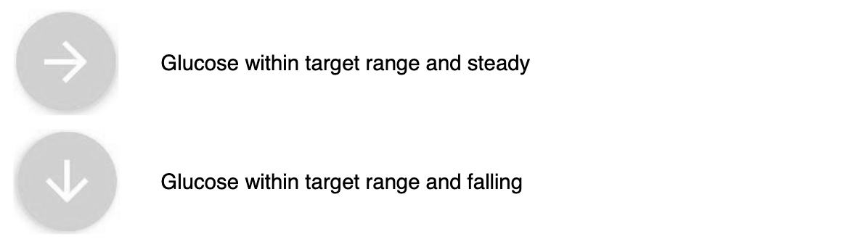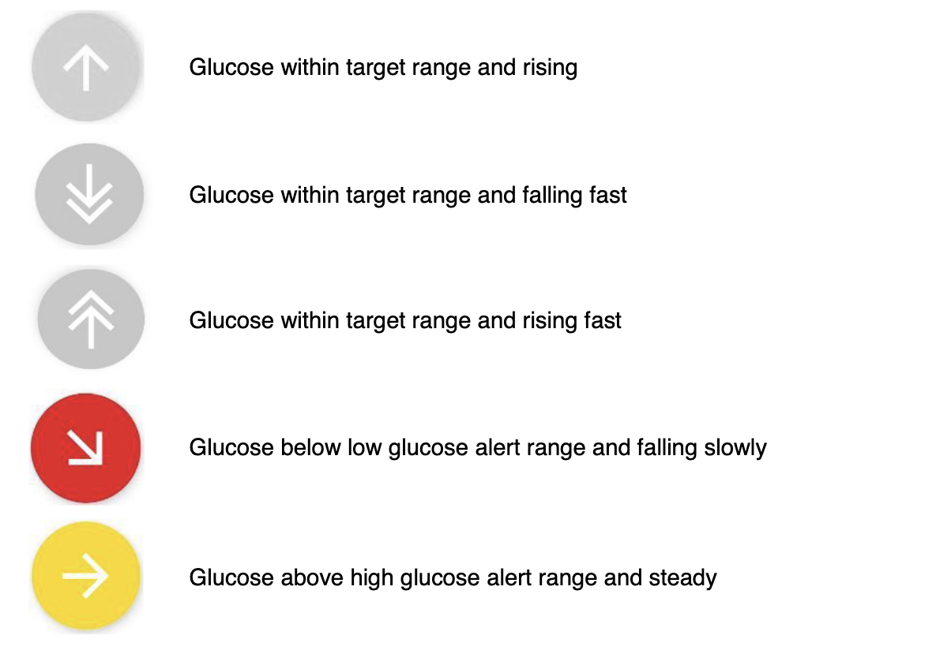

**Data Sharing**

Students who use any of the above devices have the option to pair their smart device with the medical device. This allows the student to receive glucose data on their device via Bluetooth. In addition to this convenience, this gives the student the ability to share their glucose data with up to 5 followers (different on each individual medical device), this might include the school nurse, parent, sibling, friend or guardian.

The student’s data is shared via the app on a smartphone or tablet using a wireless network or cellular data. Students using the data sharing feature on their medical device may request access to the school’s wireless network to enable this feature while avoiding smart device data charges.

The utility and need for remote monitoring should be individualised for each student based upon age and unique needs. Remote monitoring of medical device data in the school setting by staff is usually not required as the child is supervised by trained staff and device alarms are used in cases to identify glucose levels requiring action. However, in certain cases (preschool age, non-verbal, impaired cognition) closer monitoring, including remote monitoring (by the parent/carer) may be appropriate. The school staff, family and children’s diabetes team should discuss each students needs and to determine whether remote monitoring is necessary.

*Parent/guardian considerations:*

* Please discuss data sharing with your designated school team members prior to the start of school. Information from your child’s school care plan will serve as a guide during this discussion as it includes a guide for your child’s diabetes management at school.

(American Diabetes Association, Safe at School, Guidelines for the use of Continuous Glucose Monitors (CGM) and Other Sensors in the School Setting)

**WHAT TO DO IF EXPERT METER IS NOT AVAILABLE**

**If child/young person is using an expert meter, the handset is programmed with the child/young person’s personalised settings; when required, these will be changed at home or in clinic.**

**Below is a guide to the settings which may be needed to calculate insulin doses if the expert meter is not available or has broken.**

**Insulin to carbohydrate ratio (ICR):**

|  |  |
| --- | --- |
| 06:00 - 09:00 | 1 unit of insulin per _______grams of carbohydrate. |
| 09:00 - 11:00 | 1 unit of insulin per _______grams of carbohydrate. |
| 11:00 - 14:00 | 1 unit of insulin per _______grams of carbohydrate. |
| 14:00 - 16:00 | 1 unit of insulin per _______grams of carbohydrate. |
| 16:00 - 20:00 | 1 unit of insulin per _______grams of carbohydrate. |

**N.B Some younger pupils may have a ½ unit pen, therefore you would round up or down to nearest half unit.**

**When to give insulin for carbohydrate and to correct a raised BG level:**

* Lunch: Carbohydrate Counted lunch plus correction dose when blood glucose level is > ____mmol/L and it is 2 hours since last dose.
* Snack: Carbohydrate Counting plus correction dose when blood glucose level is > ____mmol/L and it is 2 hours since last dose.
* Correction dose only: For blood glucose > _____mmol/L and 2 hours since last dose.

**CARBOHYDRATE RATIO AND CORRECTION TABLE**

**Carbohydrate Ratio Table**

|  |  |
| --- | --- |
| ……..’s packed lunch will have the insulin doses calculated each day. This is an example of insulin doses required. | Current lunch ratio( …) **Current date:** |
| ..g CHO in lunch | .. units |
| ..g CHO | .. units |
| ..g CHO | .. units |
| …g CHO | .. units |

## NB: Do not give a correction dose more than 2 hourly

Remember to check for ketones if BG is over 14.0mmols and if ketones >0.6mmol/L call parent/carer or the diabetes team for further advice as a higher correction dose may be needed.

**Correction Table**

|  |  |  |  |  |
| --- | --- | --- | --- | --- |
| Current Glucose Value | Insulin dose for food  1 unit per ….g of Carbs | Correction dose (1 unit to reduce glucose by…) | Correction dose (Use if required) | Correction dose(Use if required) |
| 4.0 - 7.0mmols | Insulin for food only |  |  |  |
| 7.1 - 13.0mmols | Insulin for food + | …. unit correction |  |  |
| 13.1 - 17.0mmols | Insulin for food + | …unit correction |  |  |
| 17.1 - 21.0mmols | Insulin for food + | …unit correction |  |  |
| 21.1mmols or higher | Insulin for food + | ….units correction |  |  |

**If you use the above table please check with the family to ensure that it is up to date.**

|  |  |  |
| --- | --- | --- |
| **Date** | **Profession** | **Signed** |
|  |  |  |

**ROLES and RESPONSIBILITY FOR SUPPLIES**

|  |  |  |  |  |
| --- | --- | --- | --- | --- |
|  |  | **Responsibilities List** |  |  |
| **Item** | **Parents** | **School** | **Child/young person (when deemed competent)** | **Paediatric diabetes specialist nurse** |
| **Individualised care plan** | A parent or carer who has legal responsibility for the child/ young person will liaise with the Head of the School/establishment and the Paediatric Diabetes Specialist Nurse (PDSN) to complete a medical management plan.  Where volunteers are being trained to supervise or perform any diabetes tasks the parent or carer will sign the plan to show that they have agreed to this arrangement.  The extent of a child or young person’s ability to participate in their own diabetes care should be agreed upon by the parent/carer. | Each school should have an up-to-date medical conditions policy.  All school/setting employees are aware of a child having diabetes, being able to obtain the child’s individual plan in the school setting and know how to assist them when necessary.  The extent of a child or young person’s ability to participate in their own diabetes care should be risk assessed and agreed upon by senior school staff. | Children and young people should be allowed, as much as possible, to manage their own diabetes at school, to the extent that is appropriate for their developmental stage and his or her experience with diabetes.  The child’s capabilities and willingness to provide self-care should be acknowledged in their plan. | The extent of a child or young person’s ability to participate in their own diabetes care should be risk assessed and agreed upon by the Paediatric Diabetes Specialist Nurse (PDSN). |
| **Emergency supply box** | To provide box and contents and to ensure contents are in date | To make accessible to child/young person/staff  To make parents aware when supplies are low  Safe storage of diabetes containers (containing, if necessary, insulin injection devices as well as hypoglycaemic treatment) is established, together with the safe disposal of used needles / “sharps” | To make parents aware when supplies are low | To provide training as to the appropriate use of emergency supplies. |
| **Insulin injection and pump supplies** | To provide all supplies of insulin, pens, needles, reservoirs and cannulas, batteries | Provision of fridge space for spare supplies of insulin | To make parents aware when supplies are low |  |
| **Blood glucose and ketone testing supplies** | To provide supplies of lancets, blood glucose strips and quality control (QC) solutions  To be aware when replenishment of supplies is necessary | Provide correct storage of supplies where necessary and request for extra supplies or training when required | To make parents aware when supplies are low | To provide training in order to initiate blood glucose testing  To train parents to carry out as per local guidelines |
| **Sharps disposal** | To provide sharps bin (refer to local policy) | To make parents aware when sharps bin is two- thirds full | To make parents aware when sharps bin is two-thirds full | To provide parents with information about local policy |
| **Extra food** | To provide food for snacks and exercise as required | To make parents aware if running out of food for snacks and exercise. To give permission for CYP to eat whenever required. | To make parents aware when more food supplies are required | To provide parents / CYP with recommendations regarding when to have additional carbohydrate |
| **Risk assessment** | To provide information to facilitate risk assessment | To initiate and complete risk assessment documentation | To participate in risk assessment where possible | To provide specialist information as required |

**SCHOOL STAFF TRAINING**

The parents/carers have received training in managing their child’s diabetes and are competent and able to teach others to care for their child in the parents/carers absence. On-going training can be provided by parents. The staff that are named below have been trained in the following areas and are competent to manage the NAMED child’s diabetes care. Staff from the educational settings are expected to attend relevant training sessions and refreshers provided by the CYP diabetes team and/or parents

|  |  |  |  |  |  |  |  |  |  |  |
| --- | --- | --- | --- | --- | --- | --- | --- | --- | --- | --- |
| **CYP Name:**  **Training** | **Example Joe Bloggs 02.04.17** |  |  |  |  |  |  |  |  |  |
| What is Diabetes | x |  |  |  |  |  |  |  |  |  |
| Blood Glucose Monitoring | x |  |  |  |  |  |  |  |  |  |
| Ketone Monitoring | x |  |  |  |  |  |  |  |  |  |
| Hypoglycaemia | x |  |  |  |  |  |  |  |  |  |
| Hyperglycaemia | x |  |  |  |  |  |  |  |  |  |
| Insulin Administration (Injections) |  |  |  |  |  |  |  |  |  |  |
| Insulin Administration (Pumps) |  |  |  |  |  |  |  |  |  |  |
| CGM/Flash |  |  |  |  |  |  |  |  |  |  |
| Pump Alarms |  |  |  |  |  |  |  |  |  |  |
| Bolus Advice (Expert Meter) |  |  |  |  |  |  |  |  |  |  |
| P.E | x |  |  |  |  |  |  |  |  |  |
| Glucagon | N/A |  |  |  |  |  |  |  |  |  |
| Awareness of carbohydrate counting |  |  |  |  |  |  |  |  |  |  |

I confirm the above named CYP has been prescribed INSULIN for the treatment of DIABETES (insulin dependant) to be administered/supervised by trained volunteers. The volunteers will be trained by the CDNS.

**CYP Diabetes Team: Name (Print)…………………………… Designation**:……………………… **Signed**………………………………………………………………**Date**………………………………...

**TYPE 1 DIABETES SCHOOL CARE PLAN**

**ADVANCED EXERCISE INFORMATION**

**MUST BE USED ALONGSIDE**

**THE INDIVIDUAL HEALTH CARE PLAN FOR A CHILD OR YOUNG**

**PERSON WHO HAS TYPE 1 DIABETES**

Please use this page to describe any advanced requirements for

sports and exercise for any child or young person who is competing

in high level sports within a school setting.

**LINKS TO RELEVANT RESOURCES**

Glucagen Hypokit Training Video

<https://www.digibete.org/essentials/>

DigiBete - a place to help children, young people, their families and carers manage type 1 diabetes

[www.digibete.org](http://www.digibete.org)

School Specific Videos on DigiBete can be found here

KS1&2:  <https://www.digibete.org/schools-teachers/key-stage-1-2/>

KS3&4:  <https://www.digibete.org/schools-teachers/key-stage-3-4/>

JDRF

E-learning module - basic and advanced level

<https://jdrf.org.uk/for-professionals/school-pack/schools-e-learning-module/>

Recommend all staff complete basic level.

Staff who are performing BG tests and giving insulin, via pump or injections, need to complete advanced level.

JDRF

Information Packs and Leaflets

<https://jdrf.org.uk/living-with-type-1/information-packs-and-leaflets/>

Diabetes UK

Diabetes in Schools Resources

<https://www.diabetes.org.uk/Guide-to-diabetes/Schools/Diabetes-in-schools-resources/>

Diabetes UK

Diabetes and Exams

<https://www.diabetes.org.uk/guide-to-diabetes/teens/me-and-my-diabetes/school-and-college/exams>

Department of Education

Supporting Pupils at School with Medical Conditions

<https://www.gov.uk/government/publications/supporting-pupils-at-school-with-medical-conditions--3>

With Thanks to **The Children and Young People’s Diabetes Networks in the NE and N Cumbria and the South West for providing the template for this plan. University College London Hospitals and to members of The Children and Young People’s Y&H Diabetes Network Schools Working Group and local families and patients for their input.**

 