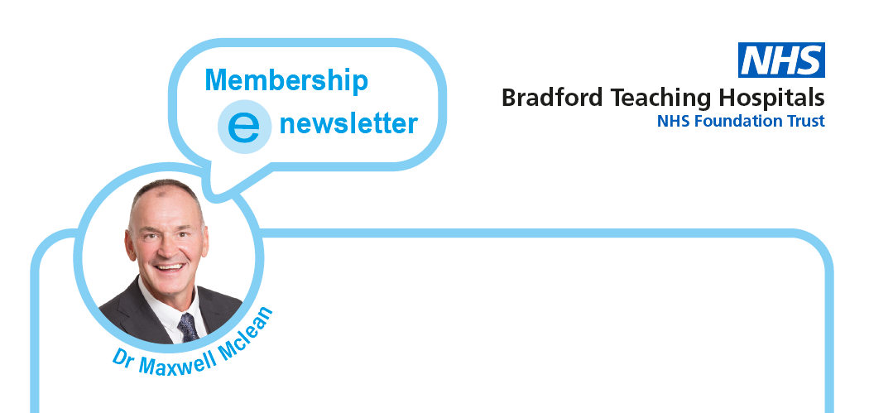

**Winter membership e-newsletter**

We are all now heading towards our one year anniversary of tackling Covid 19. Here at Bradford Teaching Hospitals Foundation Trust we continue to take all possible steps to protect our patients, visitors and staff. Much of the information presented to you throughout this newsletter relates to the pandemic. There is though other news shared, about developments at our Trust aimed to improve the quality of the care we provide. I would like to encourage you to watch our Chief Executive’s Weekly news round-ups which are available on our [YouTube channel](https://www.youtube.com/user/bradfordhospitals1), as these give you the very latest information on how our hospitals are coping with Covid 19 and, importantly, how we are still continuing to work towards improving our services.

Our Council of Governors and our Board of Directors have continued to meet virtually since May 2020 to fulfil their duties and responsibilities. Our Council has recently appointed two new Non-Executive Directors; Altaf Sadique and Karen Walker. We are all delighted to have them join us. You can find out more about Altaf and Karen on our Board of Director website pages [here](https://www.bradfordhospitals.nhs.uk/our-trust/how-we-make-decisions/). Our Board and Council meetings are now available for you to view online on our [Corporate Governance YouTube channel](https://www.youtube.com/channel/UCbWLX5_cjbxWiSHo9EhVCbw). Please have a look and see what it is we deal with and how we make decisions.

Due to the restrictions we must put in place due to Covid 19 most, but not all, visiting remains suspended. The most up to date information for visitors can be accessed [here](https://www.bradfordhospitals.nhs.uk/patients-and-visitors/information-for-visitors/). All our news items can be found [here](https://www.bradfordhospitals.nhs.uk/news/) and if you specifically want to find out more about the Covid 19 vaccination programme for our area then you can do so at this link [here](https://www.wyhpartnership.co.uk/vaccination).

I hope you do find the information here useful and would ask that you share this newsletter with all those you know. If you would like to get in touch with either myself or our Governors then we would be pleased to hear from you. The contact details are at the end of this newsletter.

**Contents**

1. **2020 Review of the year special membership publication**
2. **Elections to the Council of Governors**
3. **Council of Governors meeting 21 January 2021**
4. **Board of Directors Meeting 20 January 2021**
5. **Act as One**
6. **Mel Pickup, Chief Executive, weekly news round ups from our Trust (Nov 2020 to Jan 2021)**
7. **Keeping up to date**
8. **2020 Review of the year special member publication**

I am delighted to present to you a special communication from our Chief Executive, Mel Pickup. This 2020 review of the year special provides highlights from what has been a very significant year for us all. You can access your copy [here.](https://www.bradfordhospitals.nhs.uk/wp-content/uploads/2021/01/FT-Members-Update-review-of-the-year.pdf)

1. **Council of Governors meeting 21 January 2021**

Our last Council of Governors meeting took place on 21 January 2021.

Due to the continuing restrictions in place with regard to the Covid 19 Pandemic, our public meetings will continue to take place virtually at least until the end of April 2021. As we are not able to welcome members of the public to our meetings we are recording them and making them available online. Please do take a look and see how the Council is delivering on its duties and responsibilities. The meeting held on 21 January is available [here](https://www.youtube.com/watch?v=SkzzSiFPcY0&feature=youtu.be). You can access the agenda, papers and video timings [here](https://www.bradfordhospitals.nhs.uk/our-trust/council-of-governors-and-foundation-trust-membership/).

The key items considered that I would like to highlight to you were;

* The council’s appointment of two new non-executive directors who have now joined the Board of Directors.
* Re starting our work with the Membership Plan Group to develop a new membership strategy.
* The opportunity to hear from the Chief Executive about Act as One and how the programme is developing across our West Yorkshire and Harrogate Footprint.

The next council of governors meeting takes place on Thursday 15 April. The agenda and papers will be available from Friday 9 April and the video of the meeting will be uploaded on Friday 16 April.

1. **Board of Directors 20 January 2021**

Our Board meetings are now also available online. The most recent open Board meeting took place on 20 January. The agenda, papers and video timings are available [here](https://www.bradfordhospitals.nhs.uk/our-trust/how-we-make-decisions/) where you will also find a link to the videos (parts 1 and 2).

I would like to encourage you to take a look at our meeting so you can see the range of business we deal with. Of particular note from our January meeting is our Patient Story which details the experience of a senior sister in our Renal Team who has recently recovered from Covid 19. This story can be found approximately 7 minutes into the meeting. The video is available [here](https://www.youtube.com/watch?v=byqce5yiQTA&feature=youtu.be).

The next open Board meeting is on Thursday 18 March. The video will be uploaded on Friday 19 March.

1. **Elections to our Council of Governors**

Elections for three seats on our Council of Governors will open on Monday 15 February. Please see our formal [notice of election](https://www.bradfordhospitals.nhs.uk/wp-content/uploads/2021/02/Notice-of-Election-5.pdf). Our Trust will be seeking to fill three vacancies. That is one each in the following three public membership constituencies of

* Shipley
* Bradford South
* Bradford West

On 15 February when our election process opens you will receive the notice along with a link to the elections timetable and other supporting information. Self-nominations will be sought from any of our members who live in these areas. The information will provide details about the role including the time commitment and what you need to do to submit a self-nomination form.

Anyone interested in submitting a nomination is invited to a virtual session scheduled for Tuesday 9 March from 3pm to 4pm where I, two of our governors, and members of our corporate governance team will answer your queries and questions about the role.

Full details will be circulated on 15 February.

1. **ACT As One**



Professor Mel Pickup, Chief Executive, has previously shared information on developments in relation to ‘Act as One’ as part of her reports to our Council of Governors. The core principle of Act as One is to get health and care partners across Bradford District and Craven working in a joined-up way to improve the health, care and wellbeing of our people. In short; “Happy, Healthy at Home.”

On 21 January Mel delivered a very comprehensive presentation which you can find [here](https://www.bradfordhospitals.nhs.uk/our-trust/council-of-governors-and-foundation-trust-membership/) amongst the council of governors papers. You can also watch her delivery of the presentation on our recorded meeting available directly at this [link](https://www.youtube.com/watch?v=SkzzSiFPcY0&feature=youtu.be). Her presentation starts at approximately 1hr 45mins into the video.

1. **Mel Pickup, Chief Executive. Weekly news round ups (Nov 2020 to Jan 2021)**

Mel has recorded 16 issues of her weekly news round-ups to date. They each last approximately six to seven minutes and are proving to be a really good way to keep up to date with all that is happening at our Trust. The videos are all available on YouTube. I would like to share with you those produced over the last few months from November 2020 to January 2021. If you would like to subscribe to our You Tube Channel please select the option when you follow the links below. Again, please share these links with your friends, family and colleagues and let us know what you think.

***News round ups from 6 November 2020 to 12 February 2021***

* 6 November <https://youtu.be/63nk5Q6CtGw>

Mel talks about a new programme that will transform our maternity services, as well as what inspired us to set up our Covid-19 Relatives’ Line, which is receiving more than 1,000 calls a week and providing a fantastic service in keeping our patients connected with their loved ones. Now in our second full national lockdown, she reinforces the message of how we should all adhere to the new rules to keep each other safe and keep the virus under control.

Plus she explains why we have taken the decision to extend the pause on most non-urgent surgery and most face-to-face outpatients’ appointments for another month. The round-up also features our very own ‘field of poppies’, which are blooming on our main concourse at BRI to mark this very special time of year when we remember those who gave their lives for our freedom.

* 13 November <https://youtu.be/uEQTcWlAHfQ>

Mel reveals how our audiology colleagues have developed helpful guidance around how we can communicate better with people who have hearing difficulties and rely on lip-reading when we are all wearing facemasks. There’s a very special ribbon-cutting ceremony as, on World Radiography Day, she unveils the fantastic improvements to our radiology department thanks to our very own Bradford Hospitals’ Charity and their brilliant ‘Rays A Smile’ appeal. And she explains why kindness should underpin everything we do. Who doesn’t want more kindness in their lives? A new project is about to be unveiled! Plus you’ll see that our Urology team has ‘grown’ a special kind of facial hair for a very special reason.

* 20 November <https://youtu.be/A3VRqs8yUT8>

This week Mel shares that our Patient Recruitment Centre (PRC) – one of only five in the country – has been officially launched. The centre has been pivotal in getting COVID-19 vaccine trials in Bradford off the ground. We are still looking for more volunteers - particularly people from a BAME background – so why not get involved? There’s also news about how we are breaking new ground in cervical screening through cutting-edge technology, which will further improve diagnosis of cervical cancer in women referred to BRI. And it may not have snowed yet but have you noticed that giant snowflakes have settled on our BRI and St Luke’s Hospital sites? This is thanks to a little help from Bradford Hospitals’ Charity.

* 4 December 2020 <https://youtu.be/EXHWspAXwec>

This week’s round-up is packed full of great stories – from good news about our local vaccine trials, to how our HIV service has continued to support patients throughout the pandemic.

And we show how we’re bringing a bit of sparkle to our hospitals this month with the light-up of our Christmas trees, our charity snowflakes and the rainbow of light. Finally, see if you can spot yourself in the tremendous Clap for the Community that happened yesterday. The rain might have been falling but the atmosphere was amazing as we said ‘thank you’ to our community for supporting us throughout the year.

* 18 December 2020 <https://youtu.be/BN7kPAKrZF0>

Top billing in this week’s round-up of course is the historic milestone of the roll-out at our Trust of the very first COVID-19 vaccines for the people of Bradford. We hear about how our bowel screening services are up and running again after a brief pause - another great example of how as a Trust we are still providing vital services for our patients. There’s another heart-warming story behind our beautiful charity snowflakes, and we say ‘hello’ to a new member of our BTHFT family – our new humanist chaplain.

* 15 January 2021 <https://youtu.be/J0ce1ALHq5U>

As we enter 2021, the big news of course is the progression of our Covid vaccination roll out – plus there’s a catch up on the important role we have played in bringing the vaccines to fruition. There’s news about some major capital works that will transform our maternity services; these will make a real difference for our mums and their babies. And one of our very talented colleagues is making a name for herself as an author. Tune in to find out who.

* 22 January 2021 <https://youtu.be/4whU9BqzmWo>

This week there’s a look behind the scenes at our vaccination centre to see the vital work of our Pharmacy team in preparing the Pfizer vaccine for use. And we hear the story of David Crabtree, who started his nursing career at BRI 50 years ago, who, along with many others, is stepping up to help deliver the vaccination programme by training as a vaccinator. Plus there’s great news about a home-grown course training medical staff in how to treat more poorly children at home. There’s also a round-up of other news from across the Trust.

* 29 January 2021 <https://youtu.be/j8bGQaAX7ls>

In this week’s round-up, you can hear about the start of major capital programme at Bradford Royal Infirmary to make our healthcare facilities first class for generations to come. There’s also another spotlight on our vaccination programme as Bradford’s Lord Mayor receives her jab, and local GP, Dr Amir Khan, and his mum encourage South Asian communities to take up their vaccination invites. Plus there’s a round-up of other news – including Dolly the dog, who’s on hand for staff to go walkies with!

* 5 February 2021 https://youtu.be/y8sfoiXqNxU

This week’s round-up features great news about the successful trials of the Novavax COVID vaccine which the Trust and the people of Bradford have played such a pivotal role in. There’s also an update on our vaccination programme and the army of volunteer vaccinators who are coming forward to help. Our Head of Psychology Services shares his top tips that everyone can use to keep yourself mentally healthy during the pandemic and beyond. Finally, Mel pays tribute to Captain Sir Tom Moore for his charity NHS fundraising and his spirit of hope and kindness which inspired the nation.

* 12 February 2021 <https://youtu.be/E6aUCl3a-zE>

We recognise the invaluable support our chaplains provide to our COVID patients at the end of life. There’s news of how a digital innovation developed here at the Trust is revolutionising care for plaster-cast patients. There’s also a focus on some of our great apprentices who are building their careers with support from the Trust. Plus, you can see a round-up of other news happening right across our hospitals.

1. **Keeping up to date**

Please follow our official twitter account (@bthft)

You can visit us at linkedin.com/company/bradfordteachinghospitals

You can also visit our website at www.bradfordhospitals.nhs.uk

*As members of our Foundation Trust your views really do matter and if you have any feedback you’d like to offer, or if you’re interested in being more involved, please email me at membership@bthft.nhs.uk*

***Regards***

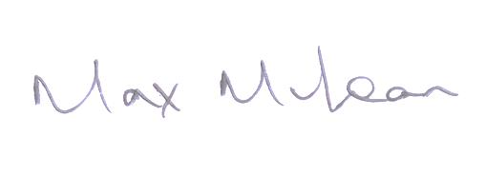

***Dr Maxwell Mclean,***

***Chairman***



*Keeping in touch with the membership office and our Governors*

Trust Membership Office

Trust Headquarters,

Chestnut House

Bradford Royal Infirmary

Duckworth Lane

Bradford BD9 6RJ

01274 364794

General membership: [members@bthft.nhs.uk](mailto:members@bthft.nhs.uk)

To contact our governors directly you can email: [governors@bthft.nhs.uk](mailto:governors@bthft.nhs.uk)

For more about our Foundation Trust and our Governors please visit https://www.bradfordhospitals.nhs.uk/our-trust/council-of-governors-and-foundation-trust-membership/