Mindfulness response to COVID-19

COVID-19 has brought great uncertainty and worry into many of our lives, and it is important that we do the best that we can to take care of our emotional well-being.

Mindfulness teachers across the world are generously making resources available online and creating ways for people to connect and practice together. This is one way that some people might find support and guidance at this challenging time.

Here is a selection of links to online practices and resources which are open to anyone who may find them helpful.

Free online mindfulness meditation sessions for support during COVID-19
 | https://oxfordmindfulness.org/online-sessions-podcasts/ | Wednesdays 7pm
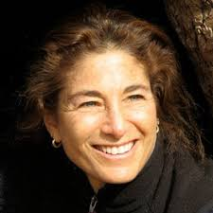 | https://www.tarabrach.com/calendar/weekly-satsang-with-tara/ | Saturdays  6pm (registration needed)
 | https://www.keepcalmer.co.uk/ | 6-6.30pm Weekdays
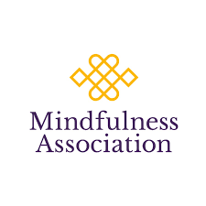 | https://www.mindfulnessassociation.net/latest-news/free-daily-online-meditation/ | Daily  10.30-11.30am  7-8pm
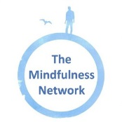 | https://www.mindfulness-network.org/free-online-practice-sessions/ | See website for details
 | https://medschool.ucsd.edu/som/fmph/research/mindfulness/free-sessions/Pages/default.aspx | See website for schedule

Recorded meditations

Tara Brach
https://www.tarabrach.com/pandemic/
https://www.tarabrach.com/meditation-times-of-pandemic/
https://www.tarabrach.com/meditation-rain-fear/

Jack Kornfield ‘A steady Heart in the time of coronavirus’
https://soundcloud.com/jack-kornfield/a-steady-heart

Jon Kabat-Zinn
Mindfulness at this Critical Moment – Daily Practice and Enquiry
http://www.wisdom2conference.com/live

Talks
https://www.tarabrach.com/facing-pandemic-fears/

Mindfulness meditation audio guidance from Clinical Health Psychology (Bradford Teaching Hospitals NHS Foundation Trust)
A range of guided mindfulness meditations are available at:
- http://www.bradfordteachinghospitals/mindfulness
- Insight Timer app – search for “Mindfulness for Health and Wellbeing”

Last updated 10/09/2020

