Mindfulness resources for support during COVID-19
COVID-19 has brought great uncertainty and worry into many of our lives, and it is important that we do the best that we can to take care of our emotional well-being. Mindfulness teachers across the world are generously making resources available online and creating ways for people to connect and practice together. This is one way that some people might find support and guidance at this challenging time. Here is a selection of links to online practices and resources which are open to anyone who may find them helpful:
Free online mindfulness meditation sessions for support during COVID-19
 | Jon Kabat-Zinn  http://www.wisdom2conference.com/live  https://www.youtube.com/user/Wisdom2conf/videos | Weekdays 7pm
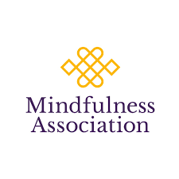 | https://www.mindfulnessassociation.net/latest-news/free-daily-online-meditation/ | Daily, 7-8pm
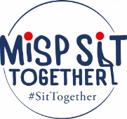 | https://mindfulnessinschools.org/misp-sit-together/ | 11am Weekdays
 | https://oxfordmindfulness.org/online-sessions-podcasts/ | Wednesdays, 7-8pm
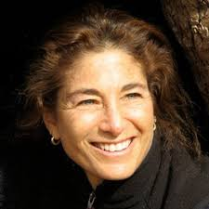 | Tara Brach, Clinical Psychologist & Mindfulness teacher  http://www.tarabrach.com  Insight Timer (free app or website link) | Wednesdays  7.30pm  Eastern Time*
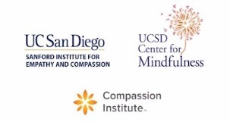 | https://medschool.ucsd.edu/som/fmph/research/mindfulness/free-sessions/Pages/default.aspx  Daily sessions and recordings of practice available. | Weekdays  – check times  2.30pm to 1.30am UK time
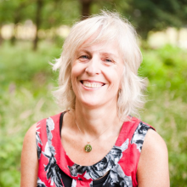 | Vidyamala Birch, founder of Breathworks  Join via this link: https://zoom.us/j/930264124  or by phone: +44 203 481 5240 (UK number)  Meeting ID: 930 264 124 | Wednesday, 7pm – 7.30pm

Apps
Headpsace have created a free resource eon their app called ‘weathering the storm’ which offers mindfulness meditation.
Insight Timer is a free app with thousands of meditations – look for teachers such as those mentioned here, but you can also explore other approaches to meditation if you wish.

Recorded meditations
Tara Brach
https://www.tarabrach.com/meditation-times-of-pandemic/
https://www.tarabrach.com/meditation-rain-fear/
Jack Kornfield ‘A steady Heart in the time of coronavirus’
https://soundcloud.com/jack-kornfield/a-steady-heart
Mark Williams
Oxford Mindfulness Centre is offering meditations to offer stability and help ‘find your ground’ with alternatives to the breath during these times:
https://mbct.co.uk/meditating-in-troubling-times/

Talks (and other resources)
Tara Brach
https://www.tarabrach.com/pandemic/

Jon Kabat Zinn – Mindfulness, Healing and Wisdom in our Time
https://www.youtube.com/user/Wisdom2conf/videos

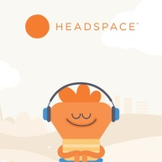
For Healthcare Workers

Free access to Headspace app until December 2020, for hundreds of free guided meditations.
https://www.nhsemployers.org/news/2020/03/free-access-to-wellbeing-apps-for-all-nhs-s taff
Breathworks are offering calming mindfulness practices for healthcare workers
https://www.breathworks-mindfulness.org.uk/the-quiet-place

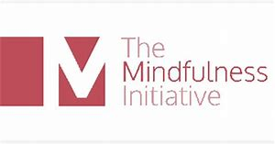
The Mindfulness Initiative
Mindfulness for Staying at Home - resource list pdf
The Mindfulness Initiative grew out of a programme of mindfulness teaching for politicians in the UK Parliament. They have released a comprehensive list of resources, including links to mindfulness meditations, to support well-being during COVID-19:

https://www.themindfulnessinitiative.org/Handlers/Download.ashx?IDMF=e7822fad-a910-496f-a7cd-1ad644e8f1d5

Last updated 29/4/2020

