Mindfulness response to COVID-19

COVID-19 has brought great uncertainty and worry into many of our lives, and it is important that we do the best that we can to take care of our emotional well-being.

Mindfulness teachers across the world are generously making resources available online and creating ways for people to connect and practice together. This is one way that some people might find support and guidance at this challenging time.

Here are a selection of links to online practices and resources which are open to anyone who may find them helpful.

Free online mindfulness meditation sessions for support during COVID-19
 | https://oxfordmindfulness.org/online-sessions-podcasts/ | Wednesdays, 7-8pm GMT
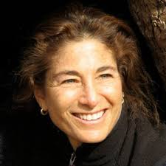 | https://www.youtube.com/user/tarabrach | Wednesdays  7.30pm  Eastern Time*
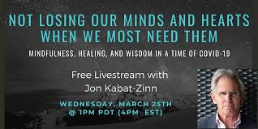 | Jon Kabat-Zinn ‘Not losing our minds and hearts when we need them most’  https://www.eventbrite.com/e/free-livestream-with-jon-kabat-zinn-tickets-100312545524 | Wednesday 25th March 2020  8-9.30pm GMT*
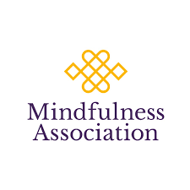 | https://www.mindfulnessassociation.net/latest-news/free-daily-online-meditation/ | Daily, 7-8pm GMT
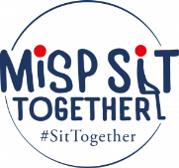 | https://mindfulnessinschools.org/misp-sit-together/ | 11am Weekdays
* Try to get a good night’s sleep. Livestreamed talks and meditations can often be found on Youtube after the event.

Recorded meditations

Tara Brach
https://www.tarabrach.com/meditation-times-of-pandemic/
https://www.tarabrach.com/meditation-rain-fear/

Jack Kornfield ‘A steady Heart in the time of coronavirus’
https://soundcloud.com/jack-kornfield/a-steady-heart

Talks
https://www.tarabrach.com/facing-pandemic-fears/

Mindfulness meditation audio guidance from Clinical Health Psychology (Bradford Teaching Hospitals NHS Foundation Trust)
A range of guided mindfulness meditations are available at:
- http://www.bradfordteachinghospitals/mindfulness
- Insight Timer app – search for “Mindfulness for Health and Wellbeing”

Last updated 23/03/2020

