**If you have any questions you want to ask? You can write them here so you remember them**

**Welcome to the Bradford Renal Transplant Service at Bradford Teaching Hospitals NHS Foundation Trust**

**A warm welcome to our services for adult transplant patients in Bradford, we are very much looking forward to getting to know you and providing the ongoing support that you need.  We recognise transferring to an adult hospital and service can be very daunting, not only for you but for your family as a whole and the importance of making your transition to adult services as smooth as possible.  To achieve this we are keen to do several things before we take over your transplant care.  We would like to see you alongside your current team in Leeds and arrange an orientation visit for you and your family to see us all in Bradford and to provide you with information and give you the opportunity to discuss any concerns and ask questions.  Hopefully you find this leaflet will provide you with information and contact details, which you will need as you prepare to transfer into the adult renal service. We welcome any other ideas you have about helping you to become more familiar with our team.** 



**The Transplant team runs a young persons’ kidney gathering for 16-30 year olds to meet up and enjoy spending time together without having to discuss they medical history or treatment. If you are interested we would be more than happy to tell you more about this.**

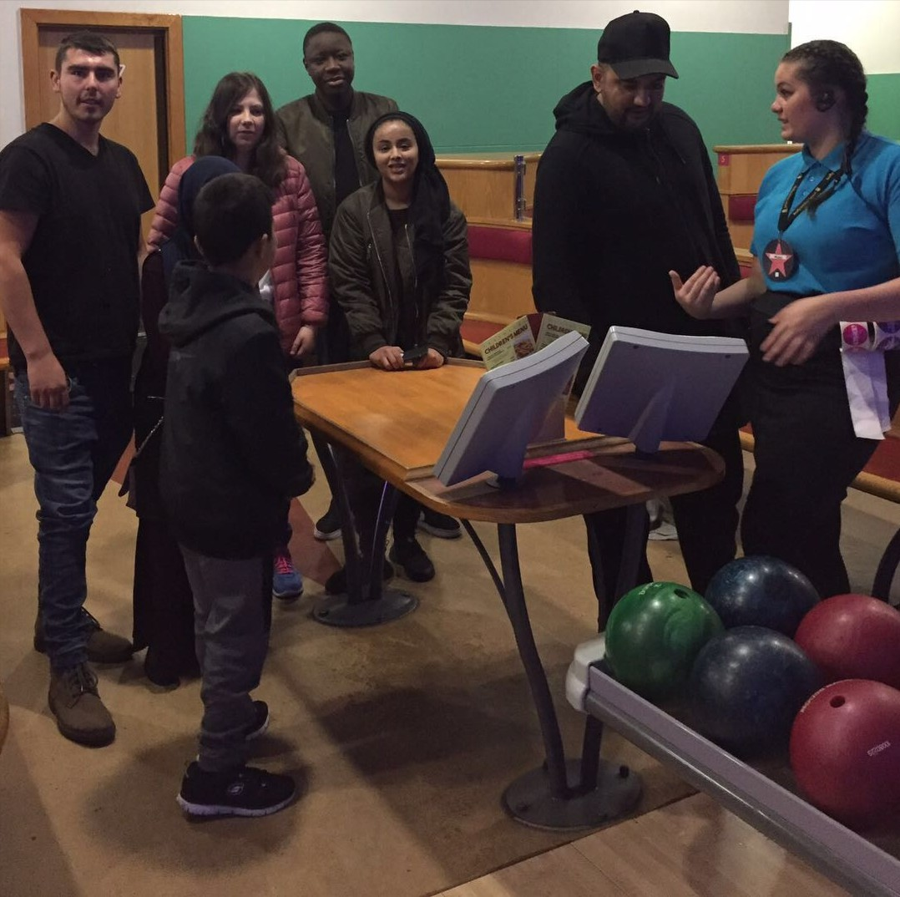

**Useful Contact Numbers**

**Transplant Nurses 01274 365557**

**Renal Ward 15 01274 383237**

**Cultural & Health 01274 365536**

**Improvement Officer**

**Renal Secretary 01274 365781**

**(Sarah Coope)**

**Renal Dietician 01274 365628**

**St Lukes OPD 01274 365272**

**Pharmacy**

**Welcome to the Bradford Renal Transplant Service**

[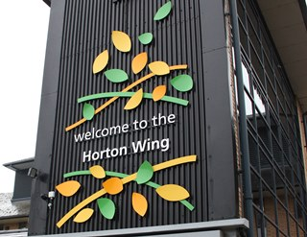](https://www.johnstonestrade.com/news/johnstone-s-trade-helps-realise-artist-s-impre-(1))

**What you may need to know and what to expect**

[Description: Bthft](https://www.bradfordhospitals.nhs.uk/)

**If you become unwell**

**Prescriptions for your Anti-rejection medication**

To request repeat prescriptions of your anti-rejection medication you can call the transplant nurses who will arrange a prescription that you can collect from the renal unit or you can ask for a repeat prescription to be ready for your next clinic visit. All your other medication must be requested from your local GP practice.

**Please keep track of your medication supply in order to request repeat prescriptions in good time. It is vital that you do not miss any doses of your anti-rejection tablets**

[](https://www.google.co.uk/url?url=https://tr.facebookbrand.com/&rct=j&frm=1&q=&esrc=s&sa=U&ved=0ahUKEwiw2ZO9ssXWAhUqAcAKHYHLDNMQwW4IIjAD&usg=AFQjCNEWLNalI6PxbS--oaG-EVKkelSRxg)

**We have a facebook group called YABA Kidney group. It is a social closed group for young adults (17-30 yrs) with kidney concerns to chat**

**If you become unwell you can telephone the transplant team on 01274 365557 during working hours (08.00-16.30) who can give you advice or guide you with what you need to do. Outside of the working hours of the transplant team, please call the renal ward which is ward 15 on 01274 383237 who will advise you further and contact the on-call renal medical staff. If it is a medical emergency please attend your local Accident and emergency department**

**The Renal Transplant team:**

**Dr John Stoves Dr Tarun Bansal**

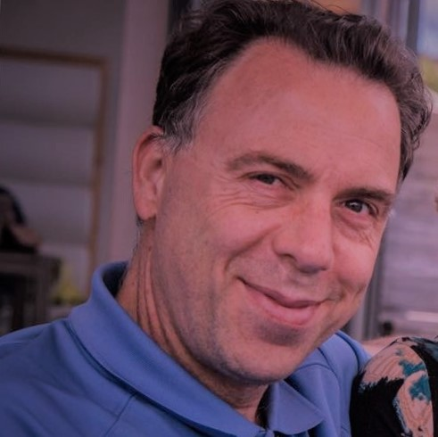 

The transplant nursing team is Karen Scroby, Michael Speight and Vickie Lai with this assistance of our Cultural & Health Improvement Officer Tahira Mir

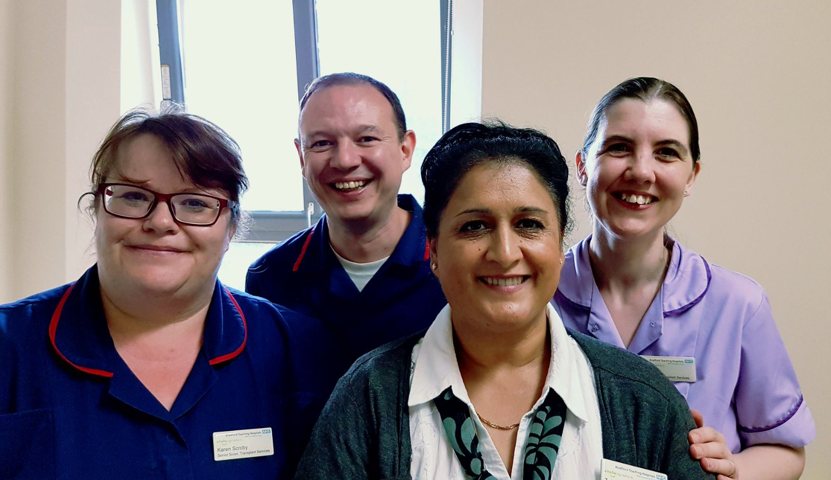

**We attend regular transition clinics with your team in Leeds and hope to meet you at one these before you move to our service.**

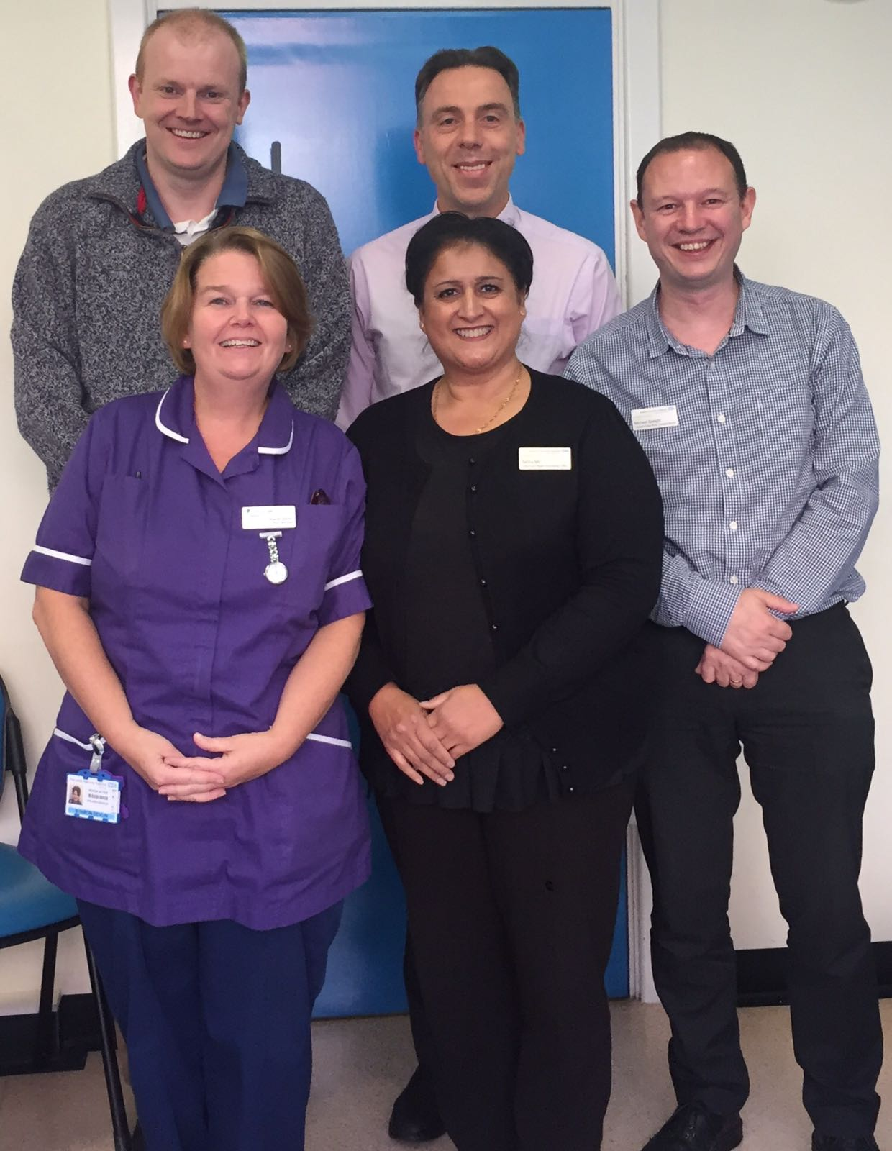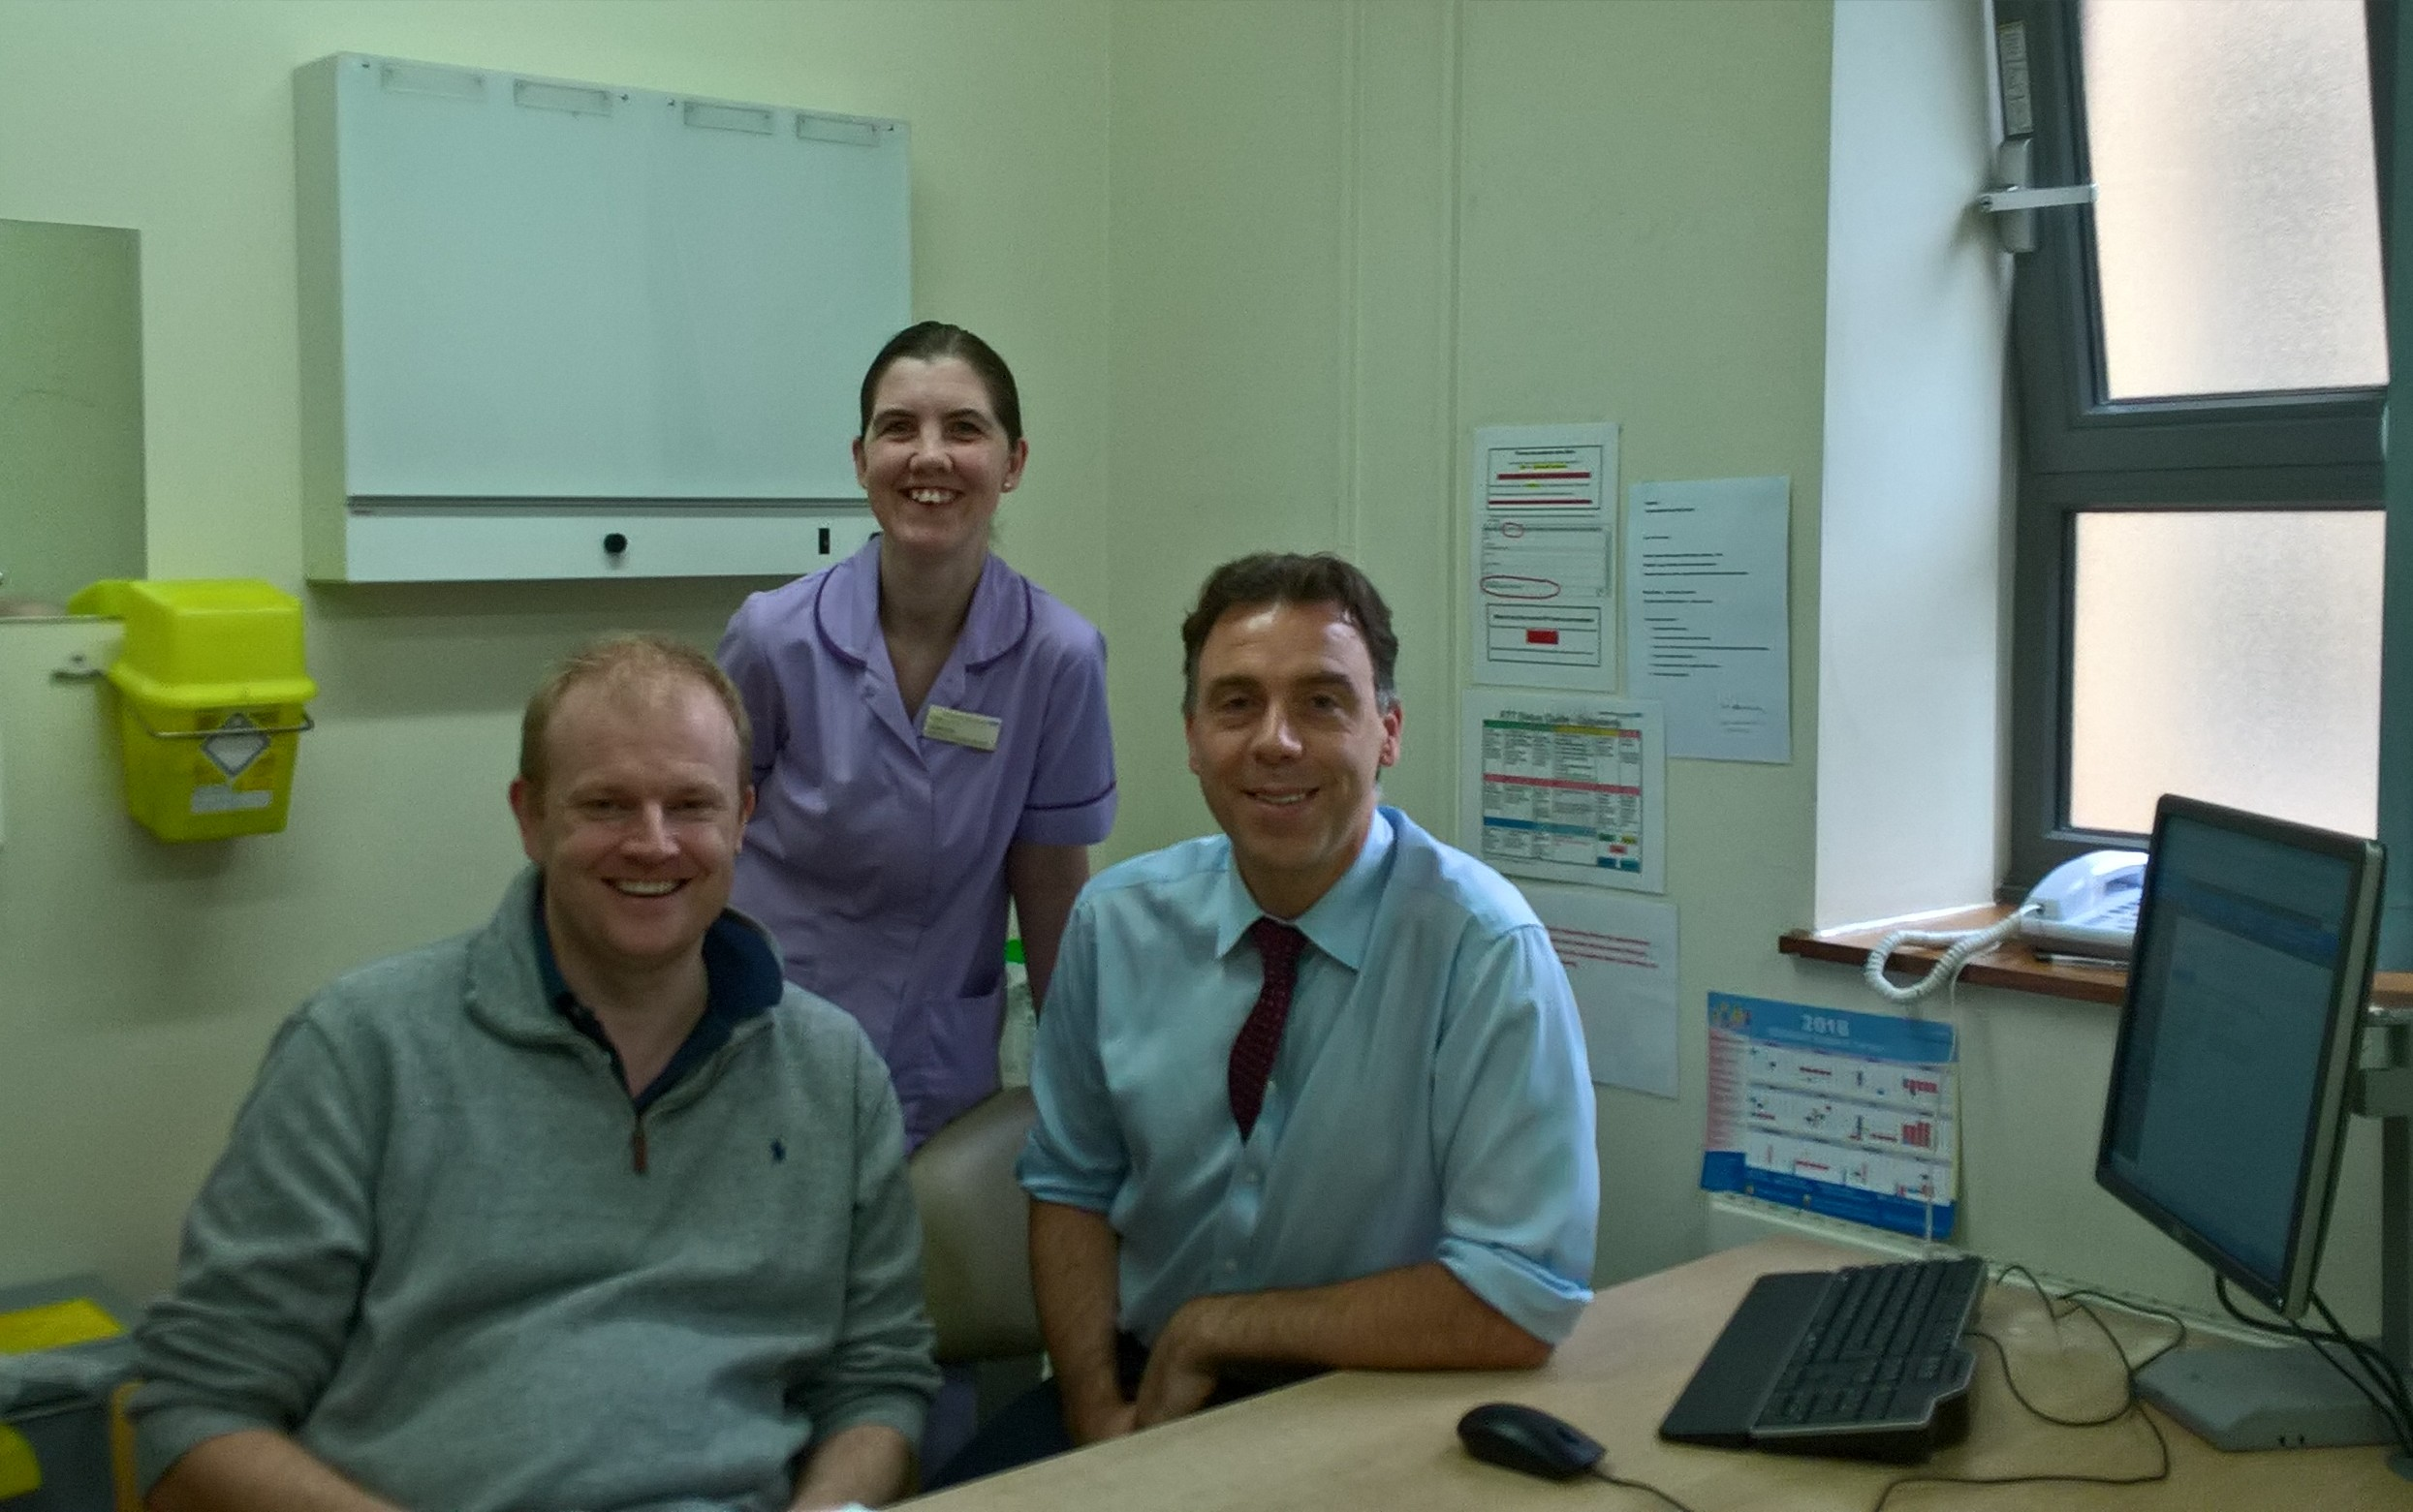

**Your First Visit to Clinic**

Your first clinic appointment in Bradford will be a double appointment to allow time for you to get to know the team and for the consultant to get to know you. You may be offered the opportunity to meet one of the renal dietitians to discuss any dietary needs you may have and for the dietitian to explain their role and how they can support you

**The Transplant Clinics**

We run two transplant clinics each week, the first on a Monday morning led by Dr Bansal with the support of the other renal consultants and the second on a Thursday morning led by Dr Stoves. The clinics are based in Adult Outpatients in Horton Wing at St Lukes Hospital. Once a month Dr Roberts runs a transplant clinic based at Skipton Hospital for the patients who prefer they care review closer to home. A member of the transplant nursing team will be in attendance during each of the transplant clinics that run here in Bradford and at Skipton.

On you visit to clinic, when you arrive into the reception area you will be booked in by one of the receptionists who will direct you to the correct waiting area. Here you will be greeted by a nurse who will ask you to provide a urine sample and then get weighed before taking a seat. You will wait here until the transplant team are ready to see you. During your consultation blood forms will be provided for you to attend the phlebotomy department to have samples taken, if you have not had them done before your appointment. You will be contacted directly should any abnormal results be identified to discuss.

**Blood Tests**

There are two outpatient phlebotomy departments at Bradford, one based at Bradford Royal Infirmary and other at St Lukes Hospital. You can either have your blood tests before your clinic appointment or you can have your bloods taken on the day. “Renal Patient View” is a password protected system that allows you to access your own results online including internet access from your smartphone if you are interested. Please ask if you do want to arrange access and the team can give you some registration forms to complete and return either at your next clinic visit or posted back to the team

**Meet our team**