|  |  |  |  |  |
| --- | --- | --- | --- | --- |
| **The Renal Newsletter** |  | |  | | --- | | The Renal Unit Newsletter  JUNE 2018 | | Issue Date | |
|  |  |  |
| Working together for patients |  | In This Issue |

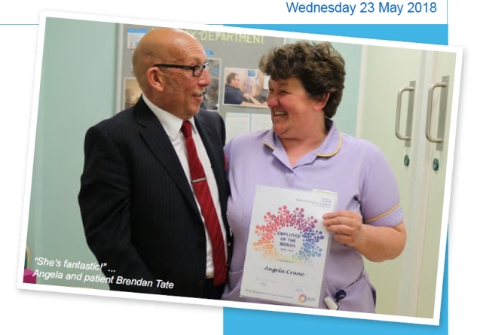

Everyone on the renal unit would like to congratulate Angela on becoming Employee of the month!

Nominated by Senior Sister Collette Devlin, Angela has shown initiative and excellence in scouring the intranet in search of surplus office items, a drugs fridge, and store equipment – to name but a few things – to help with the department’s move to Ward 15.

“She shows strong team-working

and flexibility to deliver excellent

outcomes to the everyday lives of

both patients and staff”.

One her biggest fans is Brendan Tate, who is a home dialysis patient and also works on our main reception at BRI.

“Angela is caring and very professional and has great empathy with families, which is really important,” said Brendan.

“I feel confident doing dialysis at home –and that’s down to her help and support. She’s fantastic.”

.

# Congratulations Angela!

by The Renal Unit

Eid Celebration

The renal unit was full of celebration for patients as part of Eid. See pictures of how it went

Page 2

[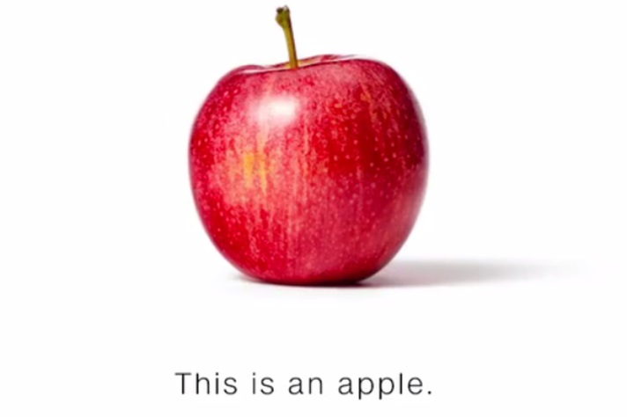](https://www.google.com/url?sa=i&rct=j&q=&esrc=s&source=images&cd=&cad=rja&uact=8&ved=2ahUKEwjvxb282PPbAhXBwBQKHe6dCGMQjRx6BAgBEAU&url=https://www.recode.net/2017/10/23/16524594/cnn-new-ad-apple-banana-trump-fake-news-mainstream-media&psig=AOvVaw3WS48ryCMcAVru0SiHUpM5&ust=1530183653661165)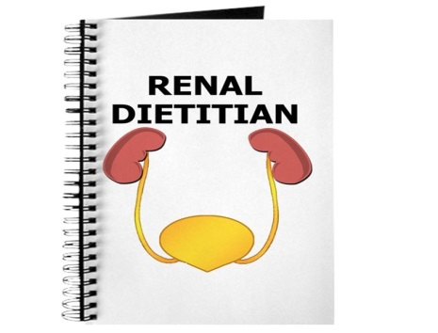

What to eat during haemodialysis

Find out what you should be eating while on haemodialysis recommended by our very own renal dietitions.

Page 4[](https://www.google.co.uk/url?sa=i&rct=j&q=&esrc=s&source=images&cd=&cad=rja&uact=8&ved=2ahUKEwjrp42U3sXZAhWfOsAKHZusB1AQjRx6BAgAEAY&url=https://blog.rendia.com/culture/&psig=AOvVaw02eZQPppLDuS2iXyT4wEsy&ust=1519808523894955)

Eid Celebrations on the renal unit

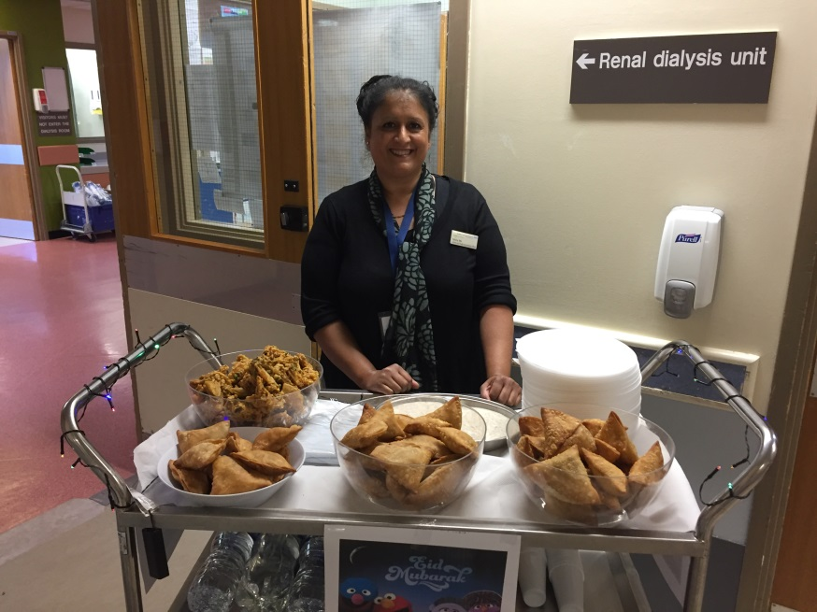B

elow are pictures of the eid celebration on the renal unit organised by our Cultural and Health Improvement Officer, Tahira Mir.

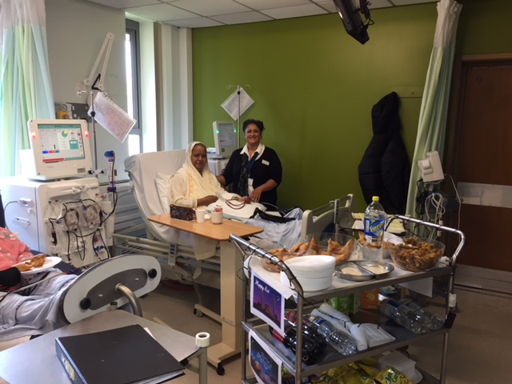

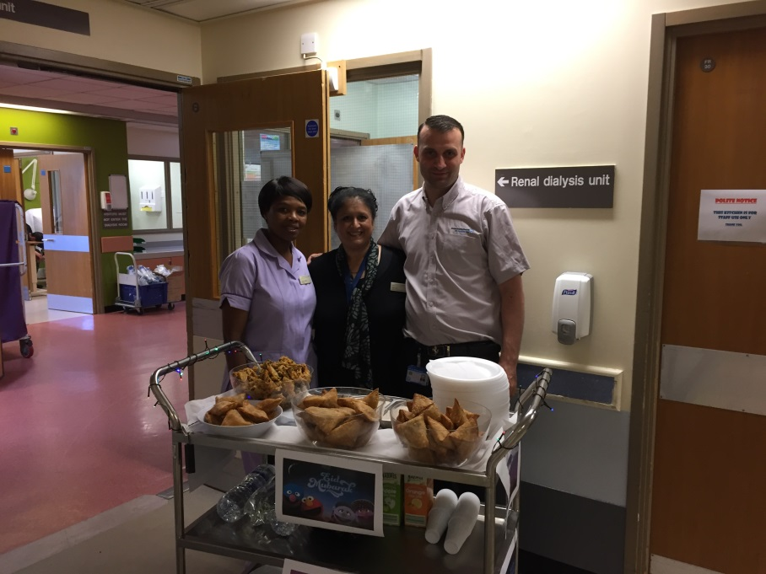

**For the Renal unit staff**

PAM Manual

by Dr Mumtaz

Step 1 – kindly complete your online training by logging into …

URL: <http://training.insigniahealth.com>

Username: renalregistrytraining1

Password: renalregistrytraining1

Step 2 – kindly make sure you check **clinical notes on BHLY** if all patients under your care have had PAM assessment. All CKD patients are required to have PAM test at the start of coming in contact with the renal service and then the PAM is to be repeated on an annual basis.

Step 3 – kindly ask your patient to do paper version of Pam questionnaire

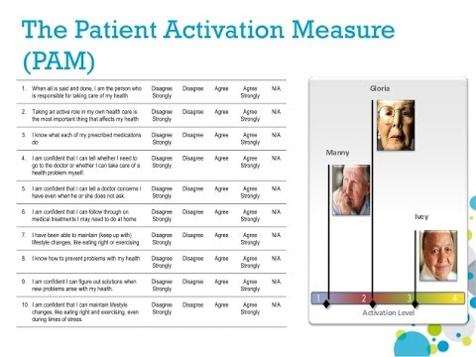

Step 4 – kindly ensure that completed forms are returned **to Intikab Khan, data analyst based at St Lukes hospital dialysis unit F7/F8, specialist nurses back office.** Kindly engage and seek help from renal volunteers who are attending St Lukes dialysis unit to facilitate survey completion.

Step 5 – Kindly **make use of PAM data provided** for a given patient in your clinical encounters with the patient. All clinical goal setting and MDT plans should take PAM level into consideration. The information given and treatment plan agreed should be tailored to activation level. As a team working together we should aim to **increase patient knowledge, confidence and skills** which will translate into improved future PAM scores. To help set agenda for clinical encounter, please ask patients to complete **patient interest check list** (PIC). This whole process should benefit the renal service by having more engaged and satisfied patients. The research also indicates additional benefits, for example an increase in PAM scores is linked to reduced frequency of hospital admissions.

Step 6 –If you would like to become **a PAM champion** and want to increase your skills as a **patient coach** please contact:

1. Dr Ramla Mumtaz, PAM coordinator.
2. Dr John Stoves, Clinical lead.
3. Kate Ryder, Clinical psychologist.

Step 7 – To get a patient prospective you can also talk to:

Peter Forest, Patient Coordinator for CKD - PAM project

|  |
| --- |
| For More Information |
| For further information please speak to Dr Ramla Mumtaz, Intikhab Khan or Peter Forest |

## Following the withdrawal of sandwiches on dialysis, a number of patients have asked what foods would be suitable to bring from home.

## Here are some ideas:

|  |  |
| --- | --- |
| **SANDWICHES**  What to eat during haemodialysis  by The Renal dietitians | |
| The base:  Choose wholegrain, granary or white bread. Wholemeal pitta bread, bagels, wraps, rolls or white alternatives. | The filling:  Choose a good source of protein such as :  cooked chicken, turkey, egg, lean ham, tuna, skinless and boneless salmon, cheese. |
|  | |
| **HEALTHY SNACKS** – naturally lower in potassium and salt  Apple, pear, peach, nectarine, plums, cherries, grapes, blueberries, strawberries, pineapple cubes, carrot, cucumber or pepper batons, mangetout, cherry tomatoes.  **Remember to have only a small handful** | |
|  | |
| **CRISPS**  Crisps appear to be a popular snack on dialysis. Due to the majority being high in salt we advise that these are limited to help stick to fluid allowances as they can make you thirsty.  Potato based crisps are also naturally high in potassium. If your potassium level is high these can increase your potassium levels causing an irregular heartbeat.  In an effort to reduce salt in foods, manufacturers are now replacing salt with potassium supplements e.g. “potassium chloride, potassium carbonate, potassium bicarbonate”.  As an example, the ingredients list below is taken from a bag of crisps:  **Ingredients**  Maize, Rapeseed Oil, Pickled Onion Seasoning [Flavourings, Lactose (from Milk), Onion Powder, Wheat Rusk, Flavour Enhancers (Monosodium Glutamate, Disodium 5'Ribonucleotide), Fructose, Salt, Acid (Citric Acid), **Potassium Chloride**, Hydrolysed Soya Protein (contains Wheat), Garlic Powder]  We include a list of non - potato/part potato based snacks below which may enable you to make better choices.   * Doritos – BBQ, hint of lime or sizzling salsa only * Mini Cheddars - original flavour * Monster Munch - Roast beef flavour only * Nik Naks * Snack – a jacks ( not salt and vinegar flavour) * Space Raiders (part potato) * Pretzels * Tyrells Posh Corn * Transform – a – snack (Golden Wonder) * Walkers Sunbites- chilli flavour, onion and rosemary lightly salted, pepper and sour cream * Warburtons baked pitta chips * Weight watchers cheesy flavour puffs (avoid Wotsits) * Asda Cheesy Wiggles (avoid Wotsits) * Asda prawn crackers (avoid Skips) * Asda Wholegrain bites * Sainsbury’s basics assorted snacks * Sainsbury’s cheese puffs (avoid Wotsits) * Sainsbury onion rings * Tesco bacon rashers * Tesco ready salted crunchy sticks * Tesco cheese puffs   This list if not exhaustive therefore, **please read food labels** to check for potassium supplements in your snacks. | |
|  | |
| **OTHER SNACKS**  Plain biscuit, cake, croissant, crackers , rice cakes, breadsticks | |

## Other things to consider:

* Protect your food from spoilage. Use a small cooler bag to protect from the environment and heat (especially items that should be stored in the fridge –sandwiches)
* Takeaway food is unacceptable on the unit
* There is no facility to warm foods up on the unit.
* Please consider your dialysis neighbor, warm food brought from home can smell on the unit which may be nice to you but not the person in the chair next to you!
* If you are prescribed a phosphate binder, please take your prescribed dose with any foods that contain protein

[](https://www.google.com/url?sa=i&rct=j&q=&esrc=s&source=images&cd=&cad=rja&uact=8&ved=2ahUKEwju4_HN2vPbAhVTsBQKHVIMDSoQjRx6BAgBEAU&url=https://nicohit.co.uk/product/strawberry/&psig=AOvVaw318y_5QKRTfkt8MSYRx-5E&ust=1530184228419940)[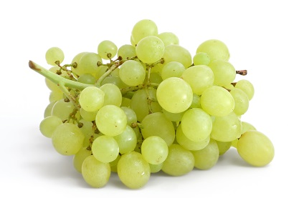](https://www.google.com/url?sa=i&rct=j&q=&esrc=s&source=images&cd=&cad=rja&uact=8&ved=2ahUKEwiV9Z7D2vPbAhUB7BQKHX4aBe4QjRx6BAgBEAU&url=https://en.wikipedia.org/wiki/Grape&psig=AOvVaw08pLZTwuhq6N9CnSuJ4-p6&ust=1530184204275732)[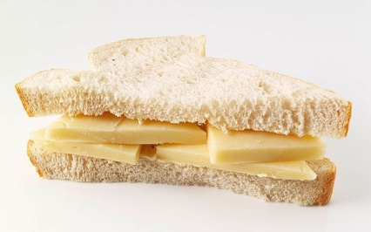](http://www.google.com/url?sa=i&rct=j&q=&esrc=s&source=images&cd=&cad=rja&uact=8&ved=2ahUKEwj_v-vY2fPbAhUHPRQKHbEeC48QjRx6BAgBEAU&url=http://sacompassion.net/the-cheese-sandwich/&psig=AOvVaw1vs1xNv34ng0rkd0N6FLWx&ust=1530183959931818)

[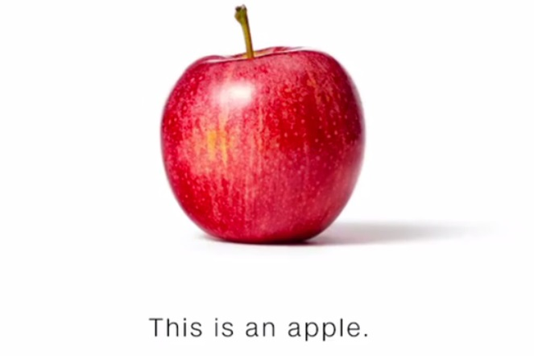](https://www.google.com/url?sa=i&rct=j&q=&esrc=s&source=images&cd=&cad=rja&uact=8&ved=2ahUKEwia0tuw2vPbAhVKXBQKHTmcCAAQjRx6BAgBEAU&url=https://www.recode.net/2017/10/23/16524594/cnn-new-ad-apple-banana-trump-fake-news-mainstream-media&psig=AOvVaw33Hx1j2LMqMsMVFUxf_-Kv&ust=1530184167954991)

|  |
| --- |
| For More Information |
| Please contact the Renal Dietitians on 01274 3655628 should you have any questions. |

[](https://www.google.com/url?sa=i&rct=j&q=&esrc=s&source=images&cd=&cad=rja&uact=8&ved=2ahUKEwjp4s_Z2vPbAhVKPhQKHdexDREQjRx6BAgBEAU&url=https://www.joe.co.uk/food/carrots-are-disgusting-and-its-high-time-we-all-stopped-lying-to-ourselves-170958&psig=AOvVaw21O7i4mDbSdpOzv6o-2udH&ust=1530184253676429)[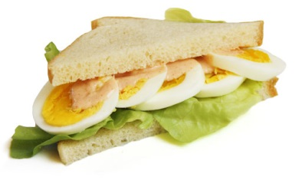](https://www.google.com/url?sa=i&rct=j&q=&esrc=s&source=images&cd=&cad=rja&uact=8&ved=2ahUKEwiomdKQ2vPbAhULPRQKHd0IBaAQjRx6BAgBEAU&url=https://en.wikipedia.org/wiki/Egg_sandwich&psig=AOvVaw1W3zGfbAJOJmx9vExxme9W&ust=1530184092447328)

[](https://www.google.com/url?sa=i&rct=j&q=&esrc=s&source=images&cd=&cad=rja&uact=8&ved=2ahUKEwiNjOH02vPbAhVCVRQKHd-8C0gQjRx6BAgBEAU&url=https://knockmart.com/pineapple-1pc&psig=AOvVaw2ywXd57wf6iECdA2h56qWG&ust=1530184301802404)

