|  |  |  |  |  |
| --- | --- | --- | --- | --- |
| **The Renal Newsletter** |  | |  | | --- | | The Renal Unit Newsletter  February 2018 | | Issue Date | |
|  |  |  |
| Working together for patients |  | In This Issue |

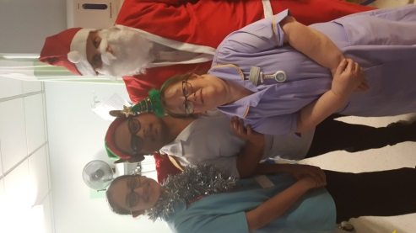Christmas has been and gone on the renal unit and a happy new year to all.

Again we enjoyed the Xmas parties on the unit and thanks to all staff who helped and got into the Christmas mood.

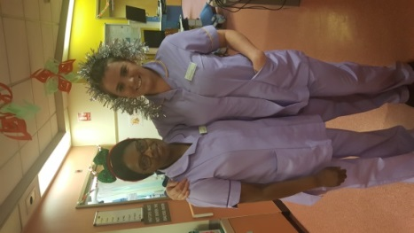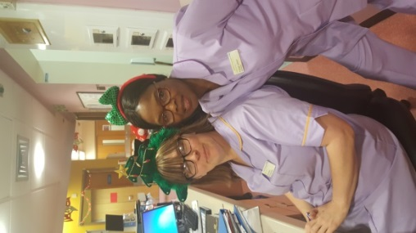Gwen (the sister of transplant patient Stephen Goy) kindly made some xmas crackers for us again which were sold on the unit. This raising £47 which was then spent on pressies for a free patient xmas raffle. Some lucky patients went home with a prize.

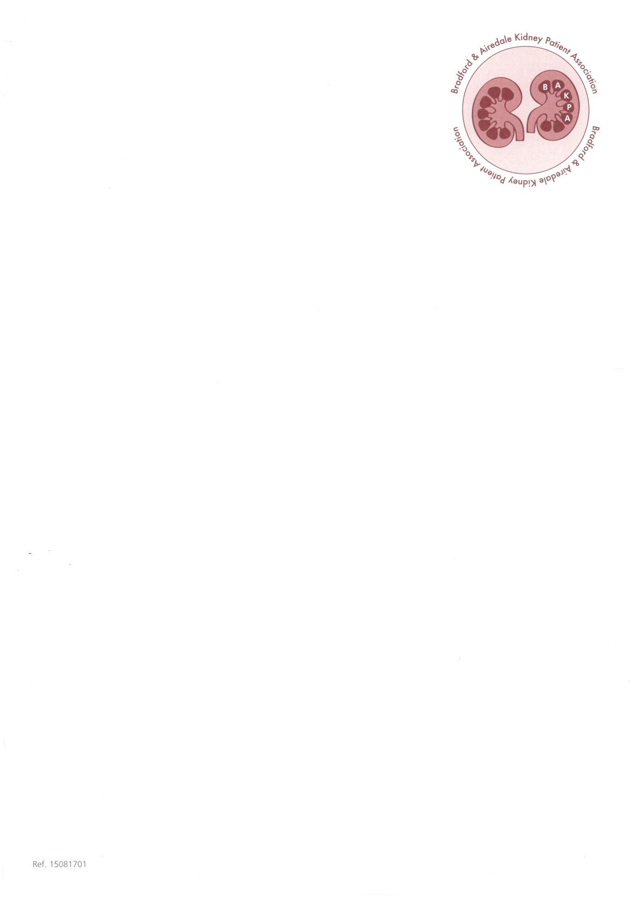Hopefully there will be other things coming up throughout the year.

Best wishes and regards from

Maureen (BAKPA treasurer)

[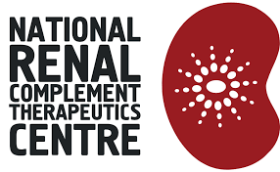](http://www.google.co.uk/url?sa=i&rct=j&q=&esrc=s&source=images&cd=&cad=rja&uact=8&ved=0ahUKEwj41Kyx5ZjZAhUSZVAKHRisCdAQjRwIBw&url=http://www.atypicalhus.co.uk/&psig=AOvVaw29To_tUJFF0SYCiQ-POCj_&ust=1518264125056423)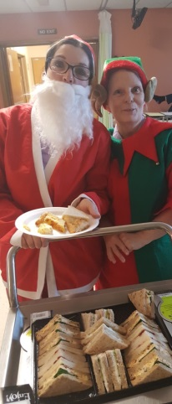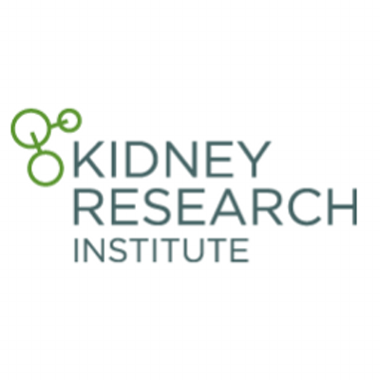

BAKPA’s Christmas

by Maureen Cain

Renal Research

Did you know we are an active renal research unit!? Find out the research projects the team is working on and how you can get involved.

Page 4

[](https://www.google.co.uk/url?sa=i&rct=j&q=&esrc=s&source=images&cd=&cad=rja&uact=8&ved=2ahUKEwjrp42U3sXZAhWfOsAKHZusB1AQjRx6BAgAEAY&url=https://blog.rendia.com/culture/&psig=AOvVaw02eZQPppLDuS2iXyT4wEsy&ust=1519808523894955)

The role of our Renal Cultural and Health Improvement Officer

Find out about our Renal Cultural and Health Improvement Officer) and responsibilities include links and referrals to local social healthcare services for all of our renal patients

Page 5

# Happy Retirement Dr Jeffrey

by The renal unit

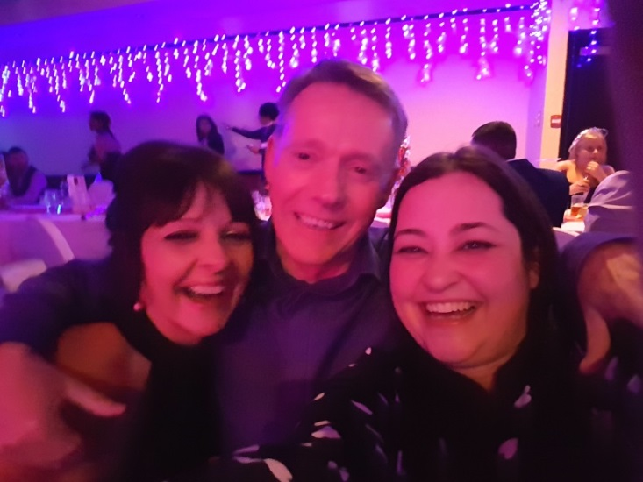

The renal unit would like to personally congratulate Dr Robin Jeffrey on his retirement from the renal unit.

It has always been a pleasure to work with you. So, while everyone is saddened to see you go, we are confident that you will find the same success and happiness in retirement that you experienced during your time here.

The renal unit wishes you the best in your future endeavors. Retirement will surely offer you many new opportunities, which we know you will embrace wholeheartedly, just as you did here.

“I’ve worked with Dr Jeffrey for a long time now; so long in fact, just to annoy him (and when I can get away with it) I call him Dad! It’s been an absolute pleasure being his second favourite “gopher”.  I will miss his demands for tea, IT assistance and probably most of all his insults!  He’s made a massive impact with staff and patients alike and we will all miss him.  Good luck Dr Jeffrey and enjoy your retirement, you’re always welcome to call in for a cuppa!” *Sarah Coope*.

“I step into the shoes of Dr Jeffrey’s secretary in July 2012 feeling a little apprehensive as his previous secretary; Jenny had been with him for sixteen years. Although I already knew Dr Jeffrey having previously worked on the renal unit some years ago it was still nerve-racking. I need not have worried as Dr Jeffrey is the most down to earth, friendly, approachable and pleasant gentleman you can come across. He made me feel welcome from day one. I soon learnt how much he was liked by all his colleagues but also his patients too. I have had many telephone conversations with patients who are full of praise and have even been referred to as “God” in some cases!

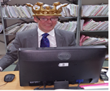He earned himself the title of Sir Jeffrey by some of his colleagues and even has his own Sir Jeffrey cup and crown which he occasionally wears around the office.

I know his patients are going to miss him tremendously as will I. The renal unit will not be the same without Dr Jeffrey around. I wish him a long and happy retirement” *Andrea Marshall, Medical Secretary*.

“Dr Jeffrey ***is*** the Bradford Renal Unit, what will we do without him! Seriously he has been a part of the unit since its very beginning and will be a hard act to follow but we would like to reassure him and all his patients that he leaves the unit in safe hands and with a healthy prognosis. We are all very grateful for his hard work for and interest in the renal unit over the years and wish him and his garden a very happy retirement.” *Dr Russell Roberts, Consultant.*.

“Our patients will be saddened to hear that Dr Robin Jeffrey, our founding father, is leaving us after nearly 25 years of dedication to the kidney care service in Bradford. We have an opportunity to celebrate all that he has achieved in pursuing a shared ambition to provide the best care for our patients.

[](https://www.google.co.uk/url?sa=i&rct=j&q=&esrc=s&source=images&cd=&cad=rja&uact=8&ved=2ahUKEwjHgdvqlcPZAhVI1iwKHaBTCKsQjRx6BAgAEAY&url=https://www.amazon.com/Retirement-Banner-Bunting-Retirement-Supplies-Decorations/dp/B071SGFTQX&psig=AOvVaw22RUaevDDSErIYdpizxGr0&ust=1519720351913939)Fare ye well Sir Jeffrey, we treasure the happy memories and wish you the very best in all of your future endeavors and your eventual retirement. We will be delighted if you regularly find occasion to call on us to say hello and drink a ‘cup o’ kindness’ from your infamous eponymous mug!” *Dr John Stoves, Consultant.*

The group comprises of renal patients and renal unit staff who work together in 50:50 partnership to oversee the progress of Patient activation measure projects undertaken by the Renal Unit.

The group was created in November 2015 as prerequisite to participate in National CKD programme “Transforming participation in Chronic Kidney Disease- “ A NHS programme to help people with CKD live their best life.

The group members have travelled to London and Birmingham to attend conferences arranged by the NHS England and the Renal Registry. The group meets at least 3-4 times a year to monitor and assess local progress.

Apart from overseeing projects, the forum also reviewed PAM related reports issued by the Renal Registry. The work undertaken so far includes the following.

* TP-CKD Project - started 2015
* PAM CQUIN Project- started 2016
* Implementation of interventions to improve PAM scores -2016-2017
* The introduction of volunteers on Dialysis Unit. 2017
* The review of Bradford PAM reports issued by the Renal Registry 2017
* The review of Bradford PREM report 2016.
* The review of CQUIN submission data.
* The review of interventions in relation to local PAM trends
* The review of Renal Staff training for PAM

A group meeting held on 28th of November 2017 celebrated 2 years of patients working together with staff to increase the level of participation of CKD patients in their own care.

The staff chairperson Dr Mumtaz thanked staff, the patient chairperson Mr Peter Forrest and renal patients for their continued support for the projects and for devoting their invaluable time to make contributions and suggestions to take the projects forward.

The group also thanked Kate Ryder (clinical psychologist) for taking keen interest in the empowerment of CKD group of patients and for arranging PAM coaching sessions for staff working on the dialysis unit at St Luke‘s Hospital Bradford.



|  |
| --- |
|  |



PAM Group

The PAM group celebrating 2 years of patients and staff working together.



Discussions

The group discusses ideas and in regards to participation of Chronic Kidney Care patients in their own care.

|  |
| --- |
| For More Information |
| For more information on the CKD-PAM Project you can speak with Tahira Mir or Dr Ramla Mumtaz |

### CKD-PAM Project Group

by Dr Ramla Mumtaz

Did you know we are an active research unit?

### Renal Research

by Diane Palframan

We have a dedicated team of renal research nurses Jodi & Diane, located on the renal unit, led by Dr Bansal.

We are currently recruiting into the following studies:

CALiPSO – A study looking into cardio-vascular calcification in haemodialysis patients.

SIMPLIFIED – A study looking at Vitamin D supplementation in dialysis patients.

**H4RT**

H4RT – A study looking at the effectiveness of different dialysis programmes used on the unit.

PDCRAFT2 - PD-CRAFT: A Study of Clinical and Genetic Risk Factors for Encapsulating Peritoneal Sclerosis.

Quality of Life in Couples starting dialysis – Questionnaires study for Patients and their partner when starting dialysis.

Paclitaxel assisted balloon Angioplasty of Venous stenosis in haEmodialysis access (PAVE); A double-blind randomised controlled clinical trial to determine the efficacy of paclitaxel-assisted balloon angioplasty of venous stenoses in haemodialysis access

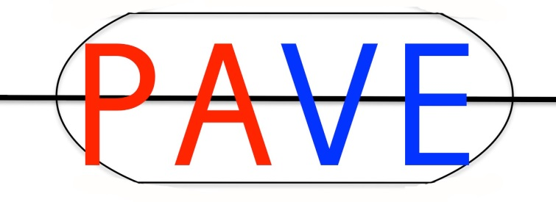OTSUKA A 6-year, Multicentre, Non-interventional, Post-authorisation Safety Study for Patients Prescribed JINARC® for Autosomal Dominant Polycystic Kidney Disease

|  |
| --- |
| For More Information |
| If you are interest in participating in Research and wish to speak to a member of the research team please ask your Dialysis Nurse to contact us |



The role of our Renal Cultural and Health Improvement Officer (CHIO)

by Tahira Mir

In 2010 we were successful in applying to the British Kidney Patient Association (BKPA) for funding to employ an Ethnic Liaison Support Worker (ELSW). The ELSW is able to engage with and support patients, relatives and other members of the multidisciplinary team (MDT).

The post has been renamed renal ‘**Cultural and Health Improvement Officer**’ (**CHIO**) and responsibilities now include the provision of links/referrals to local social healthcare services for all of our renal patients.

The CHIO is able to engage with and support patients, relatives and other members of the multidisciplinary team (MDT). Her role is multifaceted, but centres around the following core responsibilities:

* Ensuring that patients and their families feel at ease whenever they are in communication with the renal services team in Bradford.
* Contributing to formal discussion and explanation of important clinical issues in English and the patient’s first language (typically Urdu or Punjabi), thereby encouraging patients to feel more involved in decisions about their care and to attend appointments for tests and clinic assessments.
* Listening to ad hoc patient queries and concerns, and addressing these directly or indirectly through timely involvement of other members of the renal team and external organisations.
* Cultivating a greater awareness of, and empathy towards, the holistic needs of patients and their families within the renal MDT.
* The CHIO has strengthened the links between renal and social healthcare services, assisting all renal patients with their social care issues.
* The CHIO has supported education and research activities within the Bradford renal unit.

## Low clearance care including home visits

* Accompanying a member of the pre-dialysis nursing team on home visits
* to facilitate a detailed discussion about treatment options for individual patients
* to gain a clearer understanding of family dynamics and the amount of support that is available at home
* to explore cultural or religious issues that may inform care planning
* Helping to maintain continuity of care and holistic support for patients
* confirming that patients have a clear understanding of care plans and changes in medication
* encouraging and motivating patients to make decisions about treatment
* promoting patient engagement with Patient View and effective use of other resources such as the Yorkshire Dialysis Decision Aid

## Transplantation

* Supporting the process of assessing patient suitability for renal transplantation
* Confirmation that patients have a full understanding of the work-up procedure for transplant listing and all communications regarding the cadaveric (heart **-**beating and non-heart**-**beating) and living donor (including paired–pooled donation) programmes, including information that is given concerning the overall risks and benefits of transplantation and key elements of follow-up care
* Involvement in local initiatives to promote organ donation within the South Asian community and in the NHS Kidney Care Timely Listing for Kidney Transplantation project.

## Haemodialysis and peritoneal dialysis

* Involvement in day-to-day aspects of care (physical, mental, social) that arise for individual dialysis patients
* confirmation of a clear understanding of prognosis, treatment plans and medication dosage changes
* clarification of family support arrangements
* assistance with booking of holiday dialysis
* negotiation with staff in other departments to change clinic appointment times and ensure patient attendance
* reinforcement of messages and advice given to patients by other members of the team
* Contributions to the assessment of patient suitability for peritoneal dialysis
* Assistance with messages in relation to peritoneal dialysis training
* Shared care/ buttonhole/ home therapies

## Conservative and End-of-Life Care

* Involvement in the recent development of pathways of care for South Asian patients in Bradford
* NHS Kidney Care End-of-Life Care in Advanced Kidney Disease project
* Exploring End of Life Care for South Asian Renal Patients project supported by Kidney Research UK
* Contribution to the process of explaining treatment options and arranging appropriate support for patients and their families

## Diabetes and dietetic care

* Availability for consultations between patients and the diabetes specialist nurse
* Assisting the team in activities such as ascertaining patients’ diabetes treatment regimens, explaining changes in the dosage of tablets or insulin, reviewing insulin injection technique and timing, and confirming a clear understanding of the actions needed to prevent and treat hypoglycaemia
* Helping renal dieticians to assess the dietary intake of patients and their adherence to prescribed medications and nutritional supplements
* Ensuring that patients understand the types of culture specific food and drink that are permissible and the importance of restricting dietary salt and fluid intake where appropriate

## Training and education

* Sharing of knowledge of any cultural and religious issues that may influence the care of South Asian patients
* during case-based discussions
* formal training sessions for healthcare assistants and other staff groups

