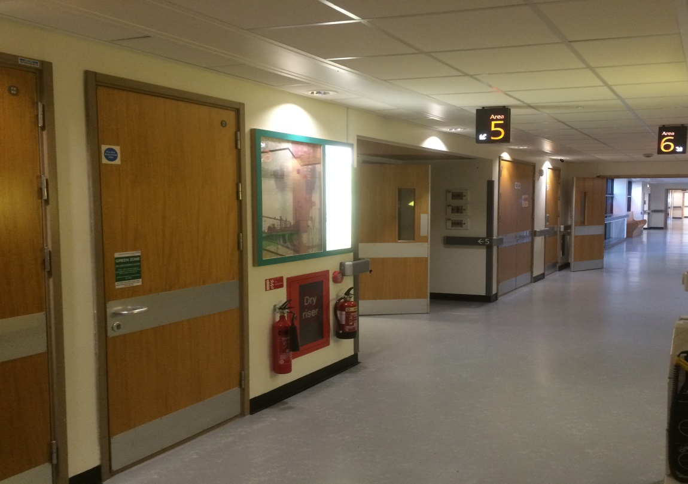  The Renal Newsletter |  | The Renal Unit Newsletter  DECEMBER 2018  - Issue Date
Working together for patients |  | In This Issue

Christmas has come to town again, the festive lights are on, the high-street is bustling and Santa’s are appearing in shop front windows. That means the usual schedule of dragging a fir tree into our homes, decorating it in lights and colorful tinsel, and gorging ourselves on as much food and drink until we can no longer stand and who doesn’t dream of a white Christmas? Building snowmen and making snow angels, what could be better than that!

Dialysis on Christmas day and New Year’s Day
Christmas and New Year days fall on a Tuesday this year. So that the unit can close on Christmas Day and New Year’s Day we will open on the Sunday before Christmas (23rd December 2018) and the Sunday before New Year’s days (30th December 2018).
Patients who would normally dialyse Monday 24th December and Monday 31st December will instead dialyse Sunday 23th December and Sunday 30st December.
Therefore the patients who usually dialyse on the on Tuesday will instead dialyse on Monday 24th December and Monday 31st December 2018.
The drivers have been made aware of these changes

More Information?
If you require more information regarding these changes please speak to the nurses in your room or Ayesha.
Any patient wishing to change their dialysis shifts in this period should also see Ayesha or the nurses.
Every effort will be made to accommodate your request but please bear in mind that we are currently using all our dialysis slots and may not be able to provide a change of shift.

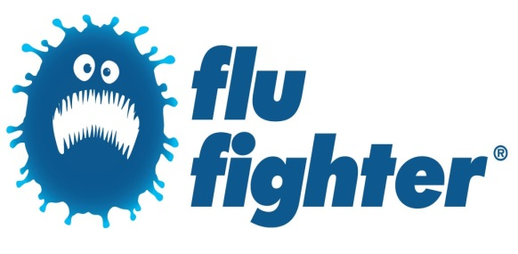

Christmas and New Year’s Day
by Shiraz Bismillah
Flu Jab Table
See where the renal unit stands on the flu jab table at Bradford teaching hospitals foundation trust!
.
Page 2
Origami expert
See how one of our dialysis patients is using his time whilst he is on dialysis!!
Page 3
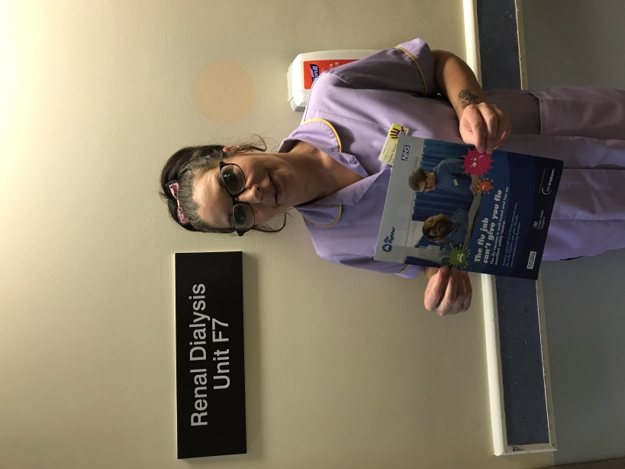
Hayley is top of the shops
In flu jab prize draw

October’s winner of a Marks and Spencer £25 voucher is healthcare assistant Hayley Wright, who works as a Healthcare Assistant on wards F7 and F8 – our Renal Unit – at St Luke’s Hospital.
After getting the jab, she said:
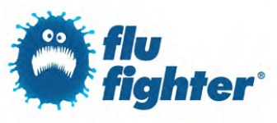
“Getting the flu jab is important to me because by having it you are reducing the risk of not only getting flu but passing it on to patients and colleagues.
“In my line of work it is very important because I come into contact with a lot of vulnerable patients every day.”
Ward 33 and Ward F8 top new flu jab table with 100% success

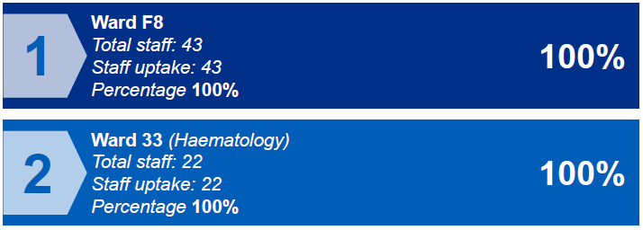
I’M delighted to announce that a fantastic 3,222 of us, including 3,025 frontline staff, have now had our flu jabs this winter.
These figures include two wards where 100 per cent of staff have been vaccinated!
Congratulations to Ward F8 at St Luke’s and Ward 33 (Haematology) at BRI for ensuring every single staff member is protected.
As you all know, it’s important that as many of us as possible have the jab as it helps protect patients and colleagues from the virus, which can cause severe illness.

Will you help young kidney patients say "I can"?

There are over 3,500 children and young adults living with kidney disease in the UK. Kidney disease is tough for every patient, but for young people it can be particularly challenging. Children are robbed of their childhood and young adults become isolated when all they want is to feel normal and fit in with their peers. Time lost through dialysis or treatment means school is often disrupted and restricted diets and fluid intake makes it hard to fit in with the social activities of peers.
The activity breaks funded by Kidney Care UK offer some much needed respite from the day to day challenges of living with kidney disease.
The young people arrive on Friday afternoon feeling isolated, overwhelmed by their condition and not knowing where to turn. They leave on Monday morning with a renewed sense of purpose, feeling more in control of their lives and saying “I can” do anything if I put my mind to it.
During the weekend they can take part in numerous challenging outdoor activities such as kayaking, archery, abseiling and raft building which helps them develop new skills and build confidence. Informal workshops provide useful support and information on topics such as diet and exercise, medication and treatment enabling patients to feel more in control of their illness. And, plenty of free time is built in to the programmes to encourage social interaction and sharing of experiences which helps them build solid peer to peer relationships and support.

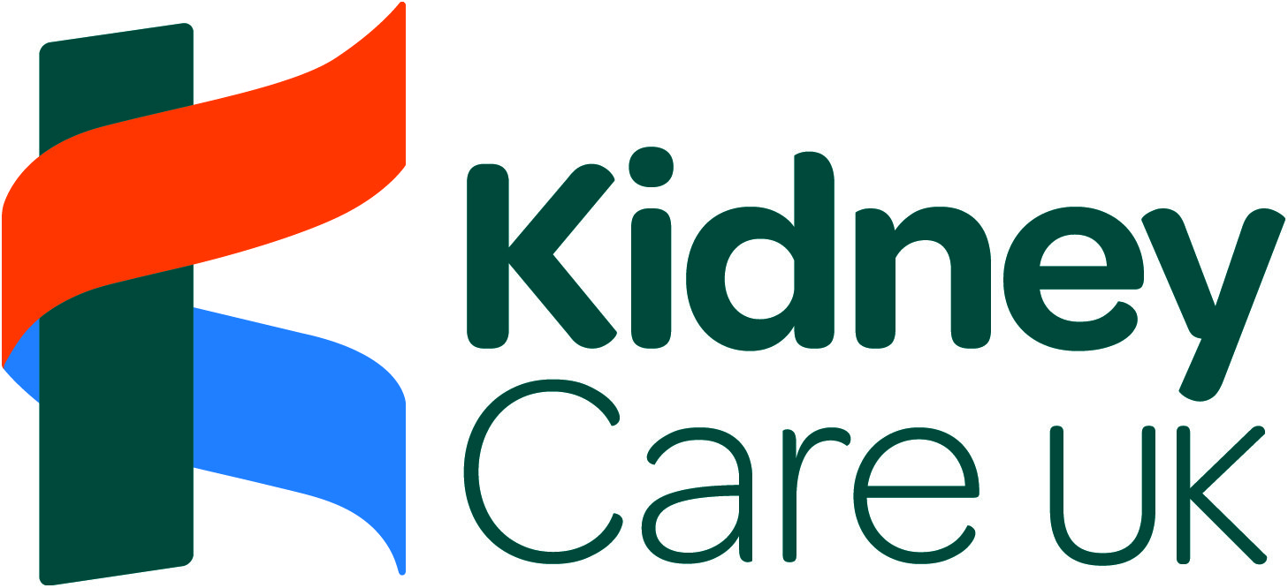

Please check out the link for the event that took place in October 2018. https://www.kidneycareuk.org/get-involved/big-give/
Two of our young renal patients attended and are featured in the video link. They told me that they had a great time and met new people and have kept in touch with some of them.
If you think any of our young renal patients aged between 18-30 would be interested in the activity weekends which run every year, please let me know and I can forward them details of the same when it is next advertised.
Our Culture and Health Improvement Officer liaises with Kidney Care UK and the young adult workers at other Trust’s, to arrange registration etc. for our patients who are interested in attending.
Please donate online. Your gift will go towards the activity breaks funded by Kidney Care UK each year and you’ll be helping even more young kidney patients say “I can”.

For More Information
For more information you can speak with Tahira Mir

Aaqif Khan, becomes origami expert

Aaqif Khan, 23, now sells some of the stunning paper creations he makes while receiving kidney dialysis three times a week at St Luke’s Hospital’s Renal Dialysis Unit.
The former Shipley College student has spent a significant amount of time in hospital throughout his young life while battling the rare congenital nephrotic syndrome, which often leads to acute kidney failure.
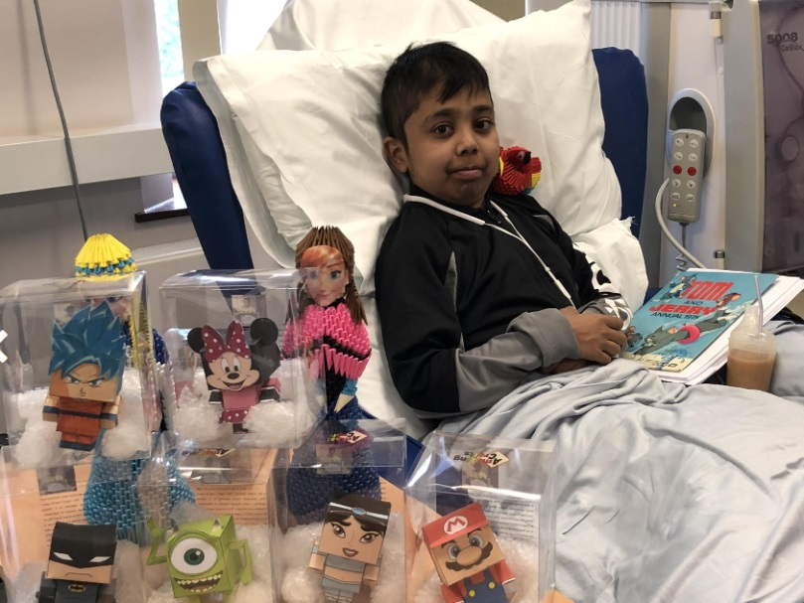
But he has found comfort, a hobby and now a fledgling business in the ancient Japanese art of paper folding.
He said: “I had my first kidney transplant aged four in Leeds, which failed, and then a second aged eight, from my Dad, which was successful. It lasted for 15 years but then started to fail in March this year. I came back into hospital to have an AV graft fitted and have been having dialysis again since April. This summer, I also went back on the kidney transplant register.”
Aaqif, of Undercliffe, Bradford, first learnt the art of origami aged eight while recovering from his second kidney transplant. He has since gone on to master the complex skill of 3D origami, which sees practitioners use hundreds of sheets of paper to create striking sculptures without using a single drop of glue.
This branch of origami is made using multiple triangular units which are connected together to form a single design. Each triangle is made from a rectangular sheet of paper, and multiple colours and patterns are used to create more life-like models.
Aaqif has become so adept at the ancient art form that he has also set up his own business selling the models.

Paper parrots, frogs and penguins have all recently emerged from his fingertips, as well as models of fictional Hollywood heroes and heroines. But his main aim is to find a new kidney and then pass on his folding skills to children from throughout the district.
“If anyone out there is willing to donate a kidney, we all really need one,” he added. “If you get a kidney you can do so much more with your life. It’s not ideal if you are stuck to a dialysis machine three times a week as after you’ve been to dialysis most of your day is gone.
“But what I really want to do is teach young people and people in similar situations to me how to do origami. I’d love to teach children from youth centres and after-school clubs."
Aaqif often practises his skills while receiving dialysis three times a week at the dialysis unit, and recently presented ward clerk Maureen Cain with a giant swan to say thank you for her support.
She said: “I was absolutely blown away by it. I couldn’t believe how clever it was. He is very talented and we are so proud of him."
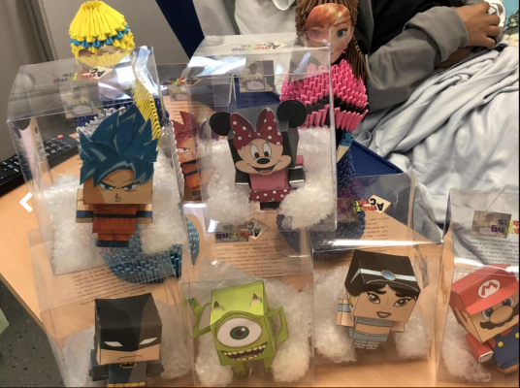
Across the UK, more than 1,000 people each year donate a kidney or part of their liver while they are still alive to a relative, friend or someone they do not know. A healthy person can lead a normal life with only one functioning kidney and may donate the other to help someone in need of a kidney transplant. Part of a liver can also be transplanted from a living donor to help someone in need of a transplant.
For more information, visit www.organdonation.nhs.uk/about-donation/living-donation or www.giveakidney.org
WIFI at SLH

The Wi-Fi network has now been changed at St Luke’s hospital. It is no longer Wi-Fi spark.
In order to use the new Wi-Fi, please find in your Wi-Fi settings the name of the new Wi-Fi “NHS Wi-Fi”
A new window will pop up which will ask the user to sign in. please select this button and read the terms and conditions. Select “agree” to agree with the terms and conditions and you will be able to access the hospital wifi.
Please note that this process only needs to be done once. Your device will automatically connect to the NHS Wi-Fi hereafter.

Renal Tweets!

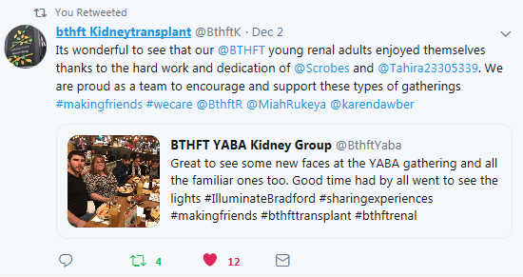

@BTHFTR
@BTHFTK

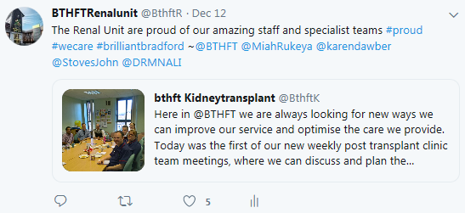

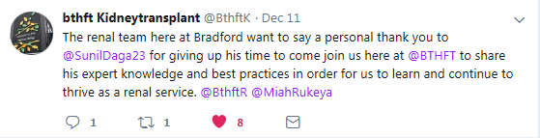

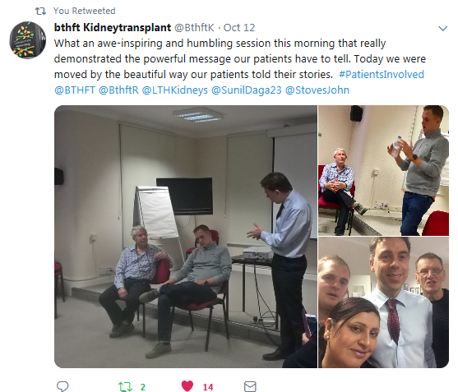
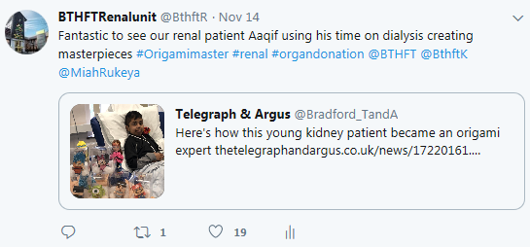

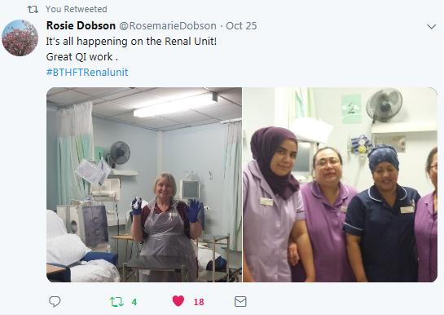

Wishing all a Merry Christmas and a happy new year from all the renal TEAM!

