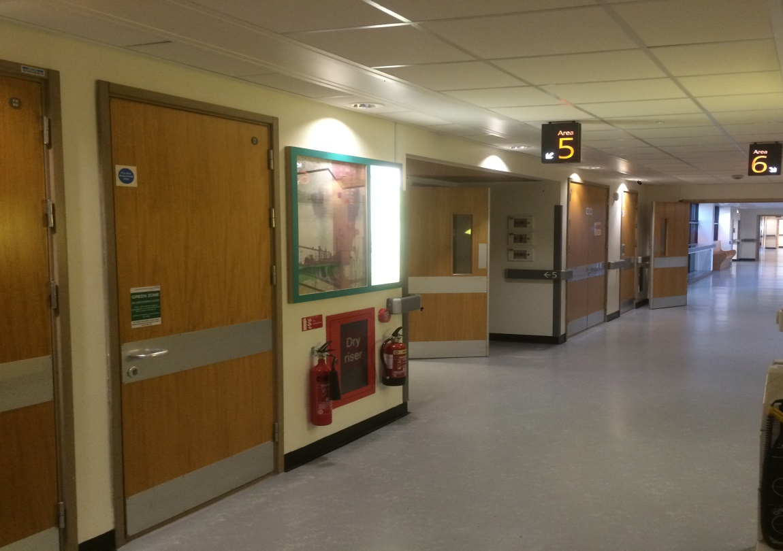  The Renal Newsletter |  | The Renal Unit Newsletter  AUGUST 2018  - Issue Date
Working together for patients |  | In This Issue

The Principal Investigator Dr Habib Akbani and Research nurses Jodi and Diane, would like to thank all the patients that took part in the PIVOTAL study, the largest clinical trial that has ever been conducted in renal units in the UK. Without the support of patients valuable clinical trials like this could not take place. Clearly, the results of the trial will have widespread impact, and will likely influence iron management in dialysis patients around the world.

Thanks also needs to go to the nurses on the dialysis unit who administered the patients iron doses, without this support this study could not have taken place. The results of the study will be shared with all once available.

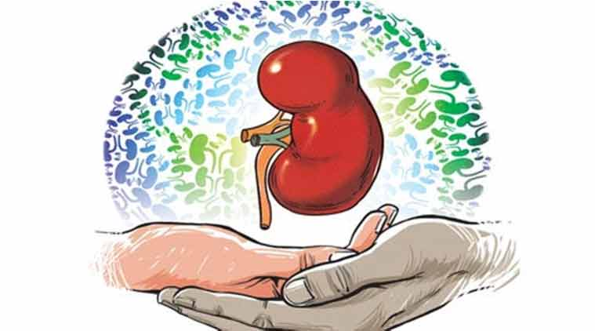

PIVOTAL – Renal Research
by The Renal Research Sisters
Kidney transplant forum
The transplant team held an excellent forum which was all about post-transplant advice and what dietary measures to take on holiday, find out more.
Page 2

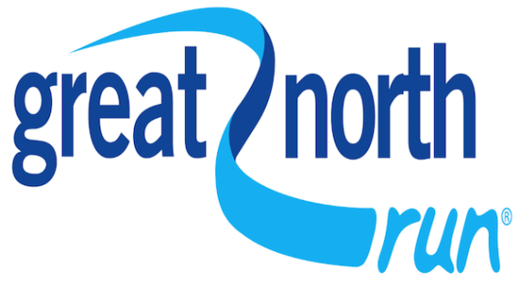

Garrie Wilder
See what our transplant patient Garrie is doing to raise awareness of kidney disease and the need for organ donors.
Page 5
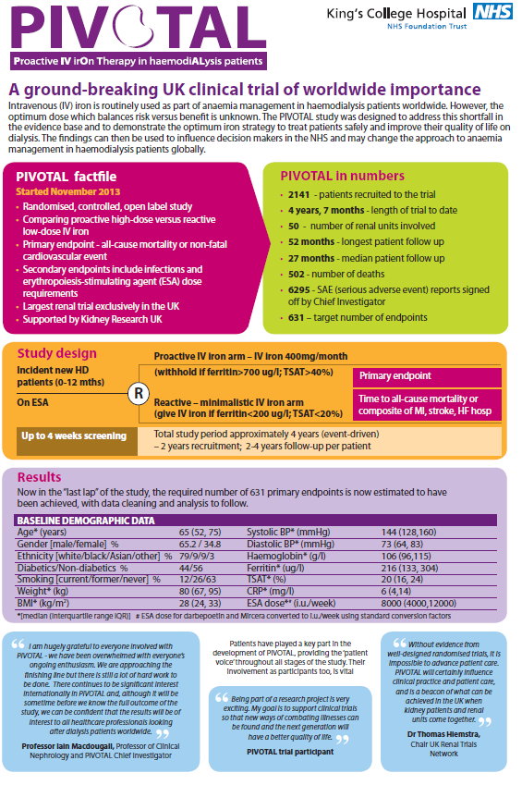

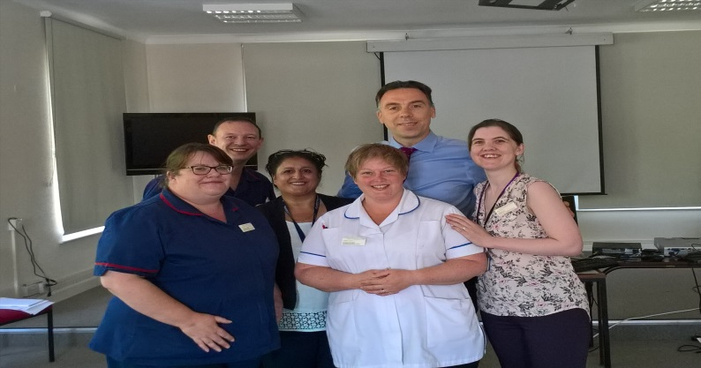

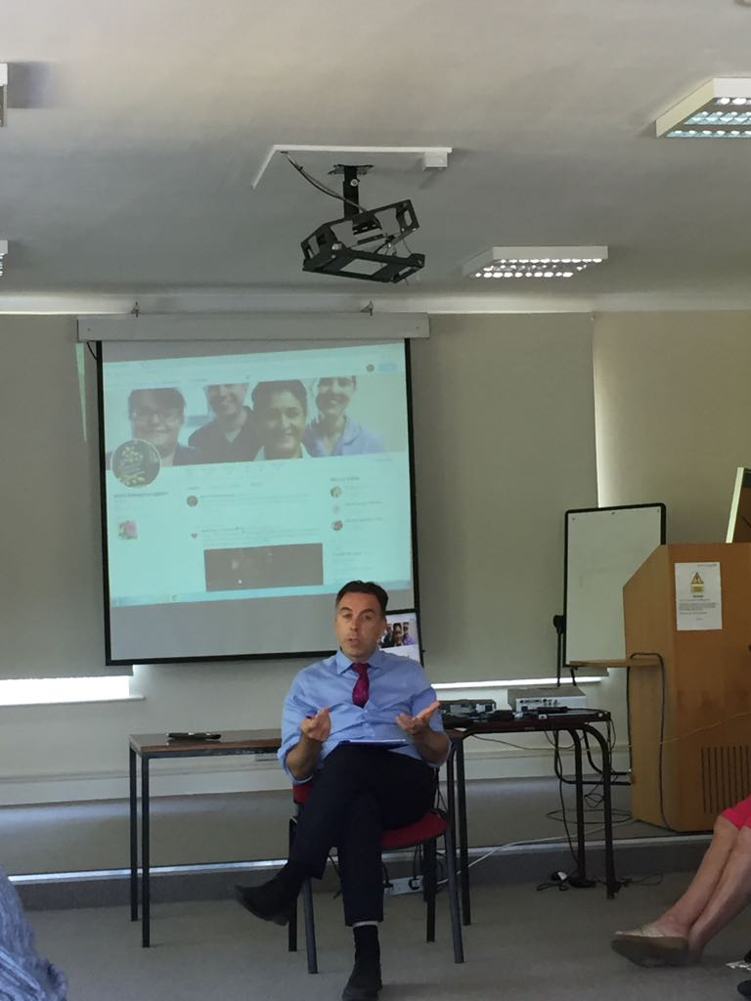

Kidney Transplant Forum
by The transplant team

I am delighted to report that a
forum set up recently to improve
the service we offer to renal
transplant patients in Bradford is
proving incredibly popular.
From the first gathering of the
Bradford Kidney Transplant
Patients’ Forum last December,
numbers at the third meeting which
took place earlier this month have
grown to nearly 30-strong … and
are continuing to rise thanks to
demand from our patients.
Transplant Nurse Vickie Lai helps
organise the forum at St Luke’s
Hospital.
She told me: “We look after more
than 400 transplant patients here
in Bradford and our numbers are
increasing, so we are always
looking at new ways of how we
can improve our service.
“Some of our patients are 20 years
post-transplant and advice about
lifestyle and medications have
changed in the intervening years.
So the forum is a great way to
update their knowledge and help
them keep fit and healthy for many
years to come.
“The engagement from our
patients is fantastic. They help
set up the meetings and drive
the topics discussed. It’s also a
great arena for them to forge new
friendships and, in turn, support
each other.”
At the latest forum, patients
asked for an update on diet related
post-transplant advice
and what dietary measures they
need to take when on holiday
abroad. Vickie added: “Transplant patients are immunosuppressed so they
need to be careful about what
they eat and drink in order to keep
themselves safe.”
Dr Stoves said: “I am very proud
that we are doing something
positive that evidently gives
patients and their families so much
satisfaction.”
It’s clear to see this patients’ forum
is providing new ways to cater for
our patients’ needs outside the
clinical setting.
It not only keeps our patients
well informed, but happy and
healthy too, as well as providing
opportunities for them to support
each other.
Our Senior Renal Dietitian,
Angela Knight, spent time going
through the latest dietary advice
and busted some myths.
Renal Consultant and Clinical
Lead Dr John Stoves, who was
involved in setting up the forum,
gave an interactive talk on antirejection
and other medications
which are commonly prescribed for
patients, before opening the floor
for questions.

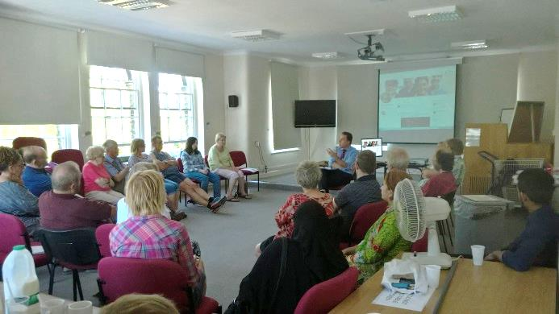

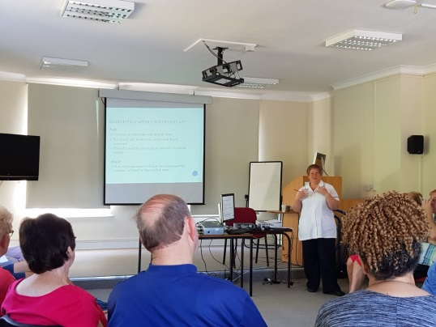

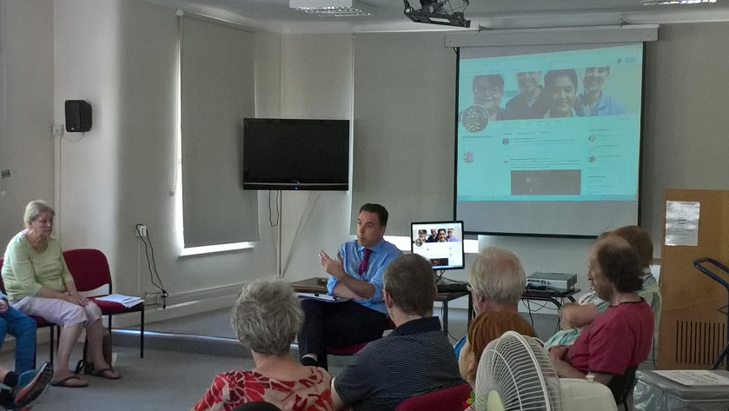

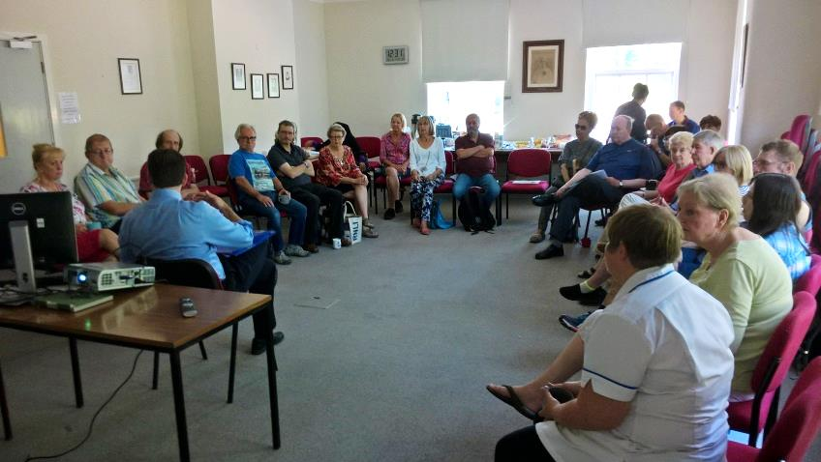

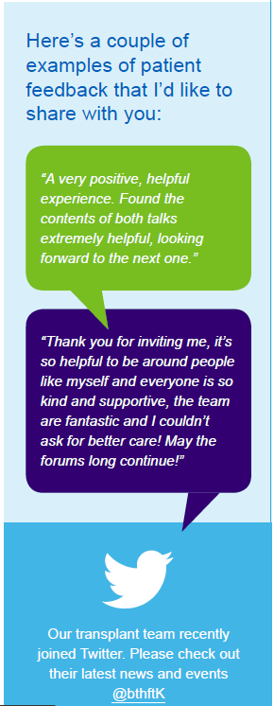

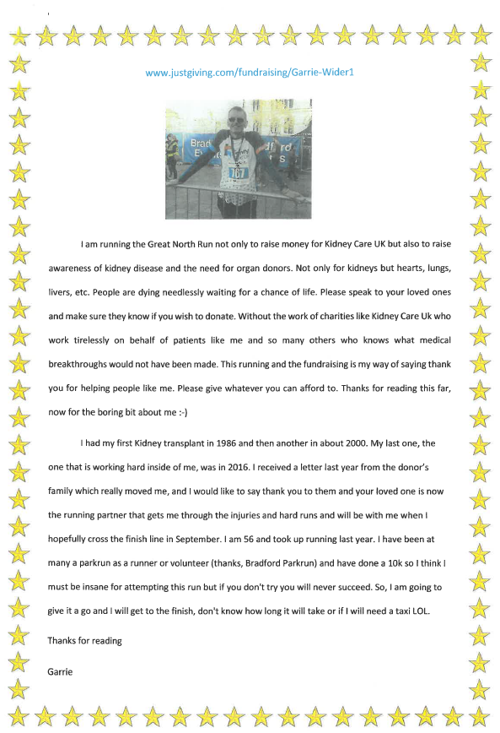

YABA – Young Adults Bradford and Airedale
by The Transplant Team

YABA is our very own Young Adult Kidney Group. Creating opportunities to meet and have fun with other young people in the Bradford and Airedale area, with kidney problems. This group gives young adults <30 years old to meet and socialise with each other and meeting new people.
The YABA group have held many successful meetings doing various fun activities like bowling going out to Nandos and gives our young adults the chance to socialise and have fun
We have a Twitter page …..

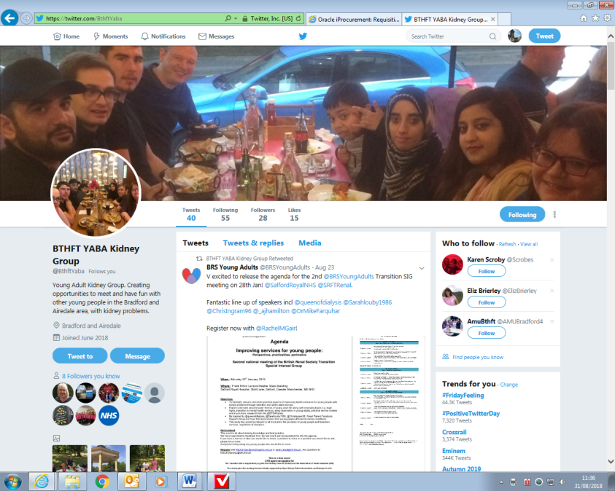
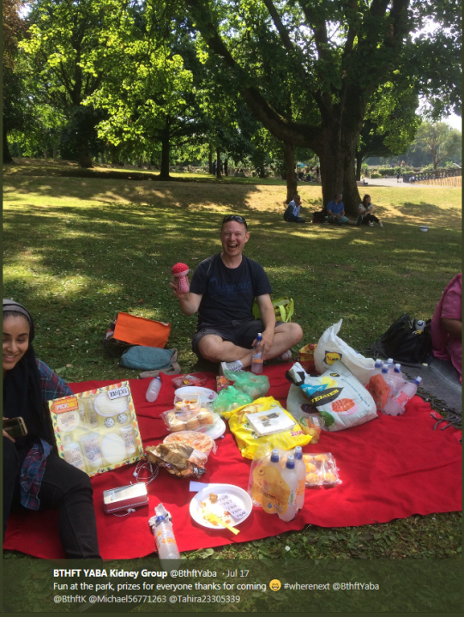

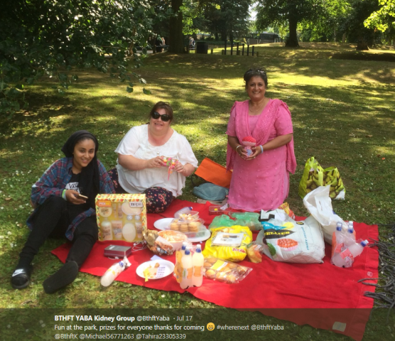

For More Information
If anyone is interested in joining the next meeting or wants more information please see Karen Scroby

