|  |  |  |  |  |
| --- | --- | --- | --- | --- |
| **The Renal Newsletter** |  | |  | | --- | | The Renal Unit Newsletter  APRIL 2018 | | Issue Date | |
|  |  |  |
| [Image result for farewell](https://www.google.com/url?sa=i&rct=j&q=&esrc=s&source=images&cd=&cad=rja&uact=8&ved=2ahUKEwj_nKG5ptXaAhWCPRQKHZcXCBoQjRx6BAgAEAU&url=https://www.iaspaper.net/thank-you-speech-farewell/&psig=AOvVaw1hExJh7hFJv2sAMYqNJJDX&ust=1524741382646634)Working together for patients |  | In This Issue |

It is with great sadness that 2 of our wonderful colleagues will be leaving the Bradford renal unit.

Sara our renal support worker who has been with the unit for 11 years and Zoe our staff nurse who has been on the unit for almost 18 years.

Zoe started on the renal unit as soon as she qualified as a staff nurse and has been here ever since.

Speaking with Zoe she had said:

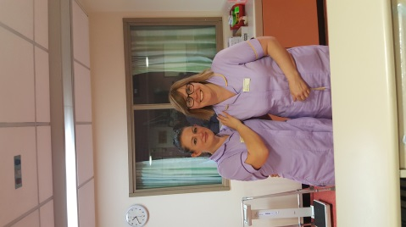“Working within the unit has been a joy; this has practically been my life because of how long I’ve been here.

It has been wonderful working with the staff and getting to know all the patients, they feel like family because of how often you see everyone and I will surely miss everyone on the unit.”

Zoe is going to work at our satellite unit in Skipton. Zoe wanted a new challenge and a change of atmosphere.

Sara has been working in our unit for over 11 years as a renal support worker.

Sara has said:

“While I’m excited about the new opportunity, there’s also a big part of me that’s sad to be saying goodbye to amazing co-workers and all of the patients. I can’t tell you how much I’ve enjoyed my time working with everyone on the ward, and I wish everyone the best.”

Sara is going to work in a private hospital helping patients with mental illnesses.

Everyone on the renal unit wishes you the best in this next phase of your career. Congratulations and best of luck!



# Farewell Sara and Zoe

by The Renal Unit

Mental health and wellbeing forum

The second gathering of the newly formed Bradford and Airedale Kidney Transplant Patients’ forum has taken place, find out how it went.

Page 2

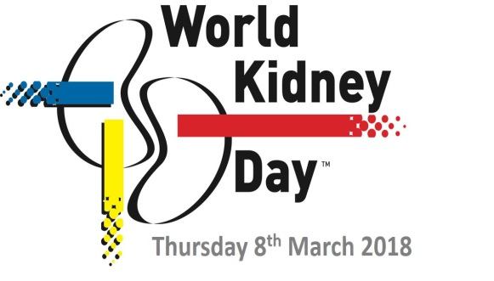

World Kidney Day

World Kidney Day is an annual global awareness and education event. Find out how our renal dietitians got involved on World Kidney day.

Page 5

|  |
| --- |
|  |

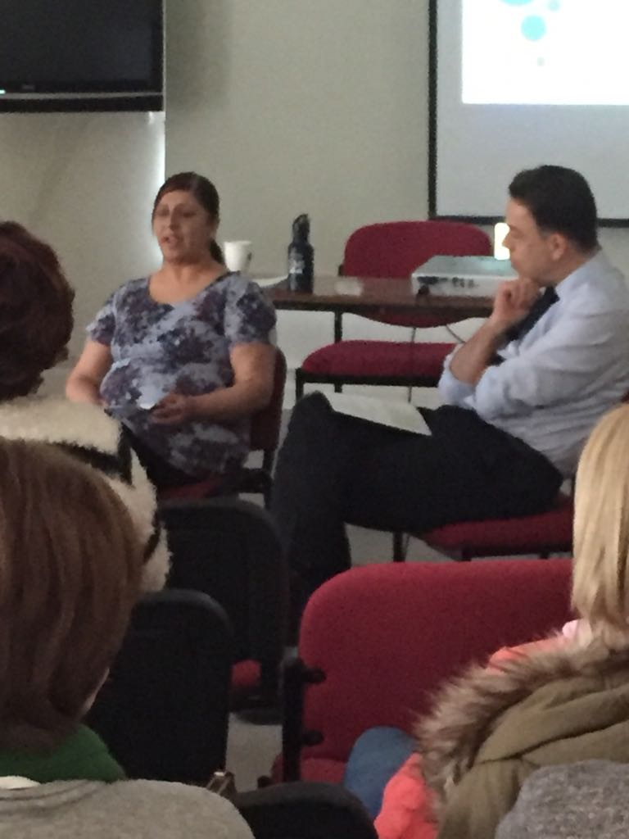

Mental Health and Well-being Forum

by The transplant team

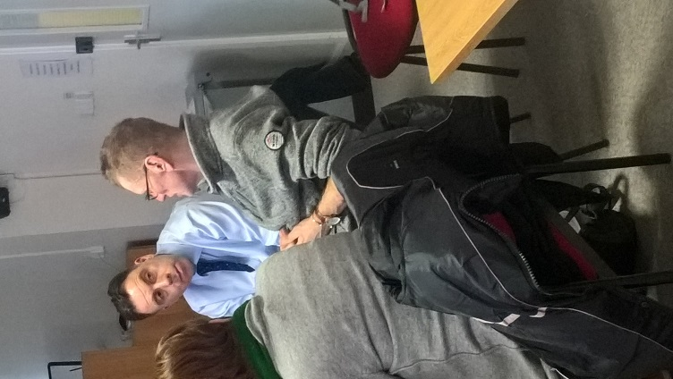

|  |
| --- |
|  |

T

he second gathering of the newly formed Bradford and Airedale Kidney Transplant Patients’ forum has taken place at St Luke’s Hospital. Following the huge success of the first gathering and positive feedback from our first audience we decided to go ahead with arranging this gathering addressing the most requested theme of mental health and Well-being post transplantation.

The Head of the Renal Transplant Patient Forum Consultant Nephrology and Transplant Clinical Lead Dr John Stoves welcomed the attendances to the forum on behalf of the renal transplant team and then introduced Kate Ryder, Clinical Psychologist who kindly agreed to organise and front an informative and supportive programme for this event.

Kate gave a very informal and interactive presentation about emotions and coping with these emotions whilst adjusting to the life changing physical event that has occurred from receiving a kidney transplant. There followed a highly moving account from one of our transplant patients who agreed to be interviewed by Consultant Dr John Stoves about her experience. She was asked three questions. 1 Can you tell us what emotional problems you have faced after having had a transplant? 2. What has helped you to cope? 3. What advice would you give others about how to cope following a transplant?

She gave the audience an insight into the anxiety and worries she experience in her answers; it was clear the constant worrying she had about her transplant; the coping mechanisms she used to help her cope and ended by advising others to try and keep positive and take each day as it comes. The number of positive remarks which were left about how amazing and powerful the patient story was by the forum attendees is testament to the power of patient stories.

Following refreshments Kate Ryder took the room through a breath exercise that can be useful to soothe and relieve anxiety and this was gratefully received from the few comments from the room. The closing reflections involved a poem that I would like to share:

## Let it go (Danna Fowlds)

Let go of the ways you thought life would unfold: the holding of plans or dreams or expecations

Let it all go.

Save your strength to swim with the tide

The choice to fight what is here before you now will only result in struggles, fear, and desperate attempts to flee from the very energy you long for.

Let it all go.

Save your strength to swim with the tide

The choice to fight what is here before you now will only result in struggles, fear, and desperate attempts to flee from the very energy you long for.

Let go

Let it all go and flow with the grace that washes through your days whether you received it gently or with all your quills raised to defend against invaders.

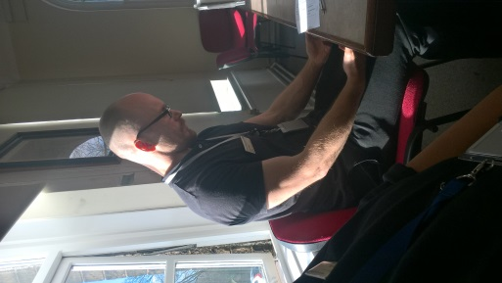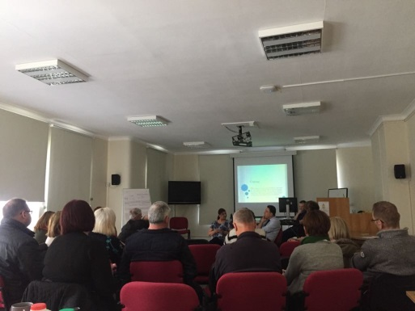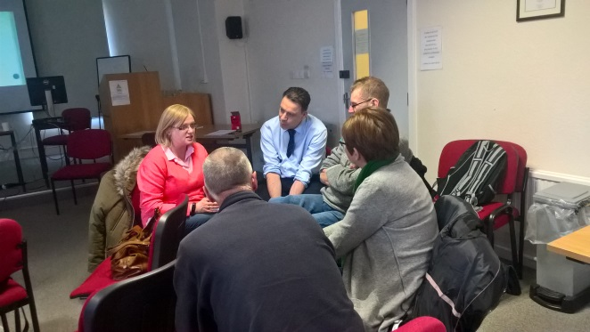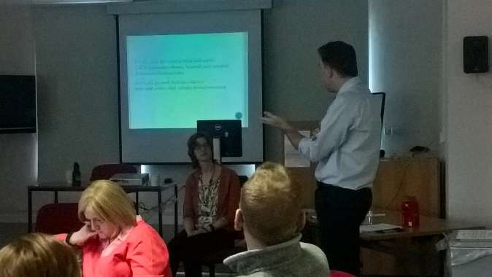Take this on faith; the mind may never find the explanation that it seeks, but you will move forward nonetheless.

Let go, and the wave’s crest will carry you to unknown shores, beyond your wildest dreams or destinations. Let it all go and find the place of rest and peace, and certain transformation

|  |
| --- |
| For More Information |
| For further information please speak to our transplant team. |

There’s no law against my listening to this thrush behind the barn, The song so loud it echoes like a bell, Then it’s further off beyond the lawn,

Whatever else there is, there’s this as well.

The forum feedback was full of positive comments so that include:

*“A very positive, helpful experience found the mindfulness extremely helpful”*

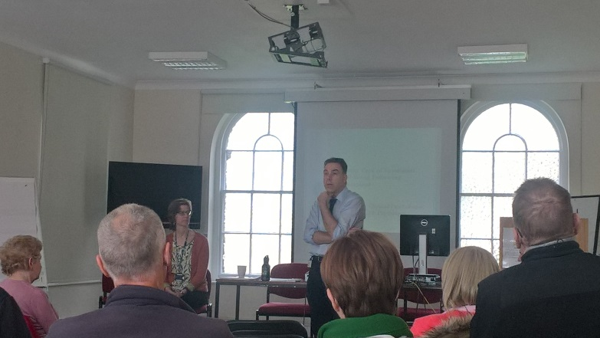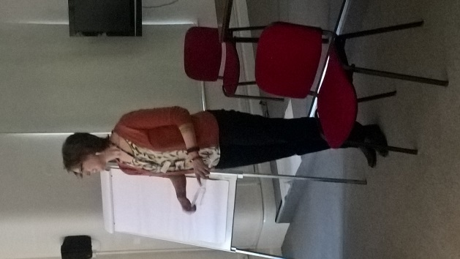*“Thank you for inviting me”*

*“Good forum and should be held more often”*

Everyone was so supportive and the forum was a great idea, will definitely attend again.

[](https://www.google.co.uk/url?sa=i&rct=j&q=&esrc=s&source=images&cd=&cad=rja&uact=8&ved=2ahUKEwjrp42U3sXZAhWfOsAKHZusB1AQjRx6BAgAEAY&url=https://blog.rendia.com/culture/&psig=AOvVaw02eZQPppLDuS2iXyT4wEsy&ust=1519808523894955)

Here are some of the things our Cultural and Health Improvement Officer continues to do for our renal patients

B

elow are some of the patients comments received by our Cultural and Health Improvement Officer, Tahira Mir, in relation to her role. Tahira continues to take care of the patients’ needs and ensures they are happy with their care.

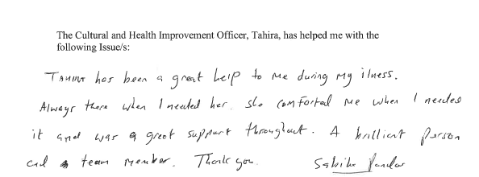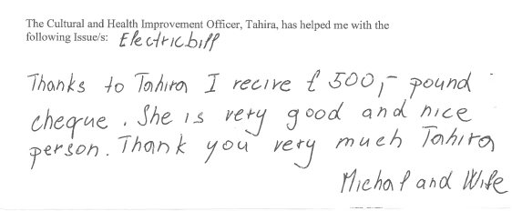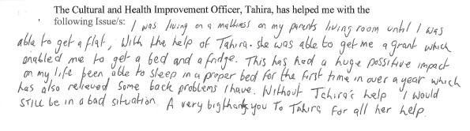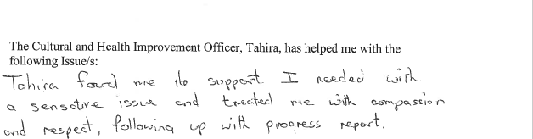

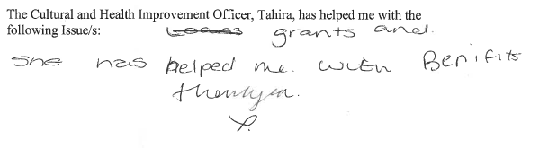

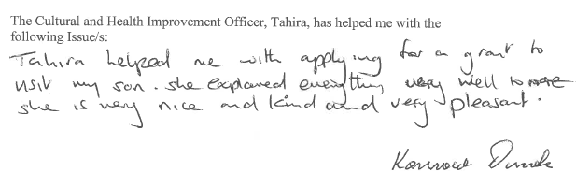

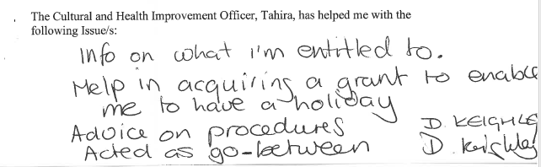

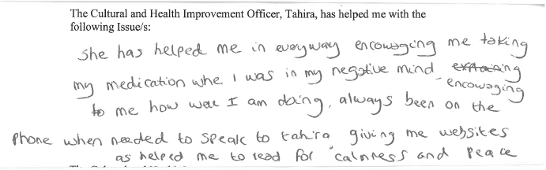

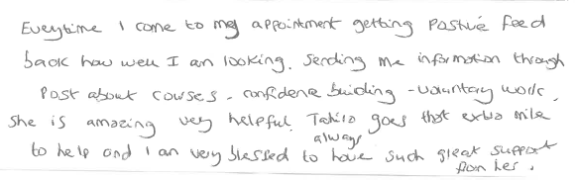

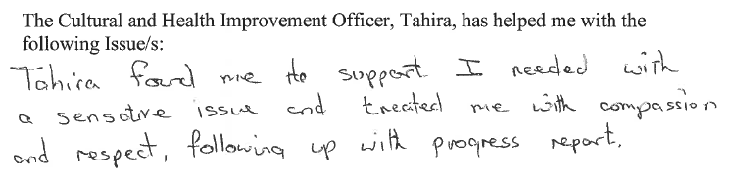

Renal dietitians show support for World Kidney Day!

by The Weigh Management Service

W

orld Kidney Day is an annual global awareness and education event, held on the second Thursday in March every year. The purpose of the Day is to draw public attention to the importance of maintaining a healthy lifestyle to help protect the kidneys and reduce the risks of developing kidney disease. This year, World Kidney Day and International Women’s Day were on the same day, so specific focus was placed on the importance of women’s kidney health.

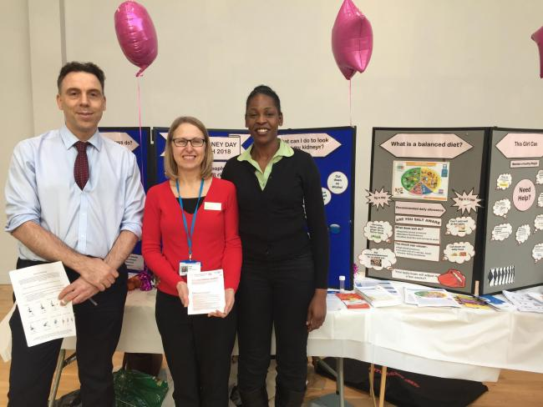 In the UK, chronic kidney disease is more common in women than in men, especially in older women, however, fewer women go on to need dialysis or a kidney transplant, therefore ensuring a timely diagnosis is important – helping women to access therapies that may help slow progression of their kidney disease. There is also a big push for better planning and close monitoring throughout pregnancy for women with kidney disease to help improve outcomes.

|  |
| --- |
| For More Information |
| For further information or to make an appointment please contact the dietetic department on 01274 365628 (8.30am-4.30pm) Answerphone available out of hours |

To help draw public attention to the importance of maintaining a healthy lifestyle our renal dietitians, along with support from public health team set up a stall in The Broadway shopping centre, Bradford. Unfortunately the event coincided with the snowfall, but that didn’t deter our renal dietitians from showing their support. Renal Dietitian Susan Dunn said: “Due to the difficult weather conditions we were a little bit later than planned in setting up the stall and we only had a few staff available. However, footfall was good in the afternoon and the team spoke to lots of people about how to look after their kidneys with particular emphasis on healthy eating, weight management, low salt diets, and avoiding diabetes. We were able to signpost people to our weight management and diabetes services at St Luke’s Hospital. Several people who had pre-diabetes came to talk to us and we were able to talk through some of the changes they had already put in place, as well as direct them to other services in the area such as BEEP (Bradford Encouraging Exercise in People) referral scheme.”

Dr John Stoves, renal consultant, and renal dietitians Susan Dunn and Jacqui Blackwood.

Also in attendance was our Staff Gym Instructor, Daniel Lane, who had put together some fantastic resources on exercises that people could do at home. See below for his exercises for the less mobile/ older adults. If you would like more information on any of the above services or would like to speak with a renal dietitian please ring the renal dietetic team on their helpline:01274 365 628 .

Clinical Lead for Renal Services, Dr John Stoves added: “Kidney disease is often a silent condition so this is an opportunity for us to raise awareness and explain how it may be prevented and treated. This year our focus is on promoting the health of women with chronic kidney disease (CKD). We have been working closely with our obstetric colleagues to improve the support we provide for women with CKD who are contemplating pregnancy or become pregnant. We have liaised with Consultant Obstetrician, Dr Nada Sabir and her colleagues to advertise the pre-pregnancy counselling clinic in Bradford, and introduced more opportunities for patients to receive multidisciplinary assessments throughout their pregnancy.”

## Exercise For Older Adults

As you get older it is very important to remain active as the health benefits are endless. Maintaining aerobic endurance, strength and balance is important to ensure you can live a health and independent lifestyle. Being active can also reduce the risk of heart attacks, high blood pressure and obesity. The exercises shown below are designed to keep you active and mobile.

Before undertaking any new exercise routine please seek advice from your GP.

Please follow the instructions to ensure you complete the exercises safely and effectively.

* Find yourself a stable seat with a supported back rest such as a dining room chair
* Start sat upright with good posture
* Aim to complete each exercise for a total of 20 repetitions each exercise
* After all exercises are complete rest for 1-2 minutes
* Repeat this routine for 2-3 rounds

Exercise 1 Exercise 2 Exercise 3 – 10 per leg Exercise 4

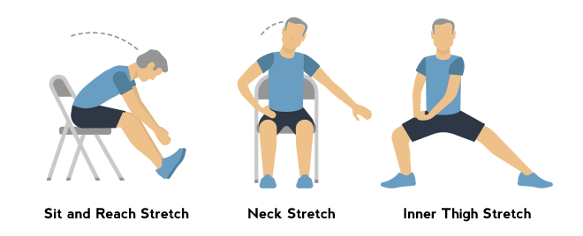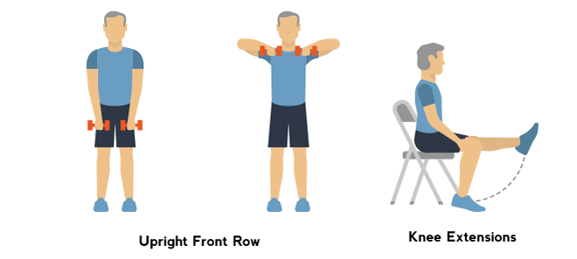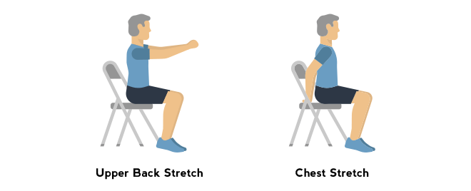

Exercise 5 – 10 per leg Exercise 6 Exercise 7 – 10 per side Exercise 8 – 10 per side

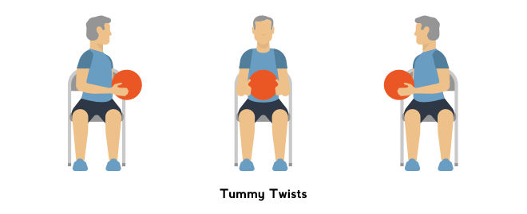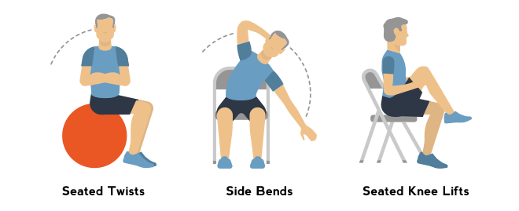

The exercises above will benefit a number of fitness components which include strength and flexibility. On the next page you’ll find a number of other exercises which will challenge you in a safe way to help you to increase your activity level further.

Exercise list

The following exercise will be slightly more challenging but performing them safely will help to further increase your strength, stability, core strength and aerobic endurance.

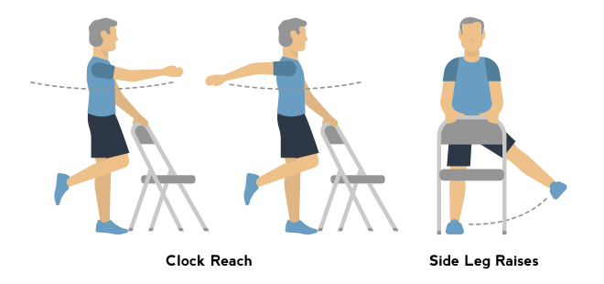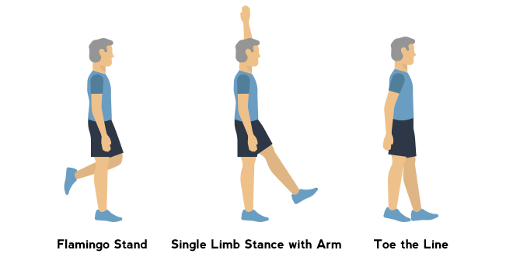

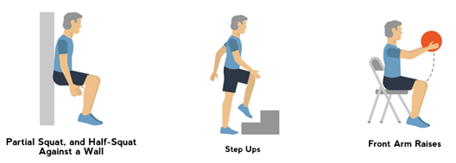

Other low impact exercises are really good to focus on aerobic and muscular endurance. This could include activities such as brisk walking, swimming and water aerobics.

