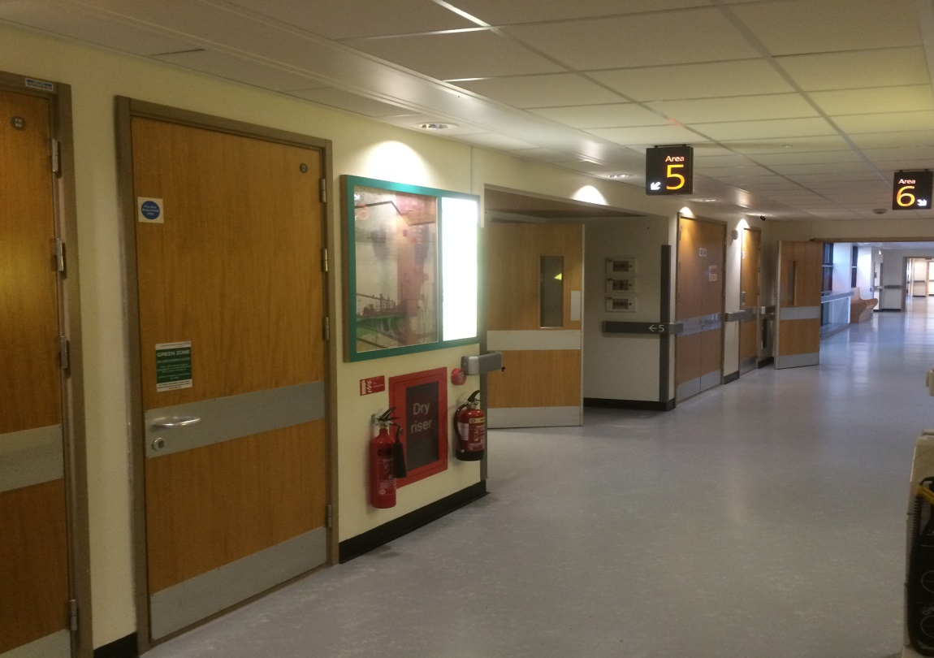  The Renal Newsletter |  | The Renal Unit Newsletter  DECEMBER 2017  - Issue Date
Working together for patients |  | In This Issue

Christmas has come to town again, the festive lights are on, the high-street is bustling and Santa’s are appearing in shop front windows. That means the usual schedule of dragging a fir tree into our homes, decorating it in lights and colorful tinsel, and gorging ourselves on as much food and drink until we can no longer stand and who doesn’t dream of a white Christmas? Building snowmen and making snow angels, what could be better than that!

Dialysis on Christmas day and New Year’s Day
As you may be aware Christmas and New Year’s Day falls on a Monday so what does this mean for patients that dialyse on Mondays? So the Nurses and Doctors can also enjoy their holidays with family and friends, the unit will be closing on Monday 25th December and 1st January 2018. Don’t worry we have not forgotten about you guys. To accommodate the closure patients who would usually dialyse on a Monday will instead dialyse on Sunday 24th December 2017 and Sunday the 31st December 2017. These changes will not affect patients that dialyse on a Tuesday, Thursday and Saturday.
The drivers have been made aware of these changes

More Information?
If you require more information regarding these changes please speak to the nurses in your room or Gary.
Any patient wishing to change their dialysis shifts in this period should also see Gary or the nurses.
Every effort will be made to accommodate your request but please bear in mind that we are currently using all our dialysis slots and may not be able to provide a change of shift.

Christmas and New Year’s Day
by Shiraz Bismillah
Dialysis Away From Base
With over 100 dialysis centres in over 30 countries around the world we have a destination to suit everyone, we’re sure you’ll be able to find your perfect holiday.
Page 2
Bradford and Airedale Kidney Transplant Patients Forum
The first gathering of the newly formed Bradford and Airedale Kidney Transplant Patients Forum took place at St Luke's Hospital last month (November 2017).
Page 4

Heading 4

Dialysis Away From Base
by Shiraz Bismillah
Freedom
Freedom the Dialysis Holiday Specialists are the UK’s first and only travel company that specialises in arranging holiday dialysis for kidney patients
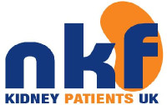
Travel Insurance
It is important that you don’t book your holiday until you have taken out holiday insurance which covers you for a ‘pre-existing medical condition’. For more information visit

For More Information
If you would like more information on dialysis away from base, please speak to the renal administrator, Shiraz Bismillah. He, with your assistance, will identify a suitable local dialysis centre and help you with booking dialysis away from base.

Many of us will remember the classic moment in the film ‘Home Alone’, when Kevin’s mother realises that, in all the hustle and bustle of going on holiday, she’s forgotten her eight-year-old son.
While this may seem a little far-fetched, if you aren’t prepared, pre-holiday stress can make you forget even the most obvious and important things.

What do I need to think about before I go away?
If you are planning a holiday or travelling for work or pleasure, the first thing to do is speak to your renal team so that they can help plan your treatment while you are away. Try to give them as much notice as possible - ideally at least 4 weeks for travel within the UK and 3 months for foreign travel. Dialysis units near to popular holiday resorts can get busy in the peak season so the more notice you can give the better.

What about travel insurance?
Travel insurance is vital. Most standard policies do not cover chronic kidney disease and it is likely that your insurance costs will be higher than someone who does not have a long-term health condition. You may need a confirmation letter from your renal team that you are well enough to travel.

What about travel within the UK?
Haemodialysis patients can dialyse at most units within the UK you should be able to book accommodation at locations near to these. Kidney Care UK’s Dialysis Freedom scheme provides access to dialysis away from home via the UK Dialysis Swap Scheme. The idea is to use the space created when patients go abroad, along with any existing holiday dialysis places. If you would like to book a UK holiday and are looking for assistance in finding a dialysis slot at a nearby hospital go to www.dialysisfreedom.co.uk/

Are there any risks to travelling abroad while on dialysis?
There is a risk of acquiring blood-borne viruses such as Hepatitis B, Hepatitis C and, to a lesser extent, HIV whilst travelling abroad. The Department of Health suggests that the risk is low in:
- Northern Europe
- The United States
- Canada
- Australia
- New Zealand
- Japan
Your renal team can check your Hepatitis B immunity and arrange a vaccination if needed before you travel. Risks do not mean you cannot go to these places but you will need to find out what changes may need to be made to your dialysis on your return home. For example, you may have to temporarily receive your haemodialysis in isolation or have a change of slot to be dialysed at the end of the day, as the renal team carries out blood tests any infections. This is particularly important if you are on the kidney transplant list.

Can I travel abroad if I am on the transplant list?
You will need to let the transplant coordinator at your unit know that you are going abroad so that they can temporarily remove you from the list until you return. You will not lose any time points whilst you are off the list. If you travel to the Indian subcontinent or Africa you will remain suspended for eight weeks after you have returned until negative virology tests have been confirmed. For all other parts of the world, unless other factors put you at risk, you will usually be reactivated on the kidney transplant waiting list as soon as your virology tests are found to be negative.
The European Health Insurance Card (EHIC) allows you to access state-provided healthcare in all European Economic Area (EEA) countries.

European Health Insurance Card (EHIC)
You can apply for a free EHIC online at www.ehic.org.uk or by phoning the automated service on 0300 330 1350. Please note that the EHIC is not an alternative to travel insurance. We advise you to discuss your insurance requirements with your insurance company and ensure your policy covers pre-existing conditions.
Please ensure when arranging dialysis abroad that the unit you choose will accept the EHIC to cover the full cost of your dialysis treatment. You will have to meet any extra costs, such as administration, yourself. Some countries, such as France and Switzerland, ask for a contribution towards the costs of your dialysis. This is often referred to as a co-payment. Please always check whether a co-payment is required as you will have to pay this cost yourself.

For More Information
For more information on dialysis away from base please speak to the renal administrator Shiraz Bismillah.

Young Adult Activity Weekend
by Tahira Mir
5 of our young adult patients enjoyed an action packed weekend at Ilam Hall Youth Hostel. This national event was organised by Kidney Care UK
There were a range of activities that were on offer including walking, arts and crafts, orienteering, rock climbing, bush craft, team challenges, karaoke, music and many more fun activates and socializing.

For More Information
For more information on days out like this speak with Tahira and the team

Our cultural and health improvement officer Tahira Mir and the transplant team promoted the event by distributing leaflets to patients during clinic visits and other encounters. Tahira also helped with event registration and arranging travel.
If you would like to know more about the trips and other fun days, Tahira and the team will advertise similar events in the future through our Newsletter.

The first gathering of the newly formed Bradford and Airedale Kidney Transplant Patients Forum took place at St Luke's Hospital last month (November 2017). The renal service now looks after nearly 400 transplant patients in Bradford and Airedale, and as part of our efforts to increase Public and Patient Involvement (PPI) in the transplant service we recently took soundings from patients and their relatives about setting up a regular forum for education, sharing of experiences and making of new friendships. The feedback was very encouraging and we therefore decided to go ahead with arranging an initial gathering to address some of the key themes identified by our patients.

A New Forum for Kidney Transplant Patients in Bradford and Airedale
by The Transplant Team
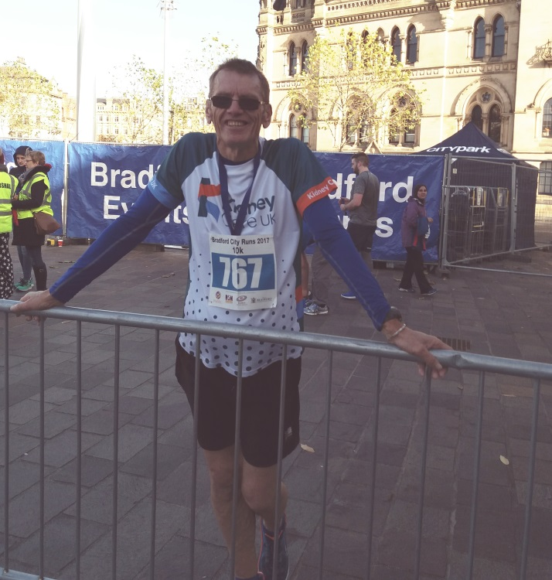
A welcoming speech was made Dr John Stoves on behalf of the renal transplant multidisciplinary team. Forum attendees then listened to an excellent presentation from Dr Kate London about various aspects of skin care, from which there followed an informative and entertaining interactive discussion. After a short interval for refreshments and networking, attendees were treated to a highly motivating talk from Garrie Wider, one of our patients who recently decided to engage in regular physical exercise and succeeded in achieving a large reduction in his body weight. Garrie also managed to raise a lot of funds for UK Kidney Care through his participation in this year’s ‘Bradford 10k’ running event. His powerful and engaging messages of health promotion through the combined pursuit of a healthy diet and regular physical exercise were complemented by a parallel commentary from our specialist renal dietician Paul Bailey.
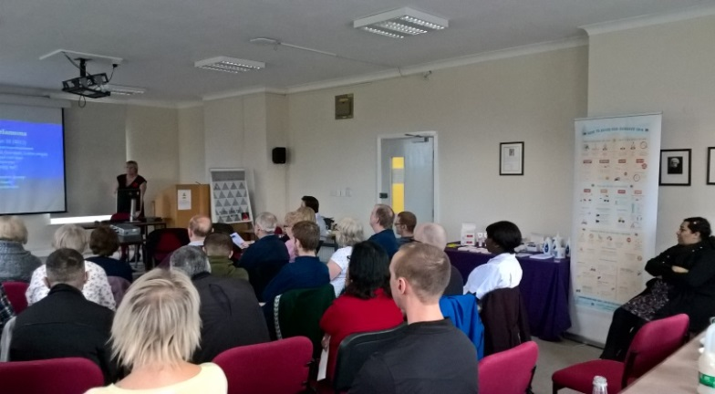
A number of positive remarks were made by the forum attendees, including the following:
“I really enjoyed the event and think that it was a great success. I don't think that it could have gone any better. I learnt a lot from the topics and, as well as that, the atmosphere in the room was really friendly.”
"I found it so helpful to be around people in the same position as myself and everyone was so kind and friendly, I can't wait for the next one"
"Fantastic event, long may it continue"
“It's a great idea and Bradford patients need this”
Transplant Clinical Lead Dr John Stoves commented: The forum has been very warmly welcomed by patients and their families, with very encouraging feedback. I am especially grateful to our transplant nurse Vickie Lai and our first day speakers for their help in organising and delivering a successful inaugural event. We now plan to arrange further meetings every few months, covering other topics such as mental health, travel and medication which have been requested by forum attendees.
Vickie Lai had these positive comments to say to everyone involved:
“I want to say a huge thank you to everyone involved in the setting up and running of this event, I especially want to thank the patients that attended for their contributions throughout the afternoon and all the comments and suggestions; their input was key to our success and we all look forward to future events.“

The Bradford and Airedale Patient Association (BAKPA) is a local independent group set up by patients for patients.
The group which is made up of renal patients and staff aims to be involved in a range of initiatives that offers support to all renal patients.
Despite being in existence for only a few years BAKPA has raised over £5,000 plus with fundraising and the support of the local community.
BAKPA are keen to empower chronic kidney disease patients to manage their condition so they can achieve personal and clinical goals that are important to them
BAKPA aims to support all renal patients and their treatment, improve service delivery, patient care and organise and subsidies social events.

Special Thanks
BAKPA received £710 from Huw and Elaine Reece (Huw is a transplant patient).
The money was collected in lieu of presents when they recently celebrated their Pearl Wedding anniversary
A very big Thank you and Congratulations to both.

Who Is BAKPA?
by Maureen Cain

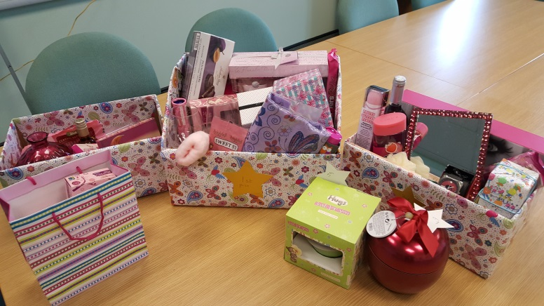

Breast Cancer Care

Pretty in Pink
by Maureen Cain
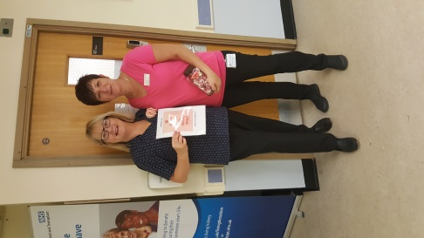
The renal unit held a Pink Day in aid of Breast Cancer Care. Patients and staff managed to raise a grand total of £267.50 by having a pink raffle and guess the number of sweets in the jar. Salim Deen a patient in Room 2 kindly donated £5O to the cause. Patients and staff chose to wear pink on the day.

The winner of the sweets was Dawn our lovely domestic

Christmas!
We have been selling Xmas crackers on the unit which were snapped up quickly now sold out. These are kindly made by Gwen a sister of a transplant patient Stephen Goy. Every year they do this for and all monies made are received by the unit to support patient care via BAKPA.
Christmas is coming and some patients asked if we could guess a number in the jar game again, we have decided to do guess the number of baubles for £1 a guess. A prize will be given to the winner.
Please note if any one has any small/medium sized baubles that they can donate this would help.
Lastly we will be having a Christmas raffle on the unit all proceeds again to go to BAKPA.
If anyone has anything they could kindly donate to this again it will be greatly appreciated. Please make any donations by the Dec 6th. Thank You

Do you?

Renal Weight Management Service
by The Weight Management Service
- Want to lose weight and keep it off?
- Want practical support to help you lose weight and help manage your kidney disease?
- Want simple advice to help you reach your goals?
- Want to make long term lifestyle changes?

Benefits of weight loss
- A healthy body weight is well recognized as important for preventing and controlling heart disease, diabetes, high blood pressure, and keeping your kidneys as healthy as possible.
- Weight loss can also help you feel more confident and improve your mood.
The Bradford Dietetic Renal Weight Management service Service was set up originally to help patients who needed to lose weight in order to be considered suitable for a kidney transplant (as part of our Bradford Timely Listing for Kidney Transplantation project) but has now been extended to include all patients who would benefit from reducing their weight).
The renal weight management programme typically consists of four appointments, a month apart with your dietitian.
At your appointments the dietitian will talk to you about food, your weight history and other aspects that affect what we eat.

Goals can be set at your appointments and your weight can be monitored.
The overall aim of the programme is for you to be able to manage your weight effectively on your own in the future.

Your appointment
The dietitian will be able to advise you on:
- Principles of a healthy diet
- Portion control for you
- Food and blood pressure
- Phosphate and potassium guidance (if necessary)
- Healthy and practical meal ideas and snacks
- Cooking methods
- Comfort and boredom eating
- Adapting your environment to help you make long term changes
- Physical activity
- Keeping motivated
- Planning for the future

For More Information
For further information or to make an appointment please contact the dietetic department on 01274 365628 (8.30am-4.30pm) Answerphone available out of hours

